LLC "Hydro - 2 0 2 0"
"Tsemi Hesi" on Tsemistskal river in Borjomi municipality

Feasibility study

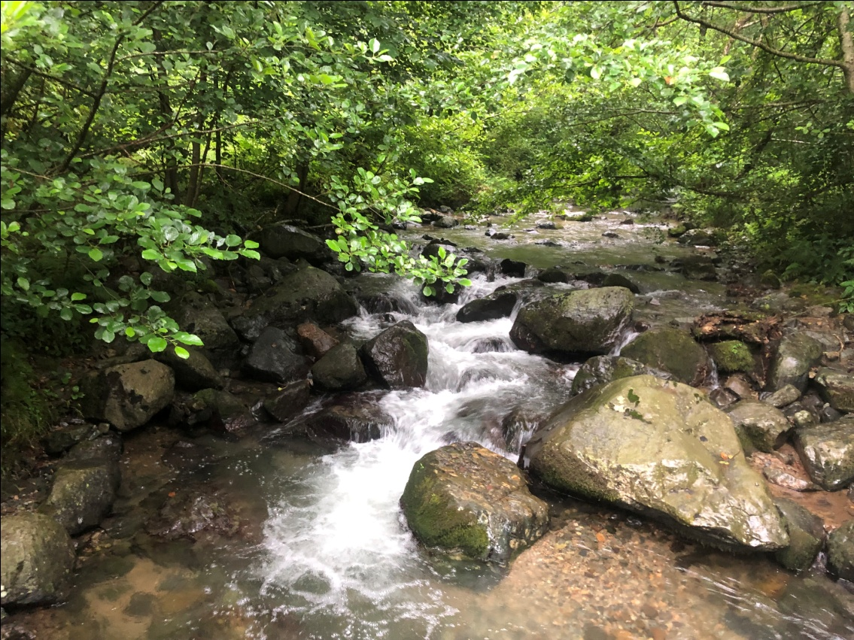

Tbilisi 2022
"Hydro-2020" LLC

"Tsemi HPP" on Tsemistskal river, in Borjomi municipality

Feasibility study

Ltd. of "Hydro-2020".
Director პ. ტუღუში

Tbilisi 2022
Table of contents
1. The main technical and economic indicators of "Tsemi Hesi";
2. Introduction;
3. Topogeodetic justification (topographic research and map preparation);
4. Results of engineering-geological studies (geology, geophysics);
5. Seismic risk assessment of the area where "Tsemi Hesi" is located
(seismic risk analysis);
6. Construction material quarries in the vicinity of "Tsemi Hesi"
(Construction materials research)
7. Characterization of the climatic conditions of the "Tsemi HPP" location area (meteorological studies);
8. Brief hydrographic characterization of Tsemistskal river (hydrological studies);
9. Review of possible alternative options for the arrangement of the HPP on the Tsemistskal river (alternative analysis)
10. The general arrangement scheme of "Tsemi Hesi" and project decisions of individual nodes (hydraulic research and technical design);
11. Calculations of net pressure, installed capacity and annual electricity generation of "Tsemi Hesi";
12. Infrastructure;
13. Connection to "Tsemi Hesi" network. power transmission line;
14. Volumes of work to be performed and preliminary benchmark assessment (source of work volumes);
15. Organization of construction;
16. Environmental impact assessment (ecology);
17. Analysis of economic and financial indicators of "Tsemi Hesi";
18. Procurement planning and implementation plan;
19. Work force training schedule;
20. The plots of land required for the implementation of the project
determination of location;

1. The main technical and economic indicators of "Tsemi Hesi".
# | Hhesis monacemebi | MMmniSvne-lobaLONA
1 | 2 | 3
1 | hesis saangariSoO xarji | 0,4
2 | wyalaRebis kveTSi mdinaris kalapotis niSnuli | 1191
3 | saagregate Senobis ganTavsebis kveTSi mdinaris kalaportis niSnuli | 1044
4 | hesis ZiriTadi kvanZebis ganTavsebis koordinatebi  saTave  milsadenis dasawyisi kveTi  milsadeniT mdinaris kalapotis gadakveTa  saagregate Senoba  wyalgamyvani traqtis mdinaresTan SeerTeba | X=372661,21 Y=4627714,69  X=3726674,56 Y=4627715,79  X=372781,7 Y=4628689,5  X=372885,64 Y=4628767,48  X=372899,97 Y=4628790,69
4 | hesis geometriuli dawneva saTave nagebobis kaSxliT gamowveuli Setborvis gaTvaliswinebiT | 154,40
5 | hesis netto dawneva saangariSo xarjis gatarebisas | 147,10
6 | sadawneo milsadenis sigrZe | 2010
7 | sadawneo milsadenis diametri | 630
8 | hesis dadgmuli simZlavre. Mmgvt | 0,500
9 | damontaJebuli turbinebis raodenoba | 1
10 | damontaJebuli turbinis tipi | peltoni
11 | eleqtroenergiis wliuri prognozuli gamomuSaveba  milioni kvt.  - saSualo wylianobis (50%) wlis pirobebSi M  - saSualod mcire wylianobis (75%) wlis pirobebSi | 2,875  2,544
12 | dadgmuli simZlavris gamoyenebis koeficienti  - saSualo wylianobis wlis pirobebSi M  - saSualod mcire wylianobis wlis pirobebSi | 0,656  0,581

2. Introduction
The technical and economic feasibility study of "Tsemi HPP" was processed by "Hydro-2020" LLC on the order of "Iota Synergy" LLC, based on the relevant agreement signed between the mentioned organizations.
In the technical and economic justification report, the issue of technical feasibility and economic feasibility of setting up "Tsemi HPP" on the Tsemistskal river in Borjomi municipality, in the surrounding area of ​​Tsemi village, is discussed.
In the process of developing the technical and economic feasibility study, the materials of the topogodetic survey of the location of the "Tsemi HPP" were used, which was processed on the basis of the materials of the aerial photography, by the organization of the topogodesic profile, "Teragrafik" LLC. The topographical plans of the locations of the individual nodes of the HPP (the main water intake node, the area where the pressure pipe crosses the bed of the Tsemitskal River, on which the aqueduct is constructed, the aggregate building of the HPP) were checked and corrected on the spot, using a tacheometer. The topogodesic survey covered the valley of Tsemitskal river at 1210-1130 m. Between the marks, both the river bed and the adjacent riverside terraces, as well as on the right bank of the river, a local dirt road passing at rather high marks compared to the bed, which can be used as a strip for the possible placement of the pressure pipeline.
The characterization of the engineering-geological conditions of the HPP location area is presented in the form of a separate report. In addition, in the present "Technical-Economic Justification", we present the main results of the conducted engineering-geological studies in the form of a brief overview.
Due to the small capacity of "Tsemi Hesi", processing of the possible environmental impact (EIA) of the cascade of HPPs is not considered. In addition, in this feasibility study, the possible impact of the construction and operation of "Tsemi HPP" on the surrounding environment is considered as a separate paragraph.
In the process of developing the present feasibility study, the design team of "Hydro-2020" Ltd. inspected in detail both the area of ​​the project HPP location as a whole, as well as the alternative locations of separate nodes included in the HPP. The materials of the hydrological and engineering-geological studies performed in the process of the feasibility study were analyzed, various alternative options for the location of the main nodes of the HPP (the main water intake node, the pressure pipeline track, the aggregate building of the HPP) were presented, and the optimal layout of the project "Tsemi HPP" was presented. , a scheme recommended for further processing and practical implementation.
The locations of the main nodes of the HPP (main intake facility, aggregate building, pressure pipeline track) were determined taking into account a number of factors: the variation of river costs along the length, relief conditions, the possibility of running the pressure pipeline in individual areas

Specifically, the following circumstances were taken into account:
• Above the selected location of the head water intake node of "Tsemi Hesi", the Tsemistskal River has a narrow bed with sharply sloping valley slopes. Accordingly, in the case of moving the head water intake node of "Tsemi Hesi" to the top, it will be difficult to bring the road to the construction site of the head structure, as well as to arrange the rack necessary for the pressure pipeline of the HPP;
• Borjomi-Bakuriani narrow-gauge railway crosses the bed of the Tsemistskal river below the site selected for the construction of the aggregate building of "Tsemi HPP" through the railway bridge (the so-called "Eiffel bridge, built more than a century ago according to the project of Gustave Eiffel). The passage of the pressure pipeline of "Tsemi Hesi" under the mentioned bridge, in which the water pressure exceeds 15 atmospheres, is connected with a number of problems. It should also be noted that even if it is possible to pass the pressure pipeline under the bridge, it will not give us a significant increase in the geometrical pressure of "Tsemi Hesi", because after the said crossing, the longitudinal slope of the river is significantly reduced. Thus, it should be considered inadvisable to move the location of the aggregate building of the HPP downstream.

Finally, based on the above arguments, the area of ​​Tsemistskal River 1200-1140 m. between the marks.
The amount of water intake cost of "Tsemi HPP" was determined based on the analysis of hydrological data of the Tsemistskal River and amounts to - 0.45 m3/s. A brief hydrographic characterization and basic data of the Tsemistskal River are given in the form of a separate paragraph included in the present feasibility study.
The characterization of the main nodes of the project HPP (the main water-intake node with a fishway, the pressure pipeline with the anchor supports placed on it and the structures arranged at the river bed crossing, the aggregate building of the HPP with the water-conveying tract, the power transmission line), the justification of the design decisions made during their design, are given in the form of the relevant paragraphs of the present technical and economic justification. . We can judge the placement of nodes, dimensions and construction details according to the drawings presented in the graphic part of the feasibility study.
The volumes of work to be performed for the arrangement of these nodes were determined according to the drawings processed at the level of technical and economic justification of individual nodes.
naxazi-2

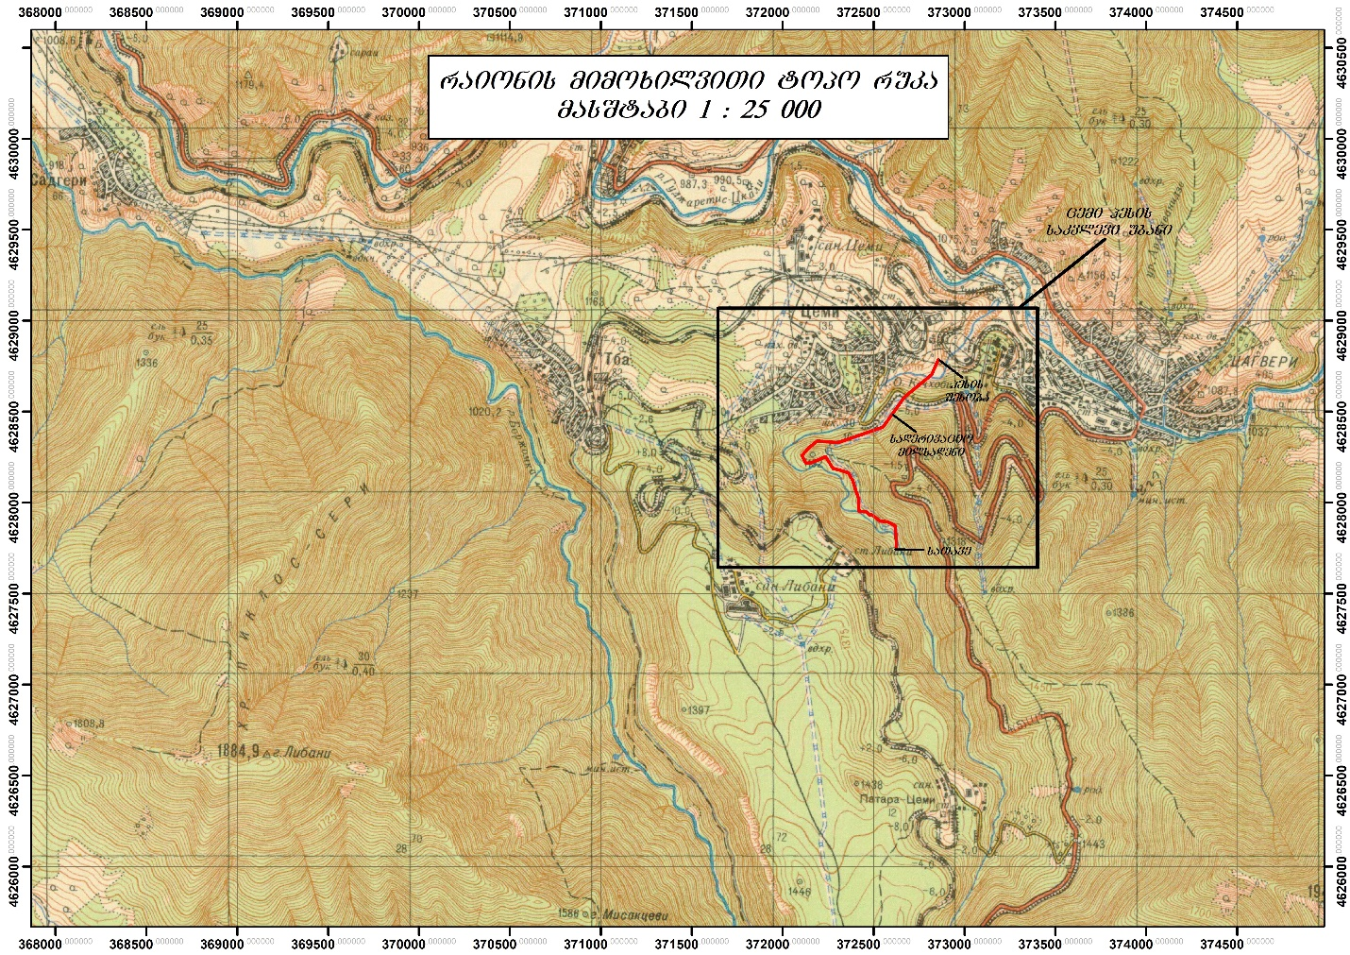
naxazi-1

- Results of engineering-geological studies
The engineering-geological study of the area where the "Tsemi HPP" is located was carried out by the geological profile organization, "Geostandard" LLC. The results of the conducted studies are presented in the form of a separate book included in the "Tsemi Hesi" project. In this feasibility study, we present only the main results and conclusions of the conducted studies.
The research area is located in Samtskhe-Javakheti area, within Borjomi municipality, village Adjacent to Tem and includes the river. of the left tributary of Gujaratiskali, river In the lower part of the Tsemistskal valley, within the 1200-1040 m.abs. points of the bed (see the topographical map of the location of "Tsemi Hesi", Fig. 1).
The program of engineering-geological studies to be implemented for the purpose of designing "Tsemi HPP" included the implementation of camera and field works, the purpose of which was to study the engineering-geological features of the area of ​​the project HPP vans:
In particular, in the process of carrying out engineering-geological studies:
- • Stock literature and geological material were searched and processed;
- • The river was studied by field studies. On Tsemistskal, the engineering-geological conditions of the site of the facilities included in the project hydroelectric node of "Tsemi HPP" - geological reconnaissance and planning were carried out, as well as field geophysical studies were carried out at the locations of the head node, the pressure derivation mill and the HPP building;
- • Mining works were removed - 14 pits (two in the alignment of the dam, two near the HPP building and 10 within the derivation pipeline corridor;
- • In the process of field studies, modern dangerous geological (geodynamic) processes and their conception-development possibilities were identified and studied;
- • For the purpose of laboratory studies, samples of loose-unbound soils and rocky rocks were taken from both mining products (shurfs) and outcrops to study their physical-mechanical properties and for petrographic analysis; A water sample was taken from the river to determine chemistry and aggressiveness;
- • Seismic hazard assessment was carried out for the project area of ​​"Tsemi Hesi";
- • Field geophysical research was performed - seismic (refracted wave method) profiling and appropriate seismogological 3 (three) trenches were taken, propagation velocities of elastic longitudinal and transverse waves (and others) were determined;
- • GPS coordination and photo illustration of the research area was carried out; • Two licensed and three unlicensed deposits of construction materials were searched (location, parameters);
- • A summary engineering-geological technical report was prepared based on the analysis of the performed field and chamber works.
- • Two licensed and three unlicensed deposits of construction materials were searched (location, parameters);
- • A summary engineering-geological technical report was prepared based on the analysis of the performed field and chamber works.

As the results of the conducted engineering-geological studies show, the project area of ​​the hydroelectric station of "Tsemi Hesi" is surrounded by the river. 1200-1040 m of the bed of Tsemistskal. Abs. Among the benchmarks, various alternative options for the layout of the buildings included in it (mainly the derivation pipeline), whose engineering-geological conditions were consistently studied in the course of the conducted engineering-geological studies, were considered in the final form.
In general, the hydroelectric power station is presented in the form of the following main structures:

• head water intake node;
• pressure derivation pipeline;
• HPP aggregate building and transmission channel.

The main water intake node with a crushing dam and a side water intake is planned to be arranged in the river. In the Tsemistskal valley, 1195 m from the edge of the river. Abs. within the mark (Fig. 1). The width of the bottom of the valley in and around the dam is 20-25 meters, the slope of the left slope is 25-300 in the lower part, and 45-500 in the upper part. The slope of the right slope is 50-550. The width of the bed is 5-6 meters, on the left side of which a low terrace is developed, the height of which is 0.5-0.7 meters, the width is 10-20 meters, and the length does not exceed 60-65 meters. The coastal terrace and bed are built with Quaternary alluvial-proluvial sediments, the thickness of which does not exceed 2-3 meters.
The rocky slope adjacent to the left terrace is covered with a layer of colluvial-deluvian sediments up to 2.0÷3.0 meters thick. The rocky part of the bed is covered with insignificant Quaternary alluvial-proluvial sediments, the thickness of which does not exceed 2.02.5 meters. A right-slope cut is built with the main rock rocks, where the layers fall in the direction of the lower buffet, with an inclination angle of 50÷60⁰.

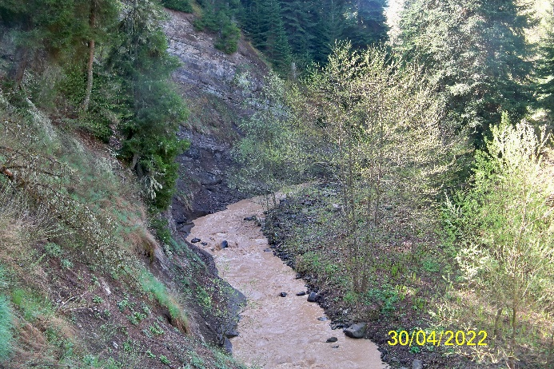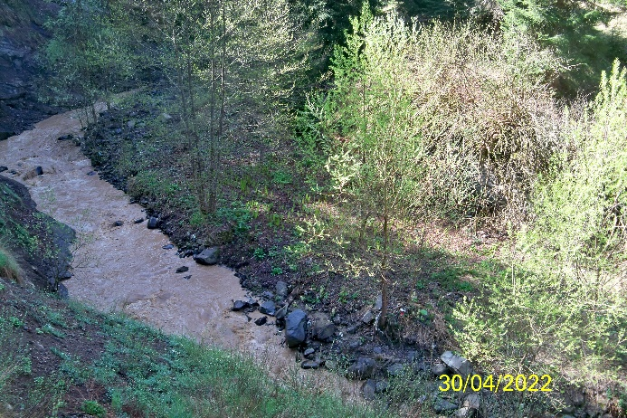
fig.3 fig.4
The tuffs, which are weakly eroded to a depth of 5.0-5.5 meters, will be used for the foundation of the reservoir dam and intake. Basic rocks will also be used to support the right side of the dam, and to support the right side, depending on the width of the terrace (10-20 meters) and the colluvial-deluvian cover on the slope, either sedimentary rocks will be used, or an intrusion into the slope sediments will be made and based on basic rocks, which will reduce the risks of bypass filtration.
In order to avoid filtration losses, we consider it necessary to arrange a 15-20 meter long concrete wall along the left slope in the upper basin, cutting it up to the weakly depleted zone of the main rocks.
Modern dangerous geological processes, which will threaten the operation of the dam in its scale, are not fixed in its alignment and in the surrounding area, although periodic water falls and landslides (probably 1-2 times a year) should be taken into account in the design decision.

The project track of the pressure diversion pipeline, the length of which is 2000 meters, is arranged from the dam to the HPP building, 1198-1053 m. Abs. Among the landmarks, the majority of which will be located within the framework of the forestry road cut into the bedrock, then cross the central highway, descend a steep slope, cross the river bed once by means of an aqueduct, and probably run along the left bank along the river bed to the HPP building.

From pk0+00 to pk17+25, from the dam to the central highway, the derivation pipeline will be buried in a trench cut in the rocky bedrock, within the framework of the forestry road, the width of which is 3-4 meters, and the slope of the surrounding slopes does not exceed 30-400. In the given section, the project area is stable, in the space of which no dangerous geological processes are recorded (Fig. 5-10).

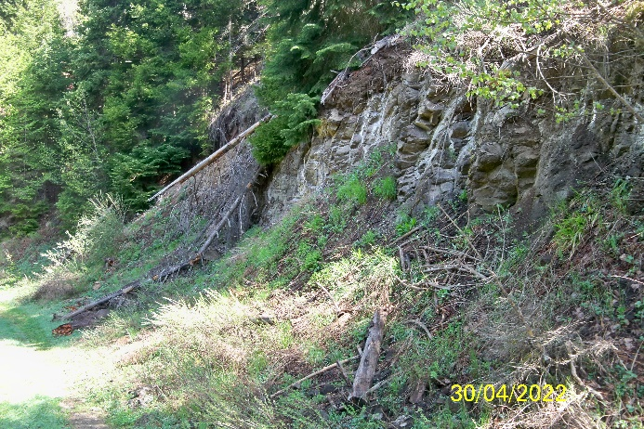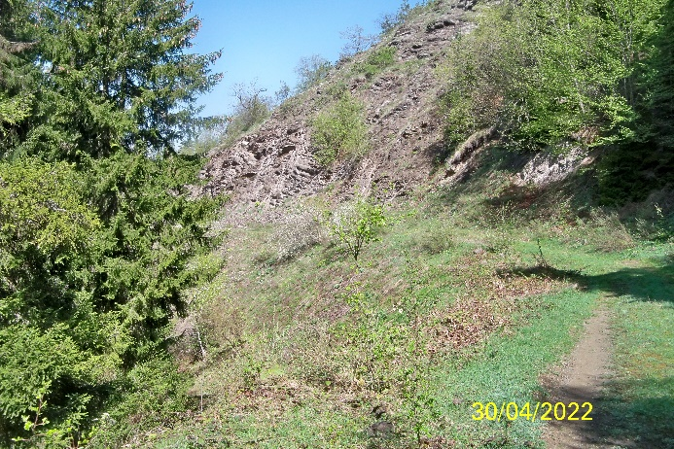
სურ.5 სურ.6
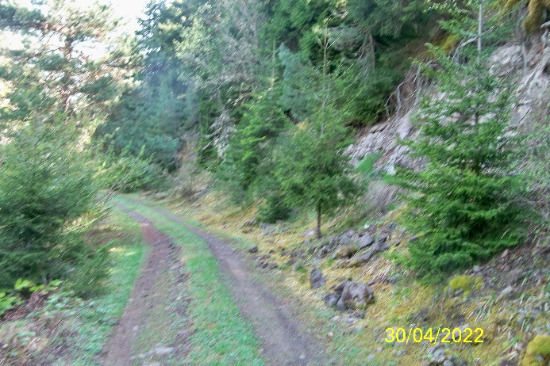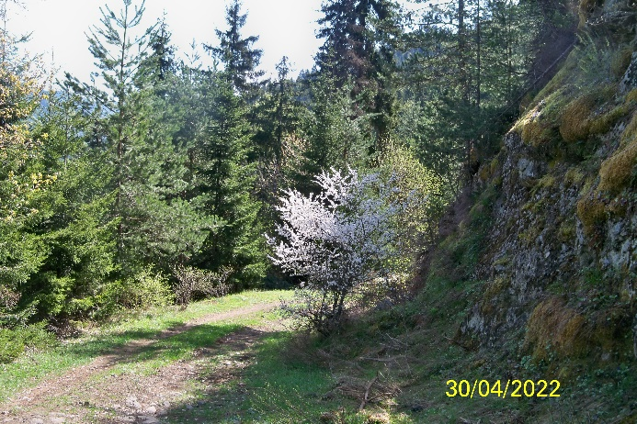
სურ.7 სურ.8
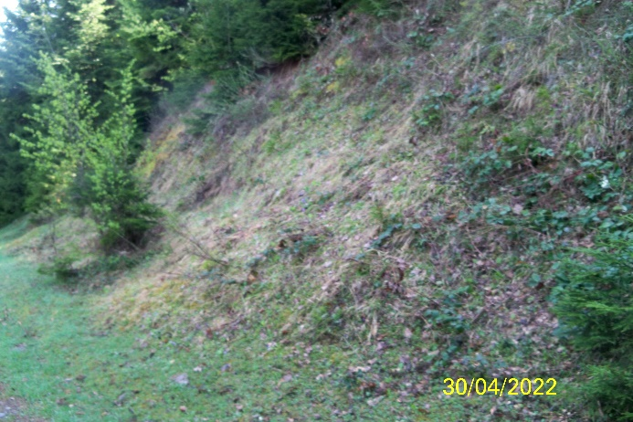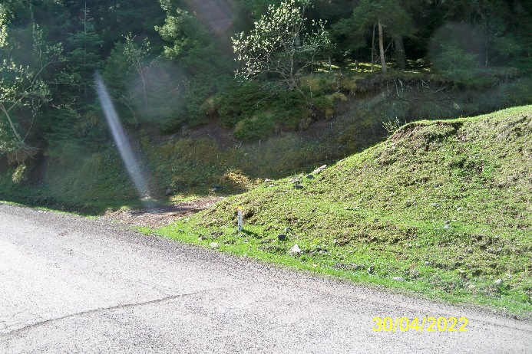
სურ.9 სურ.10

PK17+25-18+43 section, from the central highway to Md. To the terrace of Bakurianiskali, the project corridor of the derivation pipeline should pass on a slope with a large slope (30-350) with a northern exposure (Fig. 11-12). The area is geologically made up of bedrock rocks (Sge-3), weakly depleted and fissured, which are overlain by colluvial-deluvian sediments of small thickness (Sge-1).
The slope is stable and no dangerous geological processes are recorded.
The foundation of the pipeline should be carried out on bedrock using piles or anchors, the foundation of which should be based on the preserved, impervious surface of the bedrock (SGE-3).
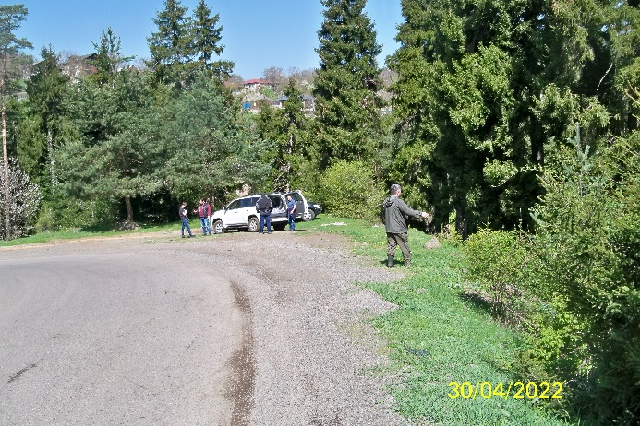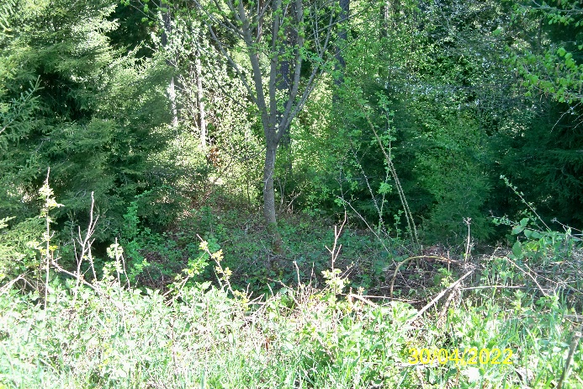
სურ.11 სურ.12

PK18+43-18+83 in this section, the diversion pipeline will be located in the alluvial-proluvial sediments of the river bed, within which it will cross the river bed (Fig. 13-14). The transition from the right bank to the left bank will be carried out either by an aqueduct-type passage, or by digging the pipeline into alluvial-proluvial soils (Sge-2) - under the bed, by arranging a protective sarcophagus.
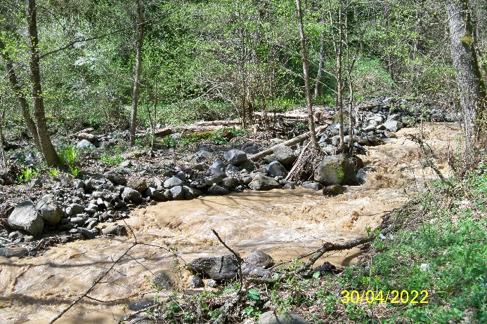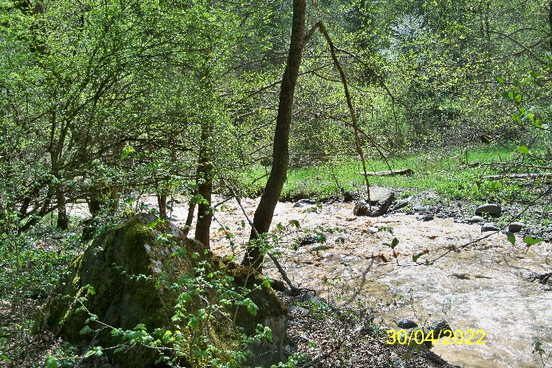
სურ.13 სურ.14
PK18+83-19+88 pipeline will be based on a slope with a small slope, on a shelf arranged in colluvial-deluvian sediments - depending on the benchmark of the derivation pipeline, or by digging in alluvial-proluvial sediments (SGE-2), or based on basic rocks (SGE-3).
When cutting the colluvial-deluvian slope, we consider it necessary to arrange a low wall supporting the slope.
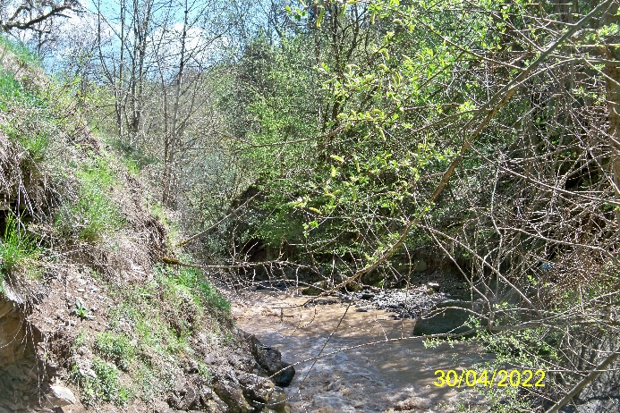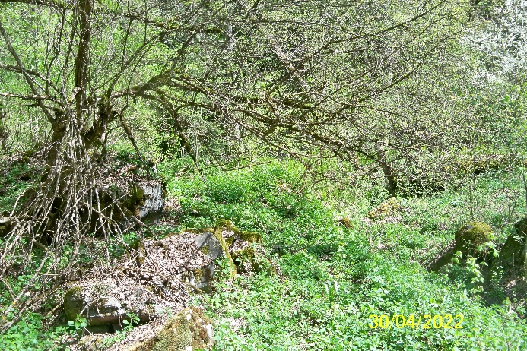
სურ.15 სურ.16
Up to PK19+88-20+15, i.e. to the aggregate building of the HPP, will be located on the alluvial-proluvial floodplain terrace of the river (Fig. 17).

სურ.17
Among the modern dangerous geological processes, both for the period of construction and operation, small landslide-gravitational and erosion processes developed on the slopes should be taken into account.
According to the project decision, the building of the HPP and the delivery channel will be located on the river. Adjacent to the left slope of the Tsemistskal gorge, on a low terrace above the floodplain, 1042-1045 m above sea level. Abs. Within the boundaries, the width of which is 25-30 meters, the length is 50-55 meters, and the height of the terrace steps increases from 1.5 meters to 2.5-3.0 meters (Fig. 18).

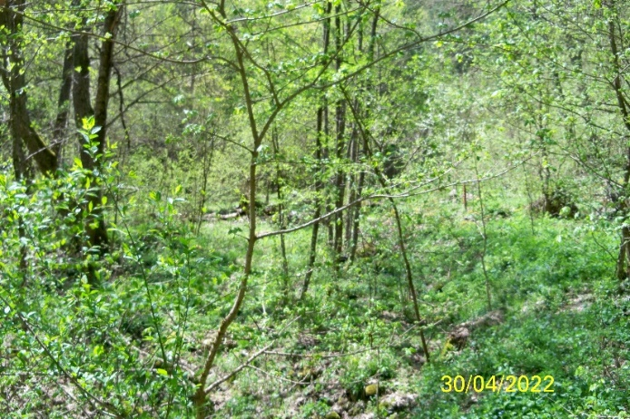
სურ.18
The terrace is geologically built with alluvial-proluvial sediments of the Quaternary age, the capacity of which varies within the limits of 3.5-4.0 meters based on geological planning and data analysis of stock materials within the structures. The surface of the terrace is covered with bushes and trees.
The slope of the slope surrounding the terrace is 30-350, which at the lower levels is represented by colluvial-deluvial sediments covering the alluvial-proluvial sediments of the terrace, the thickness of which is variable and ranges from 1-2 meters to 2-3 meters.
The ground water level in the terrace sediments corresponds to the water level in the river for the corresponding period.
Alluvial-proluvial sediments cover basic rock rocks, which in the surface zone are represented by weakly depleted (up to 5-7 meters) basic rock rocks. Both alluvial-proluvial sediments and rocky rocks are recommended for the foundation of the HPP building. Depending on the selected type of building foundation, the foundations of the buildings are likely to be implemented on a weakly worn surface of bedrock.
During the design-construction period, it should be taken into account the flow of filtered ground water into the cistern, and in the case of a deep cistern, slopes of appropriate stability (inclination) should be selected.
In order to avoid expected geohazards, i.e. erosive washing of the river terrace, we consider it necessary:
• in the given area, the alignment and deepening of the river bed along the entire length of the terrace;
• Arranging anti-erosion embankment protective concrete wall and loading it with large size (d=1-1.5m) boulders, which ensures smooth and sustainable operation of the generator building.
In general, as a conclusion, we can state that the engineering-geological conditions for the location of nodes of "Tsemi Hesi" are suitable for the planned construction works.
In more detail, you can see the assessment of the engineering-geological conditions of the "Tsemi HPP" location area in the form of a separate engineering-geological report included in the project.

4. Seismic of the "Tsemi Hesi" location area
Risk assessment
(seismuri risk analysis)
The seismic risk assessment in the territory of the "Tsemi HPP" location was carried out according to the map of seismic regions of Georgia and the engineering-geological research materials available in the territory of the "Tsemi HPP" location.
In the process of conducting engineering-geological studies, in parallel with the engineering-geological studies, a seismic hazard assessment was carried out for the project area of ​​"Tsemi HPP". Field geophysical studies were performed - seismic (transmitted wave method) profiling and appropriate seismogological 3 (three) trenches were taken, the longitudinal longitudinal was determined and propagation speeds of transverse waves (and others);
Seismic risk assessment report is presented together with materials of engineering-geological studies, included in the "Tsemi HPP" project, in the form of a separate book.
In the explanation card of the present technical-economic report, we briefly note the fact that according to the scheme of seismic districts of Georgia, the study area belongs to the 8-point seismic activity zone, therefore the seismicity of the construction site is acceptable as 8 points (Order of the Minister of Economic Development of Georgia N1-1/2284 dated 7th of 2009 October, Tbilisi, on the approval of construction norms and rules "Seismic-resistant construction (PN 01.01.09)".
The dimensionless coefficient of the maximum acceleration of horizontal wave propagation for the research and bordering areas is 0.12.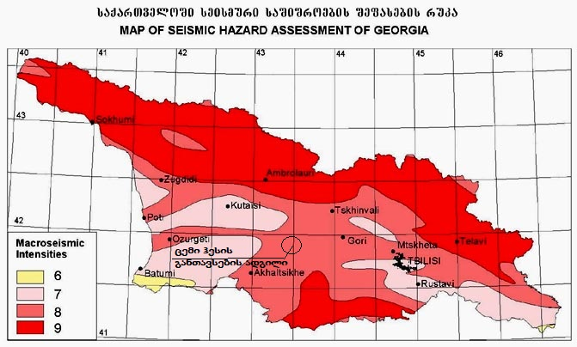

- Survey of construction material quarries in the vicinity of the project "Tsemi Hesi" location.
The presence of quarries of construction materials in the vicinity of the construction area is very important for the successful implementation of the construction of the HPP. In the vicinity of the "Tsemi Has" construction site, in the process of working on the previous feasibility study, two unlicensed (N1 and N2) and one licensed sand-gravel deposit (N3) were found in the river. in the water valley of Gujarat, which are located at the closest distance from the facilities of Tsemi HPP (see Fig. 1).
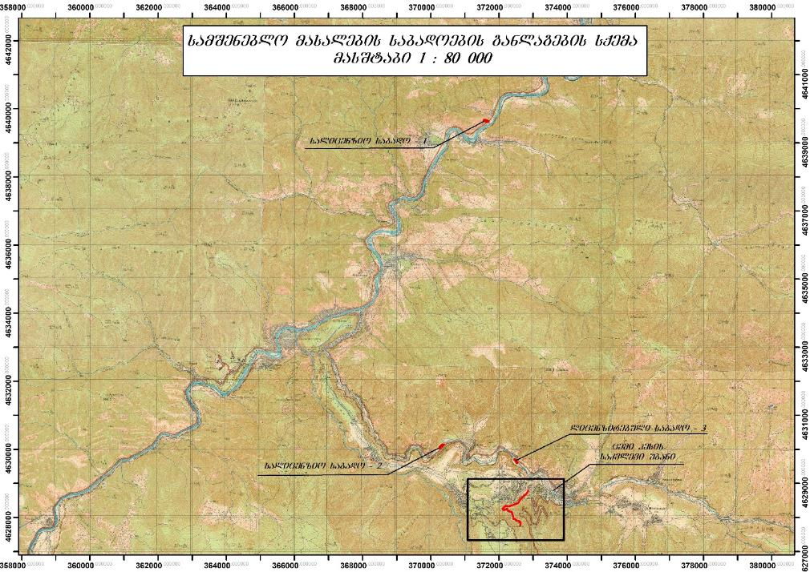
ნახ.1
From the closest unlicensed deposits located near the project facilities, we bring you the data of two of them:

1. River Unlicensed sand-gravel deposit of Gujarat water N1 (Fig. 2)
The linear coordinates of the district of mineral exploitation object (deposit) are:
N | 1 | 2 | 3 | 4 | 5 | 6 | 7 | 8
X | 371561 | 371595 | 371693 | 371688 | 371615 | 371590 | 371568 | 371553
Y | 4629678 | 4629680 | 4629641 | 4629622 | 4629626 | 4629634 | 4629647 | 4629654
S=4835 მ² WGS 1984

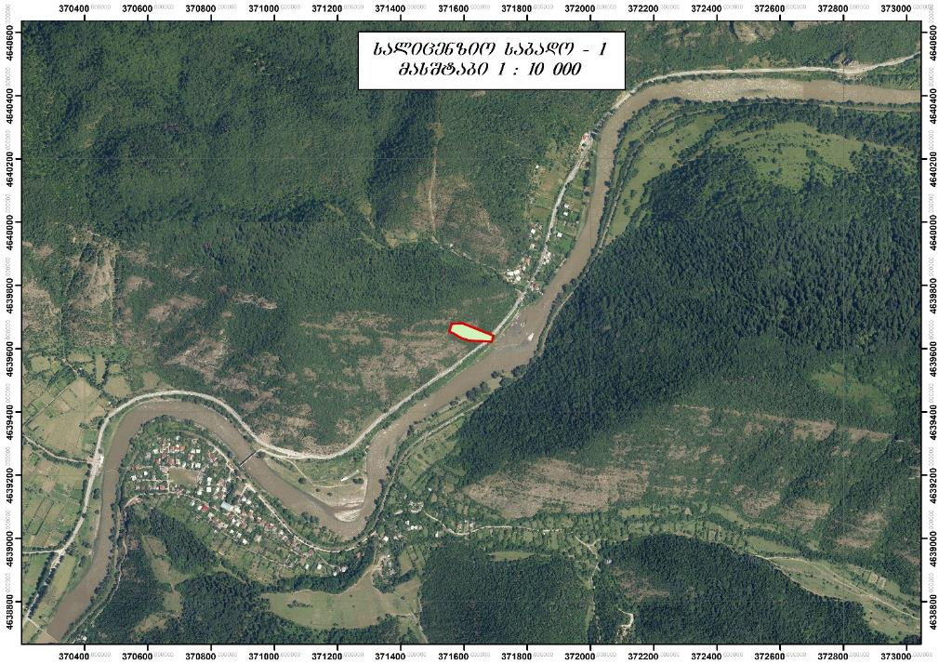
ნახ.2
The deposit is 23 kilometers away from the hydroelectric station of N1 "Tsemi Hesi".
The absolute height of the object is 980-1000 meters above sea level.
The distance from the nearest bridge is 825 and 940 meters.
A railway line is fixed 50 meters from the license facility.
Alluvial sediments of modern Quaternary age are represented by well-worked gravel, pebbles, gravel and sand. The sand is coarse and medium-grained, gray in color and consists of volcanic and sedimentary rock particles.
Granulometric composition, in %:
<5 mm - 17.7; 5-10 mm - 13.8; 10-20 mm - 9.4%; 20-40mm -14.8%, 40-70mm -26.6%; >70 mm - 17.7%.
Physical and mechanical properties are given below:
For a mixture of inert material:
Gravel: volumetric weight - 2100-2200 kg/m3
Sand: volumetric weight of bulk - 1372 kg/m3
According to the complexity of the engineering-geological conditions, the territory belongs to I, easy category.
2. River Unlicensed sand-gravel deposit of Gujarat water N2 (Fig. 3)
The linear coordinates of the district of mineral exploitation object (deposit) are:
N | 1 | 2 | 3 | 4
X | 370322 | 370388 | 370225 | 370256
Y | 4630139 | 4630151 | 4630020 | 4630078
S=4310 მ² WGS 1984

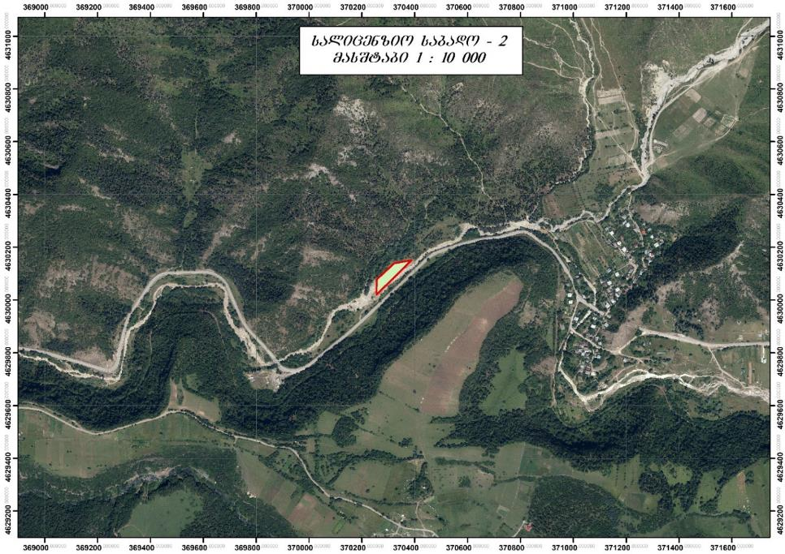
ნახ.3
The field N2 is 6.5 kilometers away from the hydroelectric station of "Tsemi Hesi".
The absolute height of the object is 950-970 meters above sea level.
The distance from the nearest bridge is 435 meters.
A railway line is fixed 90 meters from the license facility.
The granulometric composition and physical-mechanical characteristics of the sediments are similar to the first deposit and are represented by well-processed gravel, pebbles, gravel and sand.
3. River Gujarat water sand-gravel licensed deposit N3 (Fig. 4)
The linear coordinates of the district of mineral exploitation object (deposit) are:

N | 1 | 2 | 3 | 4
X | 372449 | 372468 | 372547 | 372519
Y | 4629712 | 4629717 | 4629610 | 4629595
S=3380მ² WGS 1984

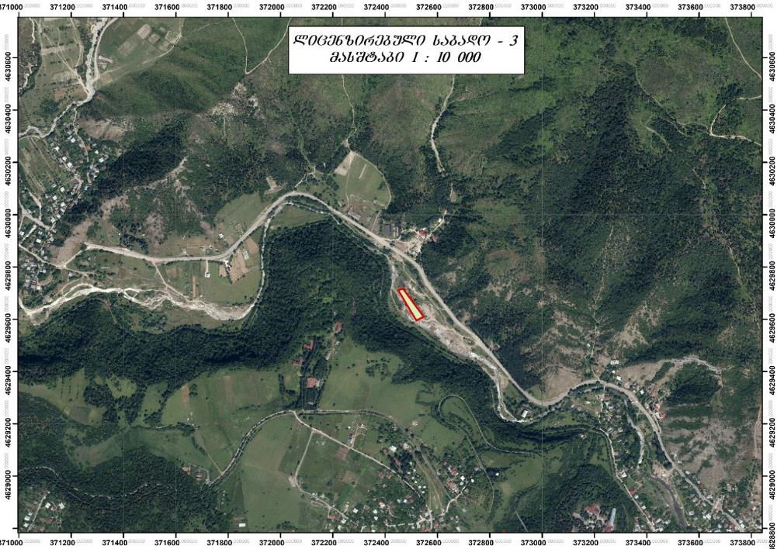
ნახ.4
The field N3 is 3.8 kilometers away from the hydroelectric station of "Tsemi Hesi".
The absolute height of the object is 950-970 meters above sea level.
The distance from the nearest bridge is more than one kilometer.
The granulometric composition and physical-mechanical characteristics of the sediments are similar to the first deposit and are represented by well-processed gravel, pebbles, gravel and sand.
The inert materials imported from the mentioned quarries can be used both for the preparation of gravel under the concrete structures and for the production of concrete, except for the wear-resistant material required for the surface layer of the dam, which will require the import of inert materials with a particularly strong synthesis, which cannot be found in the vicinity of the construction site. The inert materials required for the production of the wear-resistant master should probably be imported:
• Ghorghi - from the quarry near Kursi village of Tskaltubo municipality;
• Kvisha - village of Sachkheri municipality. From the existing quarry.

As a large concrete filler, crushed natural stone can be used: gravel, gravel, gravel or a mixture of gravel and gravel. Large filler grains are divided into the following fractions according to thickness: 510 mm, 10÷20 mm, 20÷40 mm, 40÷80 mm, 80÷120 mm. The maximum size of the grain thickness is taken to be no more than 1/36 of the minimum size of the structure.
For concretes, the class of which is less than or equal to B30, the use of coarse aggregates made of carbonate and metamorphic rocks is allowed. For higher grade concrete, the use of such fillers is allowed only after experimental testing of concrete made with such fillers.
The amount of dust, clay and silt particles in the coarse filler should not exceed 1-2%.
Natural or crushed sand with a grain thickness of less than 5 mm is used as a fine filler. If necessary, it is allowed to divide the sand into fractions.
Cement
Both Portland cement (M-400, M-500, M-600) produced at the Rustavi Cement Factory and Pozzolanic Portland Cement (M-400, M-500, M-600) produced at the Kaspi Cement Factory, in which nitrogen oxides The content should not exceed 0.6%. During concreting of massive concrete monolithic constructions, the body of the dam, in order to prevent cracking caused by exothermic heat, it is necessary to limit the content of tricalcium silicate and tricalcium aluminate in the mechanical composition of the clinker as much as possible. Cement must meet the conditions of the applicable standard (ГОСТ 10178-85).

Armature
During the construction of "Tsemi Hesi", the reinforcement used for the reinforcement of monolithic concrete structures will probably be brought to St. from Rustavi. The mechanical properties of reinforcement must be in accordance with applicable construction norms and rules (СНИП 2.06.08-87). Mainly A-1 and A-3 class reinforcement will be used.

Pipeline
d=630 mm will be used to arrange the pressure pipeline of "Tsemi Hesi". diameter and =7 mm. Thick-walled corrugated pipes, which are likely to be made to special order, overseas.
The rest of the construction materials (steel products, bitumen, waterproofing rubber profiles, bitumen, etc.) are of relatively small volume and will be brought to St. From the bases of building materials in Tbilisi.
6. Construction material quarries in the vicinity of "Tsemi Hesi"
(Construction materials research)
mdinare cemiswylis (saTaveebSi bakurianiswyali) auzi, rogorc zemoT iyo aRniSnuli, mdebareobs TrialeTis qedis CrdiloeT ferdobze, sadac gabatonebulia zRvis notiodan zomierad notio kontinenturze gardamavali hava, civi Tovliani zamTriT da xangrZlivi zafxuliT. aRniSnuli klimaturi pirobebis Camoyalibebas ZiriTadad ganapirobebs teritoriis hipsometriuli ganviTareba, orografiuli pirobebi da daSoreba Savi zRvidan.
teritoriaze gabatonebuli klimaturi pirobebis daxasiaTeba Sedgenilia md. cemiswylis auzis uSualo siaxloves arsebuli borjomis, cemisa da bakurianis meteorologiuri sadgurebis mravalwliuri dakvirvebis monacemebis safuZvelze, romelTa mixedviT mzis naTebis xangrZlivoba mTeli wlis ganmavlobaSi maRalia da misi saSualo wliuri sidide 2200-dan 2400 saaTamde icvleba, jamobrivi radiacia ki 130-150 kkal/sm²-s utoldeba.
mzis radiaciasTan uSualo kavSirSia klimaturi pirobebis maformirebeli erT-erTi ZiriTadi faqtori _ haeris temperatura, romlis saSualo Tviuri, wliuri da eqstremaluri mniSvnelobebi, aRniSnuli meteorologiuri sadgurebis mravalwliuri dakvirvebis monacemebis mixedviT, mocemulia #5.1 cxrilSi.

haeris temperaturis saSualo Tviuri, wliuri da
eqstremaluri sidideebi t⁰C
cxrili #5.1
metsadguri | t⁰C | I | II | III | IV | V | VI | VII | VIII | IX | X | XI | XII | weli
borjomi | saS. | -2.8 | -1.4 | 2.4 | 7.7 | 13.0 | 16.0 | 19.0 | 19.0 | 14.8 | 9.3 | 3.6 | -0.8 | 8.3
 | abs.maqs. | 16 | 18 | 27 | 30 | 33 | 35 | 37 | 37 | 35 | 30 | 25 | 18 | 37
 | abs. min. | -29 | -23 | -18 | -10 | -4 | 2 | 5 | 3 | -5 | -9 | -15 | -24 | -29
cemi | saS. | -4.2 | -2.8 | 1.0 | 6.5 | 11.7 | 15.0 | 17.8 | 18.0 | 14.0 | 8.8 | 3.2 | -1.7 | 7.3
 | abs.maqs. | 15 | 17 | 26 | 28 | 31 | 33 | 36 | 36 | 34 | 30 | 23 | 17 | 36
 | abs. min. | -31 | -22 | -21 | -14 | -4 | 0 | 2 | 1 | -6 | -11 | -20 | -26 | -31
bakuriani | saS. | -6.2 | -5.5 | -2.4 | 3.2 | 8.5 | 11.6 | 14.4 | 14.6 | 10.8 | 6.0 | 0.9 | -3.4 | 4.4
 | abs.maqs. | 12 | 14 | 18 | 23 | 26 | 28 | 31 | 31 | 31 | 26 | 22 | 17 | 31
 | abs. min. | -36 | -30 | -28 | -22 | -9 | -3 | -2 | -3 | -10 | -15 | -22 | -30 | -36

wayinvebi, anu saSualo dRe-Remuri dadebiTi temperaturebis fonze haeris gaciveba 0⁰C-ze qvemoT, saSualod iwyeba seqtember-oqtomberSi da mTavrdeba april-ivnisSi.
wayinvebis dawyebisa da dasrulebis TariRebi, aseve uyinvo periodis xangrZlivoba dReebSi, imave metsadgurebisa mravalwliuri dakvirvebis monacemebis mixedviT, mocemulia #5.2 cxrilSi.

wayinvebis dawyebisa da dasrulebis TariRebi da uyinvo periodis
xangrZlivoba dReebSi
cxrili #5.2
met-  sadguri | wayinvebis TariRi |  |  |  |  |  | uyinvo periodi dReebSi
 | dasawyisi |  |  | dasasruli |  |  | saSua  lo | umci  resi | udi  desi
 | saSualo | naadre  vi | gviani | saSualo | naadre  vi | gviani
borjomi | 23.X | 30.IX | 20.XI | 24.IV | 5.IV | 16.V | 181 | 149 | 219
cemi | 13.X | 15.IX | 11.XI | 1.V | 28.III | 27.V | 164 | 139 | 227
bakuriani | 27.IX | _ | _ | 24.V | _ | _ | 125 | _ | _

niadagis zedapiris temperatura, romelic damokidebulia niadagis tipze, mis meqanikur Semadgenlobaze, sinotiveze, mis daculobaze mcenareuli safariT zafxulSi da Tovlis safaris simaRleze zamTarSi, iTvaliswinebs niadagis zedapiris ramdenime mm-iani sisqis temperaturas. misi maCveneblebi mWidro kavSirSia haeris temperaturis sidideebTan. amasTan, misi saSualo wliuri maCvenebeli, sakvlev teritoraze, 1-1,5⁰-ze metad aRemateba haeris temperaturis saSualo wliur sidides.
niadagis zedapiris saSualo Tviuri, wliuri, saSualo maqsimaluri da saSualo minimaluri mniSvnelobebi, imave metsadgurebis mravalwliuri dakvirvebis monacemebis mixedviT, mocemulia #5.3 cxrilSi.
niadagis zedapiris saSualo Tviuri, wliuri, saSualo maqsimaluri da saSualo minimaluri temperaturebi t⁰C
cxrili #5.3
met-  sadguri | t⁰C | I | II | III | IV | V | VI | VII | VIII | IX | X | XI | XII | weli
borjomi | saS. | -4 | -3 | 3 | 11 | 17 | 22 | 25 | 24 | 18 | 10 | 3 | -3 | 10
 | saS.maqs. | 1 | 4 | 14 | 30 | 37 | 43 | 46 | 46 | 37 | 24 | 13 | 4 | 25
 | saS. min. | -8 | -6 | -2 | 2 | 8 | 12 | 15 | 14 | 10 | 5 | 0 | -5 | 4
cemi | saS. | -6 | -5 | 1 | 9 | 16 | 20 | 24 | 24 | 18 | 10 | 3 | -4 | 9
 | saS.maqs. | 2 | 5 | 11 | 28 | 37 | 42 | 47 | 47 | 39 | 27 | 15 | 5 | 25
 | saS. min. | -12 | -11 | -6 | 0 | 5 | 9 | 12 | 12 | 8 | 2 | -3 | -10 | 0
bakuriani | saS. | -9 | -8 | -5 | 3 | 12 | 16 | 20 | 20 | 14 | 7 | -1 | -7 | 5
 | saS.maqs. | 0 | 1 | 4 | 17 | 33 | 37 | 42 | 43 | 35 | 32 | 11 | 1 | 21
 | saS. min. | -18 | -17 | 13 | -5 | 2 | 5 | 9 | 8 | 4 | -1 | -8 | -15 | 4

niadagis zedapiris wayinvebis dawyebisa da dasrulebis saSualo TariRebi, aseve uyinvo periodis xangrZlivoba dReebSi, cemisa da bakurianis metsadgurebis mravalwliuri dakvirvebis monacemebis mixedviT, mocemulia #5.4 cxrilSi.
niadagis zedapiris wayinvebis dawyebisa da dasrulebis saSualo TariRebi da uyinvo periodis xangrZlivoba dReebSi
cxrili #5.4
metsadguri | wayinvis saSualo TariRi |  | uyinvo periodis  xangrZlivoba  dReebSi
 | pirveli  Semodgomaze | saboloo  gazafxulze
cemi | 10.X | 3.V | 159
bakuriani | 15.IX | 5.VI | 101

niadagis zedapiris temperaturis cvalebadoba vrceldeba niadagis siRrmeSi, amasTan siRrmis matebasTan erTad mcirdeba temperaturis amplituda. niadagis sxvadasxva siRrmis saSualo Tviuri da wliuri temperaturebi, bakurianis metsadguris mravalwliuri dakvirvebis monacemebis mixedviT, mocemulia #5.5 cxrilSi.

niadagis siRrmis saSualo Tviuri da wliuri temperaturebi t⁰C
cxrili #5.5
metsadguri | siRrme  m-Si | I | II | III | IV | V | VI | VII | VIII | IX | X | XI | XII | weli
bakuriani | 0.2 | _ | _ | _ | _ | _ | _ | _ | _ | _ | _ | _ | _ | _
 | 0.4 | 1.4 | 1.3 | 1.3 | 2.1 | 8.2 | 11.4 | 14.1 | 15.3 | 13.5 | 10.4 | 5.8 | 2.8 | 7.3
 | 0.8 | 3.0 | 2.3 | 1.9 | 2.2 | 6.1 | 9.2 | 12.0 | 13.4 | 13.0 | 10.6 | 7.4 | 4.5 | 7.1
 | 1.6 | 5.5 | 4.4 | 3.6 | 2.6 | 4.5 | 6.8 | 9.1 | 10.9 | 11.9 | 11.1 | 9.4 | 7.2 | 7.2
 | 3.2 | 7.9 | 7.0 | 6.2 | 4.7 | 4.8 | 5.6 | 6.7 | 8.0 | 9.0 | 9.6 | 9.5 | 8.8 | 7.3

atmosferuli naleqebi, romlebic warmoadgenen klimaturi da hidrologiuri reJimis maformirebel erT-erT ZiriTad elements, sakvlevi mdinaris auzis mdebareobis raionSi araTanabrad aris ganawilebuli. naleqebis wliuri jami 653 mm-dan 829 mm-mde icvleba auzis simaRlis mixedviT. amasTan, naleqebis wliuri msvleloba xasiaTdeba erTi ZiriTadi maqsimumiT ivnisSi da meoradi maqsimumiT oqtomberSi.
atmosferuli naleqebis saSualo Tviuri raodenoba da wliuri jami, imave metsadgurebis mravalwliuri dakvirvebis monacemebis mixedviT, mocemulia #5.6 cxrilSi.

naleqebis saSualo Tviuri raodenoba da wliuri jami mm-Si
cxrili #5.6
metsadguri | simaRle | I | II | III | IV | V | VI | VII | VIII | IX | X | XI | XII | weli
borjomi | 789 | 40 | 40 | 42 | 56 | 81 | 88 | 55 | 48 | 53 | 59 | 54 | 37 | 653
cemi | 1117 | 50 | 53 | 61 | 65 | 86 | 94 | 58 | 50 | 55 | 63 | 57 | 48 | 740
bakuriani | 1665 | 51 | 62 | 70 | 80 | 103 | 105 | 73 | 59 | 59 | 64 | 57 | 46 | 829

sakvlev teritoriaze mosuli naleqebis dRe-Ramuri maqsimaluri raodenoba sakmaod maRalia. naleqebis dRe-Ramurma maqsimalurma raodenobam, dafiqsirebulma cemis metsadgurze 1909 wlis 10 ivniss, 124 mm Seadgina. naleqebis sxvadasxva uzrunvelyofis dRe-Ramuri maqsimaluri raodenoba, dadgenili borjomisa da cemis metsadgurebis mravalwliuri dakvirvebis monacemebis safuZvelze, mocemulia #5.7 cxrilSi.
naleqebis sxvadasxva uzrunvelyofis dRe-Ramuri
maqsimumebi mm-Si (wliuri)
cxrili #5.7
metsadguri | saSualo  maqsimumi | uzrunvelyofa % |  |  |  |  |  | dakvirvebuli maqsimumi
 |  | 63 | 20 | 10 | 5 | 2 | 1 | mm | TariRi
borjomi | 32 | 27 | 38 | 44 | 50 | 57 | 62 | 61 | 26.VII.1899
cemi | 33 | 26 | 39 | 54 | 75 | 105 | 130 | 124 | 10.VI.1909

haeris sinotive erT-erTi mniSvnelovani klimaturi elementia. mas umTavresad sami sididiT axasiaTeben, esenia: wylis orTqlis drekadoba anu absoluturi sinotive, SefardebiTi sinotive da sinotivis deficiti. pirveli axasiaTebs haerSi wylis orTqlis raodenobas, meore _ haeris orTqliT gaJRenTvis xarisxs, xolo mesame _ miuTiTebs SesaZlebeli aorTqlebis sidideze. aRsaniSnavia, rom haeris wylis orTqliT gajerebisa (absoluturi sinotivis) da misi deficitis maCvenebelis wliuri msvleloba praqtikulad emTxveva haeris temperaturis wliur msvlelobas.
haeris sinotivis maCveneblebis saSualo Tviuri da wliuri sidideebi imaveEmetsdgurebis mravalwliuri dakvirvebis monacemebis mixedviT, mocemulia #5.8 cxrilSi.

haeris sinotivis saSualo Tviuri da wliuri sidideebi
cxrili #5.8
metsadguri | tenianoba | I | II | III | IV | V | VI | VII | VIII | IX | X | XI | XII | weli
borjomi | absoluturi  mb-Si | 4.4 | 4.7 | 5.5 | 7.8 | 11.5 | 14.5 | 16.7 | 16.1 | 13.1 | 9.7 | 7.2 | 5.1 | 9.7
 | SefardebiTi  %-Si | 78 | 78 | 77 | 74 | 76 | 76 | 74 | 73 | 77 | 80 | 83 | 80 | 77
 | deficiti  mb-Si | 1.4 | 1.6 | 2.2 | 4.0 | 4.8 | 5.8 | 7.3 | 7.8 | 5.4 | 3.0 | 1.9 | 1.4 | 3.9
cemi | absoluturi  mb-Si | 3.9 | 4.0 | 4.8 | 6.9 | 10.2 | 12.8 | 15.1 | 14.4 | 11.8 | 8.6 | 6.4 | 4.6 | 8.6
 | SefardebiTi  %-Si | 80 | 77 | 76 | 74 | 75 | 76 | 75 | 72 | 76 | 80 | 82 | 80 | 77
 | deficiti  mb-Si | 1.2 | 1.4 | 2.0 | 3.5 | 4.5 | 5.3 | 6.5 | 7.2 | 5.0 | 3.0 | 1.7 | 1.3 | 3.6

imave meteorologiuri sadgurebis mravalwliuri dakvirvebis monacemebis mixedviT, Tovlis safari saSualod yvelaze adre Cndeba seqtemberSi da yvelaze gvian qreba maisSi.
Tovlis safaris gaCenisa da gaqrobis TariRebi, imave metsadgurebis mravalwliuri dakvirvebis monacemebis mixedviT, mocemulia #5.9 cxrilSi.

Tovlis safaris gaCenisa da gaqrobis TariRebi
cxrili #5.9
metsadguri | Tovlian  dReTa  ricxvi | Tovlis safaris gaCenis  TariRi |  |  | Tovlis safaris gaqrobis  TariRi
 |  | saSualo | naadrevi | gviani | saSualo | naadrevi | gviani
borjomi | 67 | 8.XII | 26.X | 11.I | 24.III | 27.II | 19.IV
cemi | 104 | 19.XI. | 22.IX. | 14.XII. | 5.IV. | 4.III. | 1.V.

Tovlis safaris maqsimaluri dekaduri simaRleebis sxvadasxva uzrunvelyofis sidideebi metsadgur borjomisa da cemis mravalwliuri dakvirvebis monacemebis mixedviT, mocemulia #5. 10 cxrilSi.

Tovlis safaris maqsimaluri dekaduri simaRleebis (sm-Si) sxvadasxva uzrunvelyofis sidideebi
cxrili #5.10
metsadguri | uzrunvelyofa %
 | 95 | 90 | 75 | 50 | 25 | 10 | 5 | 1
borjomi | 7 | 12 | 14 | 22 | 32 | 42 | 60 | 98
cemi | 11 | 16 | 26 | 33 | 45 | 56 | 61 | 98

raionSi qris yvela mimarTulebis qari, magram gabatonebulia aRmosavleTis da dasavleTis mimarTulebis qarebi, rac md. mtkvris xeobis mimarTulebiT aris ganpirobebuli. qarebis mimarTulebebi da Stilebis raodenoba imave metsadgurebis mravalwliuri dakvirvebis monacemebis mixedviT, mocemulia #5.11 cxrilSi

qarebis mimarTuleba da Stilebis raodenoba %-Si wliuridan
cxrili #5.11
metsadguri | C | Ca | a | sa | s | sd | d | Cd | Stili
borjomi | 2 | 6 | 55 | 7 | 2 | 13 | 11 | 4 | 72
cemi | 2 | 4 | 25 | 15 | 3 | 12 | 32 | 7 | 30
bakuriani | 6 | 9 | 22 | 4 | 9 | 10 | 30 | 10 | 48

qaris saSualo Tviuri da wliuri siCqareebi, imave metsadgurebis mravalwliuri dakvirvebis monacemebis mixedviT, mocemulia #5.12 cxrilSi.
qaris saSualo Tviuri da wliuri siCqare m/wm-Si
cxrili #5.12
metsadguri | fliugeris  simaRle | I | II | III | IV | V | VI | VII | VIII | IX | X | XI | XII | weli
borjomi | 15 m. | 0.7 | 0.8 | 0.9 | 1.0 | 0.9 | 0.8 | 0.9 | 0.9 | 0.8 | 0.6 | 0.5 | 0.6 | 0.8
cemi | 10 m. | 1.7 | 2.0 | 2.5 | 2.8 | 2.4 | 2.6 | 2.7 | 2.8 | 2.5 | 2.0 | 1.9 | 1.6 | 2.3
bakuriani | 12 m. | 2.2 | 2.3 | 2.2 | 2.4 | 2.0 | 2.0 | 2.1 | 2.2 | 1.6 | 1.3 | 1.7 | 1.8 | 2.0

qaris sxvadasxva ganmeorebadobis maqsimaluri siCqareebi cemisa da bakurianis metsadgurebis mravalwliuri dakvirvebis monacemebis mixedviT, mocemulia #5.13 cxrilSi.

qaris maqsimaluri siCqareebi m/wm-Si
cxrili #5.13
metsadguri | qaris maqsimaluri siCqare (m/wm) SesaZlebeli erTjer
 | 1 welSi | 5 welSi | 10 welSi | 15 welSi | 20 welSi
cemi | 18 | 22 | 23 | 25 | 26
bakuriani | 21 | 25 | 26 | 27 | 28

sakvlev teritoriaze elWeqi sakmaod xSiri movlenaa, rac umTavresad wlis Tbil periodSi icis (weliwadSi 30-35 dRe). iSviaTad elWeqi zamTarSic aRiniSneba. setyvian dReTa ricxvi ki weliwadSi saSualod 2_9 dRes ar aRemateba.

7. Characterization of the climatic conditions of the "Tsemi HPP" location area (meteorological studies);

mdinare cemiswyali (saTaveebSi bakurianiswyali) saTaves iRebs TrialeTis qedis CrdiloeT ferdobze mTa sayvelosmTis (2806,4 m) Crdilo-dasavleT ferdobze 2780 metris simaRleze da erTvis md. gujareTiswyals marcxena mxridn sof. cemis aRmosavleTiT 0,5 km-Si 1020 metris simaRleze. mdinaris mTliani sigrZe 18,5 km km, saerTo vardna 1740 m, saSualo qanobi 94,0‰, wyalSemkrebi auzis farTobi ki 42,2 km²-ia.
mdinaris auzi mdebareobs TrialeTis qedis CrdiloeT ferdobze da mTiani reliefiT xasiaTdeba. misi wyalgamyofis niSnulebi icvleba 2806-dan 1300 metramde. auzis geologiur agebulebaSi monawileobas iReben qveda da Suaeocenuri qviSaqvebi, mergelebi, konglomaratebi, aseve meoTxeuli andezitebi da andezitodacitebi. ZiriTadi qanebi gadafarulia mTa-mdelos Savmiwisebri da yomrali gaewrebuli niadagebiT. mcenareuli safari warmodgenilia maRalmTis balaxeulobiT, buCqnariT da Sereuli tyiT. auzis daaxloebiT 75% dafarulia tyiT.
mdinaris xeobas saTavidan daba bakurianamde, V-s forma gaaCnia da mTis mdinarisTvis damaxasiaTebeli maRali qanobebiT gamoirCeva. am monakveTze, sadac mas Senakadebis ZiriTadi raodenoba erTvis, CrdiloeTis mimarTuleba gaaCnia. Senakadebis siuxvis mizeziT, xeoba Zlier daserilia Senakadebisa da xevebis Rrmad CaWrili kalapotebiT. daba bakurianis teritoriaze mdinaris xeoba gadis bkurianis platoze, sadac igi varclisebur formas iZens. aq reliefi SedarebiT gluvi moxazulobebiT xasiaTdeba. am zonaSi mdinaris xeobis mimarTuleba dasavleTisken ixreba. bakurianis platos teritoriaze mdinares erTvis ramdenime mcire Senakadi. bakurianis platodan xeoba Crdilo-dasavleTis mimarTulebiT miemarTeba, sadac mas yuTismagvari forma gaaCnia. am monakveTze, saproeqto hesis saTave nagebobis kveTamde, mdinares mxolod ramdenime umniSvnelo Senakadi da xevi erTvis.
mdinaris kalapoti mTel sigrZeze zomierad klaknili da ZiriTadad dautotavia. mas umniSvnelo siganisa da simaRlis terasebi gaaCnia mxolod bakurianis platos teritoriaze. mdinares Wala ar gaaCnia. mdinaris nakadis sigane icvleba 3-dan 6 metramde, siRrme 0,3-dan 0,7 metramde, xolo siCqare 2,0 m/wm-dan 0,7 m/wm-mde.
mdinare sazrdoobs Tovlis, wvimisa da gruntis wylebiT. misi wylianobis reJimi xasiaTdeba sezonuri Tovlis dnobiT gamowveuli gazafxulis wyaldidobiT, Semodgomis wvimebiT gamowveuli wyalmovardnebiT, zafxulis aramdgradi da zamTris SedarebiT mdgradi wyalmcirobiT.
mdinare gamoiyeneboda mxolod soflis wisqvilebis samuSaod sof. cemis mimdebare teritoriaze. amJamad mdinareze, ▼1230 metris simaRleze gaTvaliswinebulia axali hesis saTave nagebobis mowyoba. aRniSnul kveTamde mdinaris sigrZe 14,3 km, saerTo vardna 1550 m, saSualo qanobi 108‰, wyalSemkrebi auzis farTobi 37,0 km², auzis saSualo simaRle ki 1886 metria.

mdinare cemiswyalis saSualo wliuri xarjebi

mdinare cemiswyali Seuswavlelia hidrologiuri TvalsazrisiT. amitom, misi saSualo wliuri xarjebis dasadgenad saproeqto hesis ▼1260 metr niSnulze mosawyobi saTave nagebobis kveTSi, gamoyenebulia meTodi, romelic mocemulia saqarTvelos mecnierebaTa akademiis vaxuStis saxelobis geografiis institutSi damuSavebul monografiaSi ,,kavkasiis wylis balansi da misi geografiuli kanonzomiereba”, mecniereba, 1991 w.
aRniSnuli meTodis Tanaxmad sakvlevi mdinaris auzis mdebareobis raionisTvis agebuli auzis saSualo simaRleebisa da Camonadenis fenis simaRleebs Soris damokidebulebis mrudidan ganisazRvreba sakvlevi mdinaris auzis saSualo simaRlis Sesabamisi Camonadenis fenis simaRle.
auzis saSualo simaRle ganisazRvreba hidrologiaSi sayovelTaod cnobili gamosaxulebiT
sadac mezobel horizontalebs Soris arsebuli farTobia km²-Si;
horizontalis niSnulebis naxevarjamia m-Si;
- wyalSemkrebi auzis mTliani farTobia saangariSo kveTSi km²-Si.
Cven SemTxvevaSi, cemiswylis wyalSemkrebi auzis farTobi ▼1230 m-ze mosawyobi saTave nagebobis kveTSi, tolia 37,0 km²-is, misi saSualo simaRle 1886 metrs Seadgens, Camonadenis fenis simaRle ki 572 mm-is tolia.
saSualo mravalwliuri xarji saproeqto kveTSi miiReba gamosaxulebiT
m³/wm
sadac mdinaris wyalSemkrebi auzis farTobia km²-Si;
Camonadenis fenis simaRlea mm-Si;
wamebis raodenobaa weliwadSi, rac 31560000 wamis tolia.
mocemuli ricxviTi sidideebis SeyvaniT zemoT warmodgenil gamosaxulebaSi miReba md. cemiswylis saSualo mravalwliuri xarjis sidide saproeqto hesis saTave nagebobis kveTSi (▼1230 m) 0,67 m³/wm-is toli.
variaciis koeficientis sididis dadgenis mizniT damuSavebuli iqna imave raionSi arsebuli md. gujareTiswylis (h/s waRveri) da md. borjomula (h/s bakurianis andeziti) dakvirvebis monacemebi. aRniSnuli monacemebis statistikuri damuSavebiT miRebuli variaciis koeficientebis sidide orive SemTxvevaSi tolia =0,26-is. asimetriis koeficienti ki aRebulia saSualo wliuri xarjebisTvis miRebuli
=2=0,52-is toli.
miRebuli parametrebisa da samparametriani gama-ganawilebis normirebuli ordinatebis meSveobiT dadgenili cemiswylis sxvadasxva uzrunvelyofis saSualo wliuri xarjebis sidideebi saproeqto hesis saTave nagebobis kveTSi, mocemulia #6.1 cxrilSi.

mdinare cemiswyalis sxvadasxva uzrunvelyofis
saSualo wliuri xarjebi m³/wm-Si ▼1230 m-ze mosawyobi saTave nagebobis kveTSi
=37,0 km²; _{saS.=}1886 m; mm=572 mm; = 0,67 m³/wm;
=0,26; =2=0,52; =0,07 m³/wm;
cxrili #6.1
% | 10 | 25 | 50 | 75 | 80 | 90 | 95
m³/wm | 0.90 | 0.78 | 0.65 | 0.54 | 0.52 | 0.46 | 0.41
mdinare cemiswylis saangariSo uzrunvelyofis (10%, 50%, 75% da 90%) saSualo wliuri xarjebis Sidawliuri ganawileba saproeqto hesis saTave nagebobis kveTSi, Catarebulia h/s waRveris kveTSi md. gujareTiswylis saSualo mravalwliuri xarjis Sidawliuri ganawilebis sinqronulad. miRebuli Sedegebi mocemulia #6.2 cxrilSi. iqve mocemulia mdinaris ekologiuri xarjis sidide (rac ,,wylis Sesaxeb saqarTvelos kanonis” kanonqvemdebare aqtis miRebamde SesaZlebelia aRebuli iqnes wyalaRebis kveTSi mdinaris saSualo mravalwliuri xarjis 10%-is toli) da hesis mier asaRebi wylis raodenoba mdinareSi ekologiuri xarjis datovebis gaTvaliswinebiT.

mdinare cemiswylis (bakurianiswylis) saangariSo uzrunvelyofis saSualo wliuri xarjebis Sidawliuri ganawileba ▼1230 m-ze
cxrili #6.2

xarji | I | II | III | IV | V | VI | VII | VIII | IX | X | XI | XII | weli
10 %-iani uzrunvelyofis (uxvwyliani)
mdinareSi saTaveze | 0.35 | 0.38 | 0.98 | 3.22 | 2.44 | 1.21 | 0.54 | 0.32 | 0.26 | 0.35 | 0.38 | 0.37 | 0.90
sanitariuli xarji | 0.07 | 0.07 | 0.07 | 0.07 | 0.07 | 0.07 | 0.07 | 0.07 | 0.07 | 0.07 | 0.07 | 0.07 | 0.07
hesis mier asaRebi | 0.28 | 0.31 | 0.91 | 3.15 | 2.37 | 1.14 | 0.47 | 0.25 | 0.19 | 0.28 | 0.31 | 0.30 | 0.83
50 %-iani uzrunvelyofis (saSualo wyliani)
mdinareSi saTaveze | 0.25 | 0.27 | 0.71 | 2.33 | 1.77 | 0.88 | 0.39 | 0.23 | 0.19 | 0.25 | 0.27 | 0.26 | 0.65
sanitariuli xarji | 0.07 | 0.07 | 0.07 | 0.07 | 0.07 | 0.07 | 0.07 | 0.07 | 0.07 | 0.07 | 0.07 | 0.07 | 0.07
hesis mier asaRebi | 0.18 | 0.20 | 0.64 | 2.26 | 1.70 | 0.81 | 0.32 | 0.16 | 0.12 | 0.18 | 0.20 | 0.19 | 0.58
75 %-iani uzrunvelyofis (saSualod mcire wyliani)
mdinareSi saTaveze | 0.21 | 0.22 | 0.59 | 1.94 | 1.47 | 0.73 | 0.32 | 0.19 | 0.16 | 0.21 | 0.22 | 0.22 | 0.54
sanitariuli xarji | 0.07 | 0.07 | 0.07 | 0.07 | 0.07 | 0.07 | 0.07 | 0.07 | 0.07 | 0.07 | 0.07 | 0.07 | 0.07
hesis mier asaRebi | 0.14 | 0.15 | 0.52 | 1.87 | 1.40 | 0.66 | 0.25 | 0.12 | 0.09 | 0.14 | 0.15 | 0.15 | 0.47
90 %-iani uzrunvelyofis (mcire wyliani)
mdinareSi saTaveze | 0.18 | 0.19 | 0.50 | 1.65 | 1.25 | 0.62 | 0.27 | 0.16 | 0.14 | 0.18 | 0.19 | 0.19 | 0.46
sanitariuli xarji | 0.07 | 0.07 | 0.07 | 0.07 | 0.07 | 0.07 | 0.07 | 0.07 | 0.07 | 0.07 | 0.07 | 0.07 | 0.07
hesis mier asaRebi | 0.11 | 0.12 | 0.43 | 1.58 | 1.18 | 0.55 | 0.20 | 0.09 | 0.07 | 0.11 | 0.12 | 0.12 | 0.39

aRsaniSnavia, rom zemoT moyvanil cxrilebSi warmodgenili xarjebi dadgenilia Zveli, gasuli saukunis monacemebis mixedviT damuSavebuli meTodiT, romelic ar iTvaliswinebs bolo aTwleulis ganmavlobaSi mimdinare klimatis globaluri cvlilebiT gamowveul Sedegebs. amitom, cxrilebSi warmodgenili xarjebis gadamowmebis mizniT, mizanSewonili iqneba hidrometriuli samuSaoebis Catareba saangariSo kveTSi.

wylis maqsimaluri xarjebi

mdinare cemiswyali, rogorc zemoT iyo aRniSnuli, ar aris Seswavlili hidrologiuri TvalsazrisiT. amitom, misi wylis maqsimaluri xarjebi saproeqto hesis saTave nagebobisa da saagregato Senobis kveTebSi dadgenilia meTodiT, romelic mocemulia ,,kavkasiis pirobebSi mdinareTa maqsimaluri Camonadenis saangariSo teqnikur miTiTebaSi”.
aRsaniSnavia, rom SemoTavazebuli meTodi wylis maqsimaluri xarjebis 8-10%-iT maRal mniSvnelobebs iZleva, vidre imave teqnikur miTiTebaSi moyvanili detaluri meTodi da СНиПС2.01.14-83–Si (,,Определение расчетных Гидролгических Характеристик”) mocemuli zRvruli intensivobis formula, romelic gamoyvanilia yofili ssr kavSiris mdinareebisTvis gasuli saukunis 60-ian wlebSi. zRvruli intensivobis formula ar iTvaliswinebs bolo aTwleulebis ganmavlobaSi mimdinare klimatis globalur cvlilebebs da masTan dakavSirebul naleqebis gazrdil intensivobas, rac Sesabamisad aisaxeba zRvruli intensivobis formuliT miRebuli xarjebis dabal sidideebze. klimatis globaluri cvlilebebis fonze naleqebis gazrdili intensivobisa da Sesabamisad maqsimaluri xarjebis gazrdili maCveneblebis gaTvaliswinebiT, miRebuli iqna gadawyvetileba wylis maqsimaluri xarjebis saangariSo sidideebis dadgenis Sesaxeb teqnikur miTiTebaSi mocemuli meTodiT. aRniSnuli meTodi kargad aprobirebulia saqarTvelos pirobebSi da praqtikuli gamocdilebidan gamomdinare akamyofilebs klimatis clilebebiT gamowveul Tanamedrove pirobebs.
aRniSnuli meTodis Tanaxmad, wylis maqsimaluri xarjebis sidideebi aRmosavleT saqarTvelos im mdinareebze, romelTa wyalSemkrebi auzis farTobi ar aRemateba 300 km²-s, iangariSeba formuliT, romelsac Semdegi saxe gaaCnia
m³/wm
sadac _raionuli parametria. misi mniSvneloba aRmosavleT saqarTvelos pirobebSi miRebulia 1,15-is toli;
_ wyalSemkrebi auzis farTobia saproeqto kveTSi km²-Si;
_ raionis klimaturi koeficientia, romlis mniSvneloba aiReba specialuri rukidan;
_ ganmeorebadobaa wlebSi;
_mdinaris kalapotis gawonasworebuli qanobia erTeulebSi saTavidan saaangariSo kveTamde;
_ mdinaris sigrZea saTavidan saangariSo kveTamde km-Si;
_mdinaris auzSi arsebuli niadagis safarvelis maxasiaTebeli koeficientia. misi mniSvneloba aiReba specialuri rukidan da Sesabamisi cxrilidan;
_auzis tyianobis koeficientia, romlis sidide iangariSeba gamosaxulebiT
aq _ auzis tyiT dafruli farTobia %-Si, rac tolia 75%-is. aqedan =0,87-s;
_auzis formis koeficientia. misi mniSvneloba miiReba gamosaxulebiT
sadac _ auzis maqsimaluri siganea km-Si, rac tolia 3,50 km-is ;
_auzis saSualo siganea km-Si. misi mniSvneloba miiReba damokidebulebiT ; aqedan =2,59, xolo =1,09-s.
mdinare cemiswylis maqsimaluri xarjebis saangariSod saWiro morfometriuli elementebis mniSvnelobebi, dadgenili 1:50000 masStabis topografiuli rukis mixedviT, aseve zemoT moyvanili formuliT gaangariSebuli saangariSo uzrunvelyofis wylis maqsimaluri xarjebis sidideebi saproeqto hesis saTave nagebobisa da saagregato Senobis kveTebSi, mocemulia qvemoT, #6.3 cxrilSi.

mdinare cemiswylis maqsimaluri xarjebi m³/wm-Si
cxrili #6.3
kveTi | km² | km | kal |  |  |  | uzrunvelyofa %
 |  |  |  |  |  |  | 0.5 | 1 | 3 | 5 | 10
saTave (▼1230 m) | 37.0 | 14.3 | 0.108 | 4.00 | 1.00 | 1.09 | 98.5 | 82.1 | 54.0 | 44.5 | 34.3
Senoba (▼1060 m) | 42.0 | 18.1 | 0.095 | 4.00 | 1.00 | 1.12 | 99.5 | 82.9 | 54.5 | 45.0 | 34.6

saproeqto hesis saTave nagebobisa da saagregato Senobis kveTebSi dadgenil wylis maqsimalur xarjebs Soris metad umniSvnelo sxvaobis gamo, wylis maqsimaluri xarjebi dadgenili saagregato Senobis kveTSi, miRebulia saangariSo sidideebad saproeqto hesis orive kveTisTvis.

wylis minimaluri xarjebi

vinaidan md. cemiswyali hidrologiuri TvalsazrisiT ar aris Seswavlili, misi wylis minimaluri xarjebi saproeqto hesis saTave nagebobis kveTSi dadgenilia meTodiT, romelic mocemulia hidrologiur cnobarSi ,,ssr kavSiris zedapiruli wylis resursebi, tomi IX, gamoSveba I’’.
aRniSnuli meTodis Tanaxmad, Tavdapirvelad ganisazRvreba hidrologiurad Seuswavleli mdinaris 10 dRiani minimaluri xarjis 75%-iani uzrunvelyofis Camonadenis moduli qvemoT moyvanili gamosaxulebiT
l/wm km²-dan
sadac _saSualo mravalwliuri xarjis Camonadenis modulia, rac Cven SemTxvevaSi ▼1230 m-ze mosawyobi saTave nagebobis kveTSi 18,1 l/wm km²-dan tolia.
da _ md. cemiswylis auzis mdebareobis raionisTvis dadgenili zafxul-Semodgomis periodis wyalmcirobis parametrebia, rac Cven SemTxvevaSi =1,20 da = 0,056-s ;
_Camonadenis bunebrivi daregulirebis koeficientia, rac
damokidebulia auzis saSualo simaRleze. Cven SemTxvevaSi =0,612;
mocemuli ricxviTi sidideebis SeyvaniT zemoT moyvanil gamosaxulebaSi, miiReba zafxul-Semodgomis periodis 10 dRiani minimaluri Camonadenis 75%-iani uzrunvelyofis moduli, rac 3,82 l/wm km²-dan tolia.
imave uzrunvelyofis 10 dRiani minimaluri xarji miiReba gamosaxulebiT
m³/wm
sadac _mdinaris wyalSemkrebi auzis farTobia km²-Si;
Sesabamisi ricxviTi mniSvnelobebis SeyvaniT warmodgenil gamosaxulebaSi, md. cemiswylis 75%-ani uzrunvelyofis 10 dRiani minimaluri xarji ▼1230 m-ze mosawyobi saTave nagebobis kveTSi miiReba 0,141 m³/wm-is toli.
gadasvla 75%-iani uzrunvelyofis 10 dRiani minimaluri xarjidan sxvadasxva uzrunvelyofis xarjebze, aseve dRe-Ramur da 30 dRian minimalur xarjebze, ganxorcielebulia imave cnobarSi mocemuli specialurad damuSavebuli gadamyvani koeficientebis meSveobiT.
mdinare cemiswylis zafxul-Semodgomis periodis sxvadasxva uzrunvelyofis dRe-Ramuri, 10 dRiani da 30 dRiani minimaluri xarjebi saproeqto hesis saTave nagebobis kveTSi, mocemulia #6.4 cxrilSi.

mdinare cemiswylis zafxul-Semodgomis periodis
minimaluri xarjebi Qm³/wm-Si
cxrili #6.4
kveTi | % | 75 | 80 | 85 | 90 | 95 | 97 | 99
saTave – ▼1230 m | dRe-Ramuri | 0.130 | 0.120 | 0.110 | 0.099 | 0.086 | 0.074 | 0.058
 | 10 dRiani | 0.141 | 0.131 | 0.120 | 0.108 | 0.094 | 0.080 | 0.063
 | 30 dRiani | 0.157 | 0.147 | 0.134 | 0.121 | 0.105 | 0.090 | 0.070

myari xarji

mdinare cemiswylis myari Camonadeni ar aris Seswavlili. amitom, misi ativnarebuli myari natanis Camonadeni saproeqto hesis saTave nagebobis kveTSi dadgenilia meTodiT, romelic mocemulia hidrologiur cnobarSi ,,ssr kavSiris zedapiruli wylis resursebi, tomi IX, gamoSveba I’’. aRniSnuli meTodis Tanaxmad Tavdapirvelad ganisazRvra md. cemiswylis saSualo simRvrive saqarTvelos mcire da saSualo mdinareebis simRvrivis (gr/m³) sqematuri rukidan. aRniSnuli sqematuri rukis mixedviT md. cemiswylis simRvrive icvleba 100-250 gr/m³-mde. Cven SemTxvevaSi, misi saSualo simRvrive, auzis didi farTobis tyiT dafarvis gaTvaliswinebiT, aRebulia 150 gr/m³-is toli. aqedan, ativnarebuli myari natanis xarjis saSualo mravalwliuri sidide iangariSeba gamosaxulebiT
kg/wm
sadac _mdinaris saSualo mravalwliuri xarjia saproeqto kveTSi.
ativnarebuli myari natanis xarjis saSualo mravalwliuri Camonadeni ki miiReba damokidebulebiT
tona/weli
sadac wamebis raodenoba weliwadSi, rac tolia 31560000 wamis.
mdinare cemiswylis auzSi, fskeruli anu fskerze mcocav-mgoravi myari natanis xarji, SesaZlebelia aRebuli iqnes ativnarebuli myari natanis xarjis 20%-is toli.
zemoT moyvanili meTodis Tanaxmad Catarebuli gaangariSebebiT dadgenili md. cemiswylis myari Camonadenis sidideebi saproeqto hesis saTave nagebobis kveTSi, mocemulia #6.5 cxrilSi.

mdinare cemiswylis myari Camonadeni
cxrili #6.5
kveTi | m³/wm | gr/m³ | kg/wm  ativn. | ^{I}  kg/wm  fsk. | +  ^{I}  kg/wm | ativn.  tona/  weli | ^{I}  fsk.  tona/  weli | +  ^{I}  tona/  weli
saTave_▼1230 m | 0.67 | 150 | 0.100 | 0.020 | 0.120 | 3156 | 631 | 3787

vinaidan md. cemiswylis myari Camonadeni ar aris Seswavlili, myari Setivnarebuli masalis granulometriuli Semadgenlobis dadgena SeuZlebelia.

9. Overview of possible alternative options for the arrangement of the HPP on the Tsemistskal river.

At the stage of working on the initial feasibility study of the "Tsemi HPP" project, we discussed various options for the arrangement of the HPP, the construction solutions of individual nodes included in the HPP.
Below, we provide an overview of the various alternatives considered at the initial design stage and the arguments on the basis of which the recommended option was finally selected for implementation.
Alternative options for the location of "Tsemi Hesi"
The area of ​​the Tsemistskal river, the use of which hydropower potential is planned for the arrangement of the considered "Tsemi HPP", was determined based on the following considerations. Above the place where the headwater intake node of the project HPP is planned, the valley of the Tsemistskal river narrows sharply, the dirt road passing through the river valley moves from the right bank to the left bank of the river and after a certain distance it stops altogether. The slopes of the river valley are steep. In case of moving the main building of the project HPP from the selected place (river bed mark 1202.0 m.) to the top, it will be difficult and therefore more expensive, both the laying of the road necessary for the construction and operation of the main building, and the installation of the pressure pipeline in this area of ​​the river valley. It is necessary to take into account the fact that in case of moving the head structure upwards, the values ​​of the average costs of the river in the water intake cross section will decrease, and accordingly, we will have to reduce the design water intake cost of the HPP, which will accordingly reduce the increase in HPP capacity and electricity generation achieved by increasing the geometric pressure. Consequently, the increase in electricity production achieved by moving the main structure upwards, to higher levels, can no longer justify the costs of arranging an additional section of the pressure pipeline passing through difficult terrain conditions and arranging the access road to the place of setting up of the main structure.
As for moving the aggregate building of the HPP from the selected place (river bed mark, at the intersection of the project aggregate building's water-conveying tract with the river - 1044.0), it is possible to increase the geometric pressure of the HPP and, accordingly, the power and electricity generation. Moving the aggregate building further downstream (in the direction of the river flow) is associated with certain difficulties. In particular, at this stage, below the place selected for the construction of the aggregate building, a bridge (the so-called "Eiffel Bridge" built in the 19th century) has been built over the river, over which the Borjomi-Bakuriani narrow-gauge railway passes. Running a pressure pipeline under the bridge (or bypassing the bridge) will be associated with certain technical difficulties. In this area (down from the site selected for the aggregate building), the slopes of the river valley are very gentle, which makes it difficult to build a road, and in the sections where the river has a relatively wide coastal terrace, this terrace is occupied by private homesteads. Therefore, in order to lay the pressure pipeline, it will be necessary to purchase these private plots in whole or in part. All of the above-mentioned in total leads to the inadvisability of moving the pressure pipeline downstream (in the direction of the river flow).
In this way, the area of Tsemistskal River 1208-1044 m was finally selected for construction of "Tsemi HPP". between the marks. This decision has a number of advantages. In particular:
• The drop of the river level, within the area selected for the construction of the HPP, i.e. the geometric pressure of the HPP, allows the construction of the HPP with such an installed capacity that is acceptable to the investor.
• On the large part of the pressure pipeline route of the project HPP, on the left bank of the river, there is a local dirt road, which, after expansion and maintenance, can be used to reach the main building of the project HPP. Moreover, on the edge of the mentioned road, on the side of the slope, a trench can be arranged for the installation of the pressure pipeline of the HPP. This will make it much easier and cheaper to arrange the pressure pipeline of the HPP.

Alternative options for arrangement of the headwater intake node of "Tsemi Hesi"

Among the various options for the arrangement of the headwater intake node, known from the practice of hydropower construction, in the process of working on the "Tsemi Hesi" project, two options were considered:
• Arrangement of the main building about 2.0-2.5 m. High-rise concrete low-pressure, sluice dam and Tyrol-type intake gallery:
• Arrangement of the main building with a relatively high (6.08.0 m. high) concrete water-sweeping dam and a lateral intake.

Both considered options have their pros and cons. The advantage of the arrangement of the Tirol-type intake option is the low cost of its construction due to the low height of the dam. But the low height of the dam leads to a number of disadvantages of the mentioned option. 2.0-2.5 m. The height of the dam, i.e. the water inundation in the upper biff of the dam is 2.5 m. to the height, does not allow the initial section of the pressure pipeline to be arranged directly on the edge of the existing road, because the road in this case passes at higher points than the level of the flooded water in the upper lip of the dam. In this case, it will be necessary to lower the road shelf and place the initial part of the pressure pipeline in a very deep trench, which will be associated with the risk of landslides and the development of sinkholes on the adjacent steep slope. In addition, in the case of such a low dam head structure, it becomes necessary to arrange a separate sedimentation tank to clean the sediments of the water taken for the needs of the HPP. The arrangement of the above-mentioned sedimentation is associated with significant additional costs and is technically hardly convenient, due to the insufficient width of the riverside shelf useful for arranging the sedimentation.
In the case of arranging a head structure with a relatively high dam (the height of the dam is within 6.08.0 m. from the mark of the bottom of the river bed), there is already a possibility that the small reservoir created in the upper side of the dam will perform the function of sedimentation. Accordingly, it will no longer be necessary to arrange a separate sedimentation node. At the same time, the water will be flooded through the dam to the point that the initial section of the pressure pipeline, without any additional works (lowering the road shelf, making a very deep trench for installing the pipeline, etc.), can be placed on the edge of the existing road, placing the pipeline in a trench up to 2 m deep. conditions. In the mentioned case, when a small water reservoir created by a dam performs the function of a working sedimentation chamber, it is necessary to periodically wash the upper basin from the accumulated sediment, therefore, in such conditions, the arrangement of a Tyrolean-type water intake gallery is already irrational, and preference should be given to the option of arranging a side water intake with a washing machine. The arrangement of a high dam allows to increase the geometric pressure of the HPP by 4-5 m compared to the first option, which allows for a corresponding increase in the installed capacity of the HPP.
The disadvantage of the mentioned option is the increased cost of setting up a relatively high dam, 2-2.5 m. Compared to the option of arrangement of the headwater intake with a high dam. However, the additional costs incurred for the construction of a high dam are compensated to a significant extent by saving the funds required for the construction of a separate sedimentation unit and the savings achieved by reducing the length of the pressure pipeline.
Thus, at this stage of the design, preference was given to the option of setting up a relatively high dam head water intake node with a flushing sluice and a side water intake, the reservoir created in the upper side of which will perform the function of sedimentation necessary for the operation of the HPP.
The cost of river flooding will be met by overflowing the dam. In order to reduce the length of the water-carrying front of the dam and to ensure that the river carries the maximum design flow under the conditions of this reduced length, flood shields will be installed on the crest of the dam. The said shields ensure water flooding in the upper basin to the level required for the operation of the HPP, and in the event of a flood on the river, the said shields will be in an open state, which will increase the water permeability of the sluice on the dam and will create an opportunity for the flow of the river flood in conditions of relatively small width.
Pressure pipeline track and pipe diameter
On the section of the river selected for construction of "Tsemi HPP", due to the topography of the valley, there is literally no alternative to place the pressure pipeline route. The pipeline should be located on the right bank of the river and laid on the right, sloping edge of the local road leading here. The subject of discussion can be only the laying of the pressure pipeline after PK 9+10. At this point, the river valley, and therefore the track of the road on which the pressure pipeline is installed, makes a sharp turn to the right and goes around the hill cut into the valley. If it is possible to pass the pipeline through drilling in the body of the mentioned hill, it will reduce the length of the pressure pipeline by about 200 m. However, as the conducted engineering-geological studies have shown, the drilling of the HPP pipeline through the body of the mentioned hill is very problematic, even in the case of using a pipe of reduced diameter. Thus, it was finally decided that the pressure pipeline route would go around the mentioned hill. Based on the mentioned decision, the length of the pressure pipeline route, from the intersection of the exit from the main water receiving facility to the junction of the branch in front of the aggregate building of the HPP, reached 2010 m.
As for the diameter of the pressure pipeline. We considered the options of arranging the pressure pipeline with d=820 mm and d=630 mm diameter steel pipes. The final decision on the mentioned issue was made in the pipes of different diameters, while calculating the cost of the HPP, taking into account the amount of pressure losses. In particular:
• d=820 mm. in a diameter pipe, at a flow rate of 0.40 m3/s, 100 m. along the length, the pressure loss is 0.081 m, which is 2010 m of the pressure pipeline. In terms of length, it gives us 20.10.081=1.63 m. 1.80 m taking into account local losses.
• d=630 mm. in a diameter pipe, at a flow rate of 0.40 m3/s, 100 m. along the length, the pressure loss is 0.327 m, which is 2010 m of the pressure pipeline. In terms of length, it gives us 20.10.327=6.57 m. 7.23 m taking into account local losses.
The analysis of the mentioned data shows that d=630 mm. From pipes with a diameter of d=820 mm. Switching to pipes with a diameter of only 7.23-1.80=5.43 m reduces the amount of pressure losses in the pipeline. Accordingly, the net pressure of the HPP increases by approximately 5.43 m, which allows us to increase the installed capacity of the HPP by approximately 18 kW. We believe that this is insufficient compensation, 630 mm. instead of the diameter of 820 mm. For the additional costs incurred for arranging the pressure pipeline with diameter pipes.
Taking into account the above, it was accepted throughout 2010 m. In length, the pressure pipeline of "Tsemi Hesi" d=630 mm. =7 mm steel pipe arrangement decision. d=630 mm. In the case of using pipes, the size of pressure losses along the length, at the calculation flow of 0.4 m3/s, taking into account the length installations and local losses, amounts to 7.30 m.
Considering that the axis mark of the Pelton type turbine installed in the aggregate building is 1004.6 m, the geometric pressure of the HPP is equal to
1199,2-1044,6=154,6 მ.
Some part of the geometric pressure, in our case approximately 20 cm., will be lost in the water intake of the HPP, passing through the rough and pure grates and entering the pressure pipeline. Taking this into account, we can assume that the difference in level between the water level at the inlet section of the pressure pipeline and the axis of the turbine installed in the aggregate building is 154.4 m.
The amount of pressure losses along the length of the pressure pipeline is 7.30 m. Accordingly, the net pressure of the hydroelectric power station when carrying out the estimated water flow of 0.40 m3/s will be within the limits of 154.4-7.303=147.10 m. Which already allows the use of both Francis and Pelton type turbines, as well as zinc type turbines in the aggregate building of the HPP.
As for the material of the pipes used to arrange the pressure pipeline of the HPP. We believe that in this situation there is no alternative to using steel pipes. the so-called The use of reinforced glass, i.e. GRP pipes, despite the cheapness of such pipes compared to steel pipes, is inadvisable for two reasons:
• Depending on the terrain and configuration of the pressure pipeline route, the pressure pipeline route will have many bend points in the horizontal and vertical planes. In the case of using GRP pipes, in all such bends, including those where the bend angle is less than 10 degrees, it will be necessary to arrange monolithic concrete anchor supports, which significantly increases the total cost of the pressure pipeline arrangement.
• The pressure pipeline runs along the edge of the highway for a large part of its length, and thus it is possible to drive vehicles on top of the pipeline. In such conditions, including the use of GRP pipes, there is a great risk of mechanical damage to the pipeline laid in the trench. Steel pipes with sufficient wall thickness are much more reliable in such conditions compared to GRP pipes.
In this way, the arrangement of the pressure pipeline along the entire length is provided by steel pipes.
Type of turbine-aggregates installed in the aggregate building
As we mentioned above, the amount of pressure loss along the length of the pressure pipeline is 7.30 m. Accordingly, the net pressure of the hydroelectric power station when carrying out the estimated water flow of 0.40 m3/s will be within the limits of 154.4-7.303=147.10 m. Which already allows the use of both Francis and Pelton type turbines, as well as zinc type turbines in the aggregate building of the HPP. From the mentioned turbine types, we preferred the Pelton type turbine for installation in the aggregate building of "Tsemi Hesi", based on the following considerations:
• During 4-5 months of the year, "Tsemi Hesi" operates at the cost of water intake - 0.4 m3/s. And when operating at breakeven cost, the MCC of the zinc type turbine is significantly less compared to the MCC of the Pelton type turbine. Therefore, the installation of a Pelton type turbine, compared to the option of installing a zinc type turbine, provides a significant increase in electricity generation;
• The Pelton type turbine (as well as the "Zinc" type turbine) can operate at significantly lower water costs compared to the reference one. Accordingly, in the case of using a Pelton type turbine, 1 turbine can be installed in the generator building, which provides a significant saving in the costs for the arrangement of the HPP.
• Pelton type turbine is cheaper and easier to operate than Francis type turbines. In the case of Pelton type turbines, the problem of hydraulic shock is solved more easily. A Pelton type turbine, compared to a Francis type turbine, works much better in cases where the actual cost of the turbine is much less than the calculated cost. In the case of using Francis-type aggregates, it would be necessary to install at least two turbines in the aggregate building of the HPP, which increases the dimensions of the aggregate building. However, during periods of water scarcity in summer, the water costs of the Tsemitskal river fall so much that even in the case of installing two Francis turbines in the aggregate building, it is possible to fail to operate the Francis type turbines during periods of water scarcity because the actual cost of the operating turbine will decrease by more than 40% of the estimated cost.

Accordingly, at the current stage of designing "Tsemi Hesi", preference was given to the option of installing 1 Pelton-type turbine in the aggregate building of the Hesi. The technical and economic justification of the present "Tsemi Hesi" was processed in accordance with the mentioned decision.

10. The general arrangement scheme of "Tsemi Hesi" and project decisions of individual nodes (hydraulic research and technical design);

In the process of working on the "Tsemi HPP" project, a decision was made to implement the project HPP according to the following scheme:
"Tsemi HPP" is a derivative type HPP that works on the natural flow of the river. The HPP consists of the following main nodes:
• Hessi Dam head water receiving structure, with water intake and fish tank;
• Pressure pipeline;
• Aggregate building with water tract
Below is a description of the mentioned nodes.
Head water receiving structure
The headwater intake structure of the HPP is located at 11901191 m above sea level. on the mark (averaged mark of the river bed in the cross-section of the arrangement of the head structure). The main building, in turn, consists of the following nodes:
Single-row washing machine, in which 2.5 m is installed. width depth shield; The purpose of the mentioned shield is to wash the upper beef of the head structure from the accumulated sediment, especially its right side, adjacent to the intake hole, and thus protect the intake from sediment. The mark of the threshold of the washing machine is 1192.2 m., which is 1198.20-1192.20=6.0 m lower than the mark of the bottom of the intake hole. Accordingly, as a result of washing the area around the water intake hole of the upper beef by means of the washing rab, the water intake hole will be protected from the entry of large sediments.
A sluice dam with flood shields installed on the sluice chum. The width of the bed of the river Tsemistskal in the area surrounding the main structure does not exceed 1520 m. In such conditions, the arrangement of a conventional, concrete low-pressure water-flow dam is associated with certain difficulties. In particular, in order to handle the maximum design flow of the river (1% maximum flow - 82.1 m3/s), it is necessary either to arrange a dam with a rather long water-bearing front, or to increase the height of the side walls of the dam to increase the height of the water layer overflowing the dam, which will give us the length of the dam (in the directed direction of the river flow) allowing for reduction. Both of these decisions increase the volume of work and, accordingly, the cost of arranging the main building. In the mentioned situation, the so-called Arrangement of collapsible dam. On top of the concrete spillway, 1196.20 m. 3 m is installed on the mark. height and 3 m. wide, 2-piece flood shield. The advantage of this decision lies in the fact that under normal conditions, when there is neither a flood nor a flood on the river, the shields are in a lowered position and ensure water inundation of 1199.20 m. up to the mark. From the side of the upper buffet, the height of the side walls is 1200.60 m, which is 1.4 m higher than the height of the flood shields and provides 2 pieces, 3.0 m each, when the water costs in the river increase. On top of the width of the shields, the flow of water up to 12 m3/s through the water valve. When the flow of water in the river increases further, the first and, if necessary, the second shield is opened, which allows for the safe handling of the maximum flow rate (82.1 m3/s) of the estimated 1% flow of the river. The total width of the main building (in the direction of the river flow) including the width of the intermediate piers is 11.1 m. What fits in the existing river bed. Such a small width of the dam allows us to reduce the amount of concrete work to be performed on the construction of the main structure.
It is worth noting that the main structure can handle the maximum cost of 1% without opening the depth shield installed in the washing machine. Accordingly, the above-mentioned depth shield performs the function of a reserve shield during maximum water consumption, which will be opened if due to any reason (for example, a technical malfunction), one of the shields installed on the dam's dam cannot be opened.
Water intake - located in the right part of the main building, on the right bank of the river. The dimensions of the water intake hole are 1.0×2.0 m. The dimensions of the water intake hole ensure the possibility of inflow of water consumption of 0.40 m3/s at a speed of less than 0.4 m/s into the water intake, which meets the requirements of technical norms. A rough grating is arranged at the entrance hole of the head structure, and a clean grating is already arranged at the end of the water intake node, right next to the inlet head of the pressure pipeline. The space behind the net grid, up to the inlet section of the pressure pipeline, is covered with a monolithic reinforced concrete slab to prevent large objects from entering the pressure pipeline, bypassing the net grid. A surface sluice is arranged within the intake node to return the excess water flowing into the intake back to the river bed. Directly at the inlet head of the pressure pipeline, a special washer is arranged to hydraulically wash the sediment accumulated in the head.
It should be noted that the HPP project does not provide for the arrangement of a separate sedimentation node to clean the water flow taken for the needs of the HPP from sediment. This is due to the fact that there is no terrace of the size necessary for the arrangement of the reservoir in the mentioned area of ​​the river. The function of the reservoir is performed by the water reservoir created in the upper side of the main structure of the HPP. 1199.20 m of water is flooded by the dam of the main structure. to the mark, while the averaged mark of the river bed in the cross-section adjacent to the main structure is 1190.80 m. In this way, water is flooded with the main structure at 1199.20-1190.80=8.40 m. A reservoir of such dimensions cannot and does not fulfill the function of seasonal or even daily regulation of river flow. The purpose of the mentioned reservoir is only to fulfill the function of sedimentation, because otherwise, depending on the relief conditions, it is not possible to arrange a sedimentation node of classical construction in the selected area of ​​the river. In addition, the dam included in the main structure of the HPP, with its height, ensures the increase of the geometric and, accordingly, net pressure of the HPP, and the possibility of passing the initial part of the pressure pipeline in the trench arranged on the terrace of the road on the right bank of the river.
In the left part of the main building, on the left bank of the river, there is a fishing nod. The drop of the water level within the fishing grounds is 1199.20-1190.60=8.60 m. In the conditions of such a difference in levels, the length of the fishway designed in accordance with the requirements given in the relevant technical literature is more than 100 m, and the length of the fishway does not fit on the riverside, relatively wide terrace. In order to solve the mentioned problem, it is planned to organize a combined type of fish hatchery. Specifically, the initial part of the fishing trip will be organized in the so-called In the form of an engineering type, stepped fishway. Along the length of this part of the fishway, 30 fishway steps divided into three steps of the ladder will be arranged. The water level difference between the steps of Tevzsvali is 15 cm. We will have a water level of 4.5 m in 30 steps. On the remaining 8.60-4.5=4.1 m level drop, a fish channel of the type close to the natural water channel will be arranged, representing a trapezoidal cross-section of the ground bed channel. In order to reduce the speed of the water flow in the fishing channel, large (average diameter - 0.5 m) boulders will be placed in the channel. Tevzsvali is designed to handle the sanitary flow of Tsemistskal River, which is equal to 0.07 m3/s.
Pressure pipeline.
The length of the pressure pipeline is 2010 m. The entire length of the pressure pipeline is arranged with d=630 mm. diameter steel pipes. Depending on the relief conditions of the pressure pipeline track, there are many bend angles of the pipeline in the horizontal plane along the length of the track, on which the arrangement of special, monolithic reinforced concrete anchor supports is provided. In one section, from PK 17+29 to PK 18+48, 119 m. The length of the pipeline descends steeply, and after PK 18+57.6, 18 m. It crosses the Tsemistskal River bed with a long aqueduct
At all horizontal and vertical bending angles of the pressure pipeline route, the value of which exceeds 5 degrees, the arrangement of special anchor supports is provided. Bending angles in the vertical plane are combined with bending angles in the horizontal plane to reduce the number of anchorages wherever possible. A total of 51 anchors are installed on the pressure pipeline track (45 anchors on bend angles in the horizontal plane and 6 anchors on bend angles in the vertical plane)
Hesi aggregate building.
The construction and dimensions of the aggregate building of "Tsemi Hesi" significantly depend on the type, construction and dimensions of the turbine-units to be placed in the aggregate building of the HPP. According to the decision taken at the stage of feasibility study, it is planned to install a one-piece, Pelton-type turbine in the aggregate building of the HPP.
At this stage, until the manufacturer of the turbine-generator to be placed in the aggregate building of the HPP and the specific dimensions of this turbine-generator are known, it is impossible to accurately determine the dimensions and construction of the aggregate building based only on the type of turbine and the installed capacity. Accordingly, at this stage, it is necessary to find out the manufacturer of the turbine-units and obtain from him the specified data of the turbine-units and the so-called Before receiving the installation drawings, the dimensions of the aggregate building were determined approximately and with a certain margin. Specifically, according to the project decisions taken at this stage, the aggregate building of the HPP will consist of the following parts:
Hall of turbine-generators, which will represent the main part of the HPP building. The floor of the mentioned hall is recessed by 2 m compared to the leveling mark of the ground surface around the aggregate building. This allows the last section of the pressure pipeline and the branches of the pressure pipeline included in the aggregate building to be completely placed in a trench with a sufficient depth and not interfere with the movement of machinery around the aggregate building. The foundation slab of the hall, on which the turbine-aggregates will be installed and the walls to be arranged on its perimeter, 1.0 m from the leveling mark of the ground surface. to the height, it is arranged with monolithic reinforced concrete, concrete grade B-25 W-10, F-150. Steel orthotic columns are fixed in the foundation slab of the HPP, on top of which the moving coil of the crane is arranged. Crane-crane load capacity and gauges are determined according to the heaviest part of the equipment to be installed in the aggregate building, in most cases it is the generator, whose weight determines the crane-crane load capacity to be installed. The upper part of the aggregate building of the HPP is made of sandwich panels attached to metal structures. The height of the hall of turbine-generators, measured from the floor, is up to 9.0 m. The hall, along with its adjacent assembly area, is roofed on steel trusses with roof sandwich panels attached via steel purlins.
Installation area - 5.0 m wide. and 7.0 m long. Trucks can enter this square for loading and unloading hydromechanical equipment of the HPP.
Service building - located behind the turbine-generator hall and assembly area, along the entire length of the aggregate building. It has an operating room, a sanitary unit, a rest room, and a storage room for electrical cabinets.
Transformer building - located behind the service building and separated from it by a reinforced monolithic concrete fire-resistant wall. The transformer building will house a transformer for the turbine-aggregate, a transformer for own consumption and a diesel generator.
Below are the main calculations, on the basis of which the dimensions of individual nodes and structural elements included in "Tsemi Hesi" were determined.
Checking the gauges of the dam of the headwater receiving facility
saTave nagebobis kaSxlis sigrZe (mdinaris dinebis mimarTulebiT), romelic uzrunvelyofs kaSxlis stabilurobas, saorientaciod, teqnikur-ekonomikuri dasabuTebisaTvis miRebuli sizustiT, ganisazRvra Semdegi formuliT:
$$B=K×\frac{h}{f×\left(\frac{Y_{c}}{Y_{w}}+n-a_{1}\right)}$$
sadacL
H=1199,20-1188,00= 11,2 m. aris wylis fenis simaRle kaSxlis zeda biefSi, uSualod kaSxlis win, aTvlili wyalgaumtari horizontis zedapiridan;
K=1,2 maragis koeficientia;
f- xaxunis koeficientia romlis mniSvnelobac damokidebulia nagebobis fuZeSi arsebuli gruntebis maxasiaTeblebze. teqnikur-ekonomikuri dasabuTebis damuSavebis procesSi, Catarebuli sainJinro-geologiuri kvlevebis monacemebze dayrdnobiT, mis mniSvnelobas viRebT 0,5-is tolad;
Y_{c}=2,4 aris betonis moculobiTi wona;
Y_{w}=1 aris wylis moculobiTi wona.
n-aris koeficinti, romlis mniSvnelobac damokidebulia kaSxlis sadawneo ferdis daxrilobaze. gansaxilvel SemTxvevaSi, kaSxlis zeda, sadawneo zedapiri vertikaluria. Sesabamisad n =0.
a=0,6 aris koeficienti, romelic teqnikur-ekonomikuri dasabuTebis doneze Catarebuli winaswari, saorientacio gaangariSebebisas, iTvaliswinebs nagebobis wonis Semcirebas, filtraciuli dawnevis zemoqmedebiT;
Catarebuli gaangariSebebis safuZvelze viRebT:
$B=1,2×\frac{11,2}{0,5×\left(\frac{2,4}{1,0}+0-0,6\right)}=14,93$ m.
aRniSnuli gaangariSebis safuZvelze, garkveuli maragiT, wyalsaSviani kaSxlis kveTis sigrZes viRebT 16,0 m.-is tolad.
aRniSnuli saorientacio sigrZisa da moTxovnili simaRlis safuZvelze damuSavda nagebobis ganivi kveTi, romlis mixedviTac Catarebuli iqna nagebobis mdgradobis gadamowmeba.
imisaTvis, rom nageboba mdgradi iyos dacurebaze, saWiroa dakmayofilebuli iqnes Semdegi kriteriumi:
$K=\frac{f\left(\sum{Y}\right)}{\sum{H}}$>1,3
sadac:
K – kaSxlis stabilurobis koeficientia dacurebaze;
$\sum{Y}$ - aris yvela im vertikaluri Zalebis jami, romlebic moqmedebs kaSxalze;
$\sum{H}$- aris yvela horizontaluri Zalebis jami
f – aris betonis safruZvelis gruntTan xaxunis koeficienti, romlis mniSvnelobasac, rogorc zemoT ukve avRniSneT, viRebT f =0,4–is tolad.
kaSxali ar aris dayofili deformaciuli nakerebiT. Sesabamisad misi wyalsaSviani nawili, gamrecxi mali, Sualeduri gamyofi burjebi da gverdiTi kedlebi warmoadgens erTian bloks, da misi mdradobac ganxiluli unda iqnes erTianad, rogorc erTi მთლიანი bloki. aRniSnuli blokis betonis moculoba Seadgens 950 m³-s. betonis moculobiTi wonis 2,4 t/m³ gaTvaliswinebiT, kaSxlis betonis saerTo wona iqneba 950×2,4=2280 t. farebisa da gadasasvleli xidebis wonis CaTvliT viRebT 2300 t.-s.
kaSxalze momqmedi horizontaluri Zala toli iqneba:
$A=b× \frac{1}{2}×h^{2}=13,7×0,5×{11,2}^{2}=859$ t.
sadac b=13,7 m. kaSxlis sruli sigrZea Sualeduri burjebis da gverdiTi kedlebis siganis CaTvliT, xolo h=8,0 m. kaSxalze momqmedi wylis fenis simaRlea, aTvlili kaSxlis saZirkvelis kbilis CaRrmavebis donidan im pirobebSi, rodesac kaSxlis win, zeda biefSi, wyali Setborilia kaxlis Semtboravi farebis qimamde, anu 1199,20 m. niSnulamde.
Sesabamisad dacurebaze kaSxlis mdgradobis piroba
$K=\frac{0,5×2300}{859}=\frac{1150}{859}=1,34>$1,3
dakmayofilebulia.

kaSxlis gadamowmeba mdinaris maqsimaluri saangariSo xarjis usafrTxod gatarebaze.

hesis saTave nagebobas, Tanaxmad teqnikuri normebis moTxovnebisa da Sesabamis teqnikur literaturaSi moyvanili rekomendaciebisa, vangariSobT, 1%-iani uzrunvelyofis maqsimaluri xarjis usafrTxod gatarebaze.
Tanaxmad teqnikur-ekonomikuri dasabuTebis damuSavebis procesSi Catarebuli hidrologiuri kvlevebis monacemebisa, “cemi hesi”-s wyalaRebis kveTisaTvis, mdinare cemiswyali 1%-iani uzrunvelyofis maqsimaluri xarjis sidide Seadgens 82,1 m³/wm-s.
saTave nagebobis wyalgamtaroba viangariSoT im pirobebisaTvis, rodesac wyalsaSviani kaSxlis qimze mowyobili farebi bolomde aweul mdgomareobaSi da ar zRudavs kaSxlis wyalgamtarobas. kaSxlis wyalgamtari fronti Sesdgeba ori wyalgamtari malisagan, TiToeuli siganiT 3,0 m. wyalsaSvis mier gatarebuli wylis xarjis sidide daam xarjis saangariSo formulebi damokidebulia wyalsaSvis tipze da wyalsa Svze wylis gadadinebis saxeze. mocemul konkretul SemTxvevaSi, kaSxlis simaRlidan gamomdinare viRebT, rom gvaqvs wyalsaSvze dauZiravi gadadinebis SemTxveva.
dauZiravi wyalsaSvis mier gatarebuli wylis xarjis sidide iangariSeba formuliT:
$$Q=mb\sqrt{2g}×H_{0}^{3/2}$$
sadac m-aris wylis xarjis koeficienti, romlis mniSvnelobac aiReba wyalsaSvis formisa da nakadis gadadinebis pirobebis gaTvaliswinebiT, hidravlikur literaturaSi moyvanili rekomendaciebis mixedviT. saproeqto wyalsaSviani kaSxlis qimis konfiguraciidan gamomdinare, Sesabamis teqnikur literaturaSi (agroskini. Hhidravlika. rusul enaze. Tavi 24-18. sworxazovani moxazulobis praqtikuli profilis wyalsaSvebi), moyvanili rekomendaciebis mixedviT m koeficientis mniSvneloba aiReba 0,48-is toli. Sesabamisad gveqneba $M=m×\sqrt{2g}$=0,48×4,43=2,126
amave dros gaTvaliswinebuli unda iqnes wyalsaSvze gadadinebuli nakadis gverdiTi kumSvis zegavlena. amisaTvis, kaSxlis seqciebiT gatarebuli wylis xarjis saangariSo formulaSi unda Caisvas ara am seqciebis geometriuli siganis mniSvneloba, aramed e.w. SekumSuli siganis mniSvneloba b_{Sek}, anu wyalsaSvze gadadinebuli nakadis sigane gverdiTi kumSvis gaTvaliswinebiT $b_{შეკ}=εb$ sadac b wyalgamtari frontis geometriuli sigrZea (dinebis marTobulad) xolo ε gverdiTi kumSvis koeficientia.
ganvixiloT is SemTxveva, roca gamrecxi malis siRrmuli fari daketilia da wylis mTelis xarjis gatareba xdeba mxolod wyalsaSviani kaSxlis meSveobiT. saproeqto kaSxalis wyalgamtari fronti, Sesdgeba 2cali, TiTo 3,0 m. siganis malisagan. Sesabamisad gverdiTi kumSvebis raodenoba toli iqneba n=2×2=4
aRniSnuli gverdiTi kumSvis koeficienti ganisazRvreba formuliT:
$$e=1-0,2\frac{ξ+(n+1)ξ_{0}}{n} ×\frac{H}{b}$$
sadac:
$ξ$ – koeficientia, romlis sididec ganisazRvreba burjis moxazulobiT gegmaSi, da naxevradwriuli burjebis SemTxvevaSi tolia 0,7-is;
$ξ$₀ – koficientia, romlis sididec damokidebulia burjis ganTavsebaze gegmaSi, da saproeqto saTave wyalmimRebi kvanZis kaSxlis burjis ganTavsebidan gamomdinare aiReba aiReba 0,45-is toli
b=6,0 m. - wyalgamtari malis siganea;
H-dawnevaa wyalsaSvis zRurblze. wyalsaSvis zRurblis niSnulia 1196,20 m. amgvarad, saTave nagebobis zeda biefSi, wylis 1200,20 m. niSnulamde Setborvis pirobebSi, kaSxlis zRurblze dawneva Seadgens 4,0 m.-s.
amasTan, kaSxlis wyalgamtarobis gaangariSebisas unda gaviTvaliswinoTKAkaSxalTan wylis nakadis modinebis siCqaris zegavlena. hidrologiuri gaangariSebebis paragrafSi moyanili monacemebis gaTvaliswinebiT, saangariSo maqsimaluri wylis xarjis gatarebisas, kaSxalTan wylis midinebis siCqaris mniSvnelobas viRebT 3,0 m. /wm.-is tolad. Sesabamisad gveqneba $H_{0}=h+\frac{v^{2}}{2g}=4,0+\frac{{3,0}^{2}}{19,62}=4,46$. Mm.

$$e=1-0,2\frac{ξ+(n+1)ξ_{0}}{n} ×\frac{H}{b}=1-0,2×\frac{0,7+\left(4+1\right)×0,45}{4}×\frac{4,46}{6}=0,89$$

Sesabamisad wyalgamtari frontis SekumSuli sigrZe iqneba 6,0×0,89=5,34 m.
wyalgamtari frontis miRebuli SekumSuli sigrZis pirobebSi,
$Q=5,34×2,126 ×{4,46}^{3/2}=106,93$ m³/wm
amgvarad wyalsaSviani kaSxlis ori wyalgamtari mali uzrunvelyofs maqsimaluri saangariSo xarjis 82,1 m³/wm wylis xarjis usafrTxod gatarebas. im SemTxvevaSi, Tu raRac garkveuli teqnikuri mizezebis gamo ver moxerxdeba wyalsaSviani kaSxlis qimze damontaJebuli erTerTi faris gaxsna, maqsimaluri saangariSo wylis xarjis gatarebaSi SeiZleba CaerTos gamrecx malSi damontaJebuli, 2,5 m. siganis siRrmuli fari, rac uzrunvelyofs saangariSo maqsimaluri xarjis gatarebas, EerTerTi zedapiruli faris amwe mowyobilobis mwyobridan gamosvlis SemTxvevaSic.

Tevzsavali kvanZis gaangariSeba
saproeqto TevzsatariT unda moxdes mdinare cemiswyalze gavrcelebuli Tevzis jiSebis gatareba, romlebic warmoadgenen mcire zomis mdinaris Tevzebs, rogoricaa mdinaris kalmaxi; qaSapi; qorWila; wvera; nafota da sxva. Tevzsavalis farglebSi wylis donis vardna Seadgens 8,6 m.-s. aseTi didi donis vardnis pirobebSi,Tevzsavalis sigrZe aRwevs 90 m.-s da Tevzsavali ar eteva mdinarispira terasaze. Sesabamisad miRebuli iqna kombinirebuli tipis Tevzsavalis mowyobis gadawyvetileba. Tevzsavalis sawyisi nawili ewyoba sainJinro tipis safexurebiani Tevzsavalis saxiT, romlis farglebSic wylis donis vardna Seadgens 4,5 m.-s, xolo Semdeg ukve Tevzsavali ewyoba miwis kalapotiani arxis saxiT, romlis farglebSic wylis donis vardna Seadgens 4,0 m.-s.
Tanaxmad teqnikur literaturaSi moyvanili rekomendaciebisa, safexurebiani Tevzsavalis proeqtirebisas, roca Tevzsavali gaTvaliswinebulia saTave nagebobis qveda biefidan zeda biefSi e.w. mdinaris wvrili Tevzebis gasatareblad, saWiroa daculi iqnes Semdegi moTxovnebi:
- wylis dinebis siCqare TevzsavalSi ar unda aRematebodes 2,0 m/wm-s;
- Tevzsavalis safexurebis sigrZe unda iyos 1,0÷1,2 m.-is farglebSi;
- Tevzsavalis safexurebis sigane unda iyos 1,0÷1,5 m.-is farglebSi;
- wylis siRrme TevzsavalSi ar unda iyos naklebi 0,6÷0,8 m.-ze
- wylis donis vardna Tevzsavalis TiToeuli safexuris farglebSi ar unda aRematebodes 15-20 sm-s.
- roca wylis donis saerTo vardna Tevzsavalis farglebSi aRemateba 2,0 m.-s, safexurebiani Tevzsavalis farglebSi unda moewyos gazrdili zomebis safexuri, Tevzsavalze asvlisas Tevzebis Sesasveneblad;
- Tevzis gasatareblad mowyobili e.w. siRrmuli xvretebis zomebi unda iyos aranaklebi: xvretis sigane 0,20÷0,35 m.; xvretis simaRle 0,20÷0,35 m.;
- zeda biefis mxridan Tevzsavalis Sesasvleli xvretis niSnuli unda uzrunvelyofdes wylis saWiro xarjis garantirebulad Sedinebas TevzsavalSi, saTave nagebobis funqcionirebis nebismieri reJimisas;
- mdinaris kalapoti Tevzsavalis qveda biefis mxridan unda iZleodes Tevzsavalis gamosasvleli xvretisaken Tevzebis gadaadgilebis SesaZleblobas.
- e.w. wylis nakadis energiis moculobiTi gafantvis sidide, ar unda aRematebodes 150-200-s;
- mizanSewonilia, rom Tevzsavalis saangariSo xarji ar aRematebodes mdinaris sanitarul xarjs. Mdinare cemiswyalis sanitaruli xarji saTave nagebobis mowyobis kveTSi Seadgens 0,07 m³/wm-s. rac saqarTvelos hidroteqnikuri mSeneblobis praqtikaSi damkvidrebuli rekomendaciebis Tanaxmad, Seadgens gansaxilvel kveTSi mdinaris saSualo mravalwliuri xarjis 10%s-s..
Tevzsavalis gaangariSebas vawarmoebT im meTodikis mixedviT, romelic miTiTebulia Sesabamis teqnikur literaturaSi (FISH PASSES. DESIGN, DIMENSIONS AND MONITORING. Published by the Food and Agricultrure organization of the United Nations. Rome, 2002. inglisur enaze).
“cemi hesi”-s saTave nagebobasTan, mdinare cemiswyalze mosawyobi Tevzsavalis safexurebian nawils vangariSobT Semdegi monacemebis mixedviT:
- mdinaris sanitaruli xarji saTave nagebobis mowyobis ubanze – 0,07 m³/wm.
- Tevzsavalis Sesasvleli xvretis niSnuli zeda biefis mxridan – 1199,0 m.
- Tevzsavalidan gamosasvleli xvretis niSnuli qveda biefis mxridan – 1194,5 m.
- wylis normaluri Setborvis donis niSnuli saTave nagebobis zeda biefSi – 1199,20 m.
- wylis donis vardna Tevzsavalis safexurebiani nawilis farglebSi – 4,5 m.
wylis donis vardna Tevzsavalis TiToeuli safexuris farglebSi aviRoT 0,15 m.-is tolad. Tevzsavalis farglebSi ewyoba 29 cali safexuri. e.i. Tevzsavalis sigrZeze gvaqvs 30 cali vardna.
radganac wylis donis vardna Tevzsavalis farglebSi aRemateba 2,0 m.-s, Tanaxmad Sesabamis teqnikur literaturaSi moyvanili rekomendaciebisa, viTvaliswinebT Tevzsavalis sigrZeze ramdenime SedarebiT didi zomis safexuris mowyobas, romelic Seasrulebs Tevzsavalze gadaadgilebisas Tevzis dasasvenebeli auzis funqcias. aRniSnuli dasasvenebeli safexurebi ewyoba safexurebis mimarTulebis Secvlis kveTebSi.
safexurebze vawyobT siRrmul wyalagamtar xvretebs. zomiT 0,20×0,25 m.
wylis nakadis siCqare Tevzsavalis siRrmul xvretebSi iangariSeba formuliT
$V_{s}=\sqrt{2g∆h}=\sqrt{2×9,81×0,15}=1.72$m/wm.

amgvarad saTave nagebobis funqcionirebis nebismieri reJimisas wylis dinebis siCqare Tevzsaval xvretSi naklebia zRvrul dasaSveb 2,0 m/wm siCqareze, rac uzrunvelyofs Tevzsavalis funqcionirebis efeqturobas.
TevzsavalSi gamdinare wylis xarji iangariSeba formuliT:
$$Q_{s.}=ψ×A_{s}×\sqrt{2g∆h}=0,75×0,05×\sqrt{2×9,81×0,15}=0,064$$
sadac:
ψ e.w. xarjis koeficientia, romlis mniSvnelobac aiReba 0,65-0,85–is farglebSi, wylis gadinebis pirobebis Sesabamisad. saangariSo SemTxvevisaTvis viRebT ψ=0,75
A – wyalgamtari siRrmuli xvretis farTobia, romelic Seadgens 0,20×0,25=0,05 m²-s.
amgvarad, Catarebuli gaangariSebebiT, TevzsavaliT gatarebuli wylis xarji Seadgens 64 l/wm-s. rac mcirediT naklebia ganxilul unbanze mdinaris sanitaruli xarjis sidideze. amgvarad mdinaris sanitaruli xarjis ZiriTadi nawilis gatareba xdeba TevzsavaliT.
Tevzsavalis farglebSi wylis nakads unda hqondes dabali turbulentoba, risTvisac saWiroa, rom energiis moculobiTi gafantvis sidide ar aRematebodes 150÷200 W/m³-s.
energiis moculobiTi gafantvis sidide iangariSeba formuliT:
$$E=\frac{ρ×g×∆h×Q}{b×h_{m}×\left(l_{b}-d\right)}$$
aRniSnul formulaSi:
h-aris safexuris farglebSi wylis siRrmis sidide. daproeqtebuli TevzsavalisaTvis miviRoT 0,6 m.-is tolad;
h_{m}- aris safexuris farglebSi wylis saSualo done, romelic iangariSeba formuliT:
$h_{m}=h+\frac{∆h}{2}=0,6+\frac{0,15}{2}=0675$
sadac $∆h$ aris safexuris farglebSi wylis donis vardnis sidide.
L_{b—}aris safexuris sigrZe. saangariSo TevzsavalisaTvis Seadgens 1,4 m-s;
d – safexurebs Soris tixrebis sisqea. saangariSo TevzsavalisaTvis Seadgens 0,20 m.-s.
b – Tevzsavali Raris siganea. Seadgens 1,0 m.-s.
Q- TevzsavalSi gamdinare wylis xarjia, romelic zemod moyvanili gaangariSebis Tanaxmad tolia 0,064 m³/wm-is.
ρ=1000
moyvanili mniSvnelobebis CasmiT, saangariSo formulaSi, miviRebT:
$$E=\frac{1000×9,81×0,15×0,064}{1,0×0,675×\left(1,4-0,2\right)}=116,2$$
radgan 116,2<150, e.i. Tevzsavalis safexurebiani nawilis funqcionirebisas, energiis moculobiTi gafantvis sidide naklebia maqsimalur dasaSveb sidideze. Sesabamisad, Tevzsavalis safexurebze, nakadis dabali turbulentobiT gadineba da aqedan gamomdinare Tevzebis gadaadgilebisaTvis Sesaferisi pirobebis Seqmna uzrunvelyofilia.
rac Seexeba safexurebiani Tevzsavalis gagrZelebaze mowyobil miwis kalapotian Tevzsaval Rars. ewyoba e.w. swrafdenis tipis Tevzsavali (Fish ramp), romelic warmoadgens, zeda da qveda biefebis SemaerTebel maRalqanobian tranSeas, romlis fskerzec, wylis nakadis energiis Casaqrobad dalagebulia fleTili qvebi.
Tevzsaval RarSi Sesasvleli zRurblis niSnulia - 1194,40 m.
qveda biefis mxridan TevzsavalSi Sesasvlili zRurblis niSnulia- 1190,40 m.
doneTa vardna Raruli Tevzsavalis farglebSi – 1194,40-1190,40=4,00 m.
Casatarebeli gaangariSebebis mizania gadamowmdes, akmayofilebs Tu ara zemod moyvanil pirobebSi mowyobili Tevzsavali im moTxovnebs, romelTa dakmayofilebac saWiroa saproeqto tipis TevzsavalisaTvis, Tevzebis gadasaadgileblad saWiro pirobebis Sesaqmnelad.
Tevzsavalis zomebis SerCevas da gaangariSebas vawarmoebT im meTodikis mixedviT, romelic moyvanilia Sesabamis teqnikur literaturaSi (Fish passes. Design, dimensions and monitoring. Published by FAO. Rome 2002. Chapter 4. close-to-nature types of fish passes. 4.2 Bypass channels. 4.3 Fish ramps. 4.4 Hydraulic design. Pages 61-63).
mdinareSi gavrcelebuli Tevzis jiSebisa (mcire zomis mdinaris Tevzebis nairsaxeoba), da miTiTebul teqnikur literaturaSi moyvanili rekomendaciebis gaTvaliswinebiT, SerCeuli iqna Tevzsatari arxis ZiriTadi parametrebi. konkretulad, saproeqto Tevzsavalis ZiriTadi saangariSo monacemebia:L
- Tevzsavali kalapotis saangariSo fskeris sigane –b= 0,60 m.;
- Tevzsavali kalapotis ferdebis daxra 1:1. anu m=1;
- wylis siRrme Tevzasaval kalapotSi – h=0,3 m.
- Tevzsavali kalapotis qanobi SeirCeva im moTxovnidan gamomdinare, rom wylis saWiro xarji Tevzsaval kalapotSi daemTxvas wylis im xarjs, romelic tardeba safexurebiani TevzsavaliT;
- wylis nakadis energiis Casaqrobad gamoyenebuli lodebis zomebi (gasaSualebuli diametri) – 0,5 m.
- lodebis centrebs Soris manZili – 0,7÷0,8 m.
gaangariSebis mizania davrwmundeT, rom wylis dinebis siCqare, zemod moyvanili monacemebis mixedviT daproeqtebul Tevzsaval arxSi, misaRebi iqneba aq gavrcelebuli Tevzebis jiSebisaTvis. kerZod wylis dinebis siCqare ar unda aRematebodes 2 m/wm-s.
gaangariSebas vatarebT miTiTebul teqnikur literaturaSi moyvanili meTodikis mixedviT. konkretulad, zemod miTiTebuli saangariSo monacemebisaTvis gvaqvs:
wylis nakadis cocxali kveTis farTobi:
$A=bh+mh^{2}=0,6×0,3+1×{0,3}^{2}=0,27$m²
wylis nakadis sveli perimetris sigrZe:
$l=b+2×h×\sqrt{1+m^{2}}=0,6+2×0,3×\sqrt{1+1^{2}}=1,45$ m.
kalapotis hidravlikuri radiusi r_{hy}:
$$r=\frac{A}{l}=\frac{0,27}{1,45}=0,186≈0,19$$
arxis sigane wylis nakadis zedapirze:
$B=b+2×m×h=0,6+2×1×0,3=1,2$ m.
wylis nakadis energiis Camqrobi msxvili fleTili lodebi dalagebulia centrebs Soris 0,7÷0,8 m. manZiliT (Wadrakuli wyobiT). viRebT, rom 10 m.-is sigrZeze unda dalagdes 24 cali lodi. TiToeuli lodis sveli zedapiris farTobi, romelzec pirdapir moqmedebs wylis nakadi, Seadgens 0,5×0,3=0,15 m²-s.
10 m. sigrZis Tevzsavalis kalapotis seqciisaTvis:
wyliTa da qvebiT dakavebuli moculobebis Sefardeba tolia
$$ε_{v}=\frac{24×\frac{π}{4}}{l×A}×d^{2}×h=\frac{24×0,785}{10×0,27}×{0,5}^{2}×0,3=0,523$$
wyliTa da qvebiT dakavebuli farTobebis Sefardeba tolia
$$ε_{o}=\frac{24×\frac{π}{4}}{L×l}×d^{2}=\frac{24×0,785}{10×1,45}×{0,5}^{2}=0,324$$
lodebis sveli zedapiris saerTo jamuri farTobi 10 m. sigrZis monakveTisaTvis tolia – ∑A_{s}=24×0,5×0,3=3,6 m²;
kalapotis jamuri zedapiris farTobi tolia A_{0,tot} - 10×1,45=14,5 m²;
lodebis zemoqmedebiT ganpirobebuli winaRobis koeficienti iangariSeba formuliT:
$$λ_{s}=4×c_{w}×\frac{\sum{A_{s}}}{A_{0}}=4×1,5×\frac{3,6}{14,5}=1,113$$
am formulaSi C_{w}=1,5 koeficientia.
kalapotis fskeris simqisis koeficientis gaTvaliswinebiT, kalapotis winaRobis koeficienti iangariSeba formuliT:
$$\frac{1}{\sqrt{λ}}=-2×log\frac{{k_{s}}/{r_{hy}}}{14,84}=-2×log\frac{{0,11}/{0,19}}{14,84}=-2×log0,039=-2×\left(-1,408\right)=2,816$$
sadac K_{s}-aris eqvivalenturi qviSis simqisis (Roughness) koeficienti, romelic gaangariSebebisas aiReba, kldovani kalapotebisaTvis lodebis saSualo diametris toli, xolo im SemTxvevebSi, roca fskeri agebulia sxvadasxva saxis gruntebis nareviT d₉₀⁻is toli. misi mniSvneloba unda akmayofilebdes pirobas K_{s}<0,45r_{hy}
moyvanili gantolebidan λ₀=0,126
jamuri winaRobis koeficienti toli iqneba:
$$λ_{tot}=\frac{λ_{s}+λ_{0}×(1-ε_{0})}{1-ε_{v}}=\frac{1,113+0,126(1-0,324)}{1-0,523}=2,512$$
viciT ra jamuri winaRobis koeficienti, SeiZleba gaviangariSoT wylis dinebis saSualo siCqare:
$V=\sqrt{\frac{8grI}{λ_{tot}}}=\sqrt{\frac{8×9,81×0,19×0,01}{2,512}}=0,24$ m/wm, rac sakmaod mcire da amgvarad misaRebi mniSvnelobaa.
Sesabamisad, TevzsavalSi gamdinare wylis xarji toli iqneba:
Q=V×A=0,24×0,27=0,064 m³/wm.
amgvarad wylis xarjis mniSvneloba Tevzsaval RarSi daemTxva wylis xarjis mniSvnelobas safexurebian TevzsavalSi.
garda wylis dinebis saSualo siCqarisa, unda gadamowmdes wylis siCqare, kalapotSi Calagebuli lodebis mier SezRudul (Seviwroebul) kalapotSi. aRniSnuli iangariSeba formuliT:
$v_{max}=\frac{v}{1-\frac{\sum{A_{s}}}{A}}=\frac{0,24}{1-\frac{0,3×0,5}{0,27 }}=\frac{0,24}{0,44}=0,54$m/wm
rac aseve sakmaod dabali da misaRebi siCqarea.
Tevzsavalze nakadis moZraobis saxis gasarkvevad, gaangariSebuli unda iqnes frudis ricxvis mniSvneloba.
frudis ricxvis mniSvneloba tolia:
$${Fr}^{2}=\frac{v^{2}}{g×A_{tot}}×B=\frac{{0,24}^{2}×1,2}{9,81×3,6}=0,002$$
radganac frudis ricxvis mniSvneloba, gacilebiT naklebia 1-ze e.i. gvaqvs wynari dineba (Subcritical flow).
lodebiT Seviwroebuli kveTisaTvis, sadac:
b=b_{sp.}- d_{s}=1,2-0,5=0,70 m.
A_{e}=A_{tot.}-$3\sum{A_{s}}=0,27-0,15=0,12$
frudis ricxvis mniSvneloba toli iqneba:
$${Fr}^{2}=\frac{v^{2}}{g×A_{tot}}×B=\frac{0,54×1,2}{9,81×0,27}=0,244$$
Rogorc vxedavT frudis ricxvis mniSvneloba,$\sqrt{0,244}$=0,493 naklebia 1-ze rac niSnavs rom lodebiT SezRudul kveTSic nakads aqvs wynari dineba. Sesabamisad Tevzsaval kalapotSi Camoyalibebuli wylis dineba, rogorc siCqareebis ise nakadis xasiaTis mixedviT misaRebi iqneba Tevzebis gadaadgilebisaTvis.

sadawneo milsadenis sawyisi kveTis saWiro CaRrmavebis gaangariSeba

sadawneo milsadenis Sesasvleli saTavisisa da Sesabamisad sadawneo milsadenis sawyisi kveTis CaRrmaveba iangariSeba im moTxovnidan gamomdinare, rom wylis nakadis mier ar moxdes sadawneo milsadenSi haeris Seyoleba, rac gamoiwvevs hesis turbinebSi kavitaciuri movlenebis ganviTarebas. aRniSnulis Tavidan asacileblad, sadawneo milsadenis Sesasvleli kveTis saWiro minimalur CaRrmavebas vangariSobT e.w. gordonis formuliT, romelsac aqvs Semdegi saxe:
$$S=0,72×v×\sqrt{D}$$
sadac:
S-sadawneo milsadenis Sesasvleli xvretis zedapiris (sadawneo milsadenis zedapiris) saWiro CaRrmavebaa, milis Sesasvlel saTavisTan wylis saangariSoO donidan.
v – sadawneo milsadenSi wylis moZraobis siCqarea saangariSo wyalaRebis, 0,4 m³/wm pirobebSi. misi mniSvneloba tolia:
$v=\frac{Q}{{πd^{2}}/4}=\frac{0,40}{3,14×{{0,6}^{2}}/4}=\frac{0,40}{0,2826}$=1,42 m/wm
d=0,6 m. “cemi hesi”-s sadawneo milsadenis diametria.
moyvanili mniSvnelobebis CasmiT miTiTebul formulaSi, miviRebT:
$S=0,72×1,42×\sqrt{0,6}=0,79$m.
amgvarad, manZili milis Tavidan, Sesasvlel saTavisTan wylis saangariSoO donemde unda iyos aranaklebi 0,79 m.-sa. Sesabamisad, manZili milis Ziramde unda aRematebodes 0,79+0,63=1,42 m.-s. aRniSnulis Sesabamisad, garkveuli maragiT daniSnuli iqna sadawneo milsadenis niSnulი sawyis kveTSi.
zemod moyvanili gaangariSebebis safuZvelze gansazRvruli kaSxlis ZiriTadi kvanZebis detaluri zomebi, vertikaluri gegmarebis niSnulebi da calkeuli konstruqciuli elementebi warmodgenilia winamdebare teqnikur-ekonomikuri dasabuTebis grafikul nawilშi warmodgenil Sesabamis naxazebze.

11. Calculations of net pressure, installed capacity and annual forecast electricity generation of "Tsemi Hesi"
The capacity and electricity generation of the project "Tsemi Hesi" depends on the size of the river costs in the cross-section of the head of the hydroelectric power station and the variation of these costs during the year under different water supply conditions.
The main hydrological data of the Tsemistskal river are presented in the paragraph of the hydrographic data of the Tsemistskal river of the present feasibility study. In particular, in the form of a table (Table 6.1), the values ​​of the average monthly costs of the Tsemistskal River for the water intake section are given for the conditions of different water supply years (abundant water - 90%, medium water - 50%, average small water - 75%, small water - 90%) and the sanitary expenses in the river are determined. Taking into account the need to leave, the values ​​of water costs for the HPP needs.
On the basis of the data given in the indicated table, the cost of water extraction of the project HPP was determined as 0.40 m3.s, which is provided for 4 months of the year under the conditions of an average water year.
We know that under the conditions of different water supply years, the values ​​of the costs of water taken from the river, the geometric pressure of the HPP, the length and diameter of the pressure pipeline, which allows us to calculate the pressure losses along the length of the pipeline and, accordingly, the net pressure of the HPP for individual months, we can calculate the annual electricity generation by the HPP for the conditions of different water supply years values.
We make calculations taking into account the following assumptions:
• Local pressure losses amount to approximately 10% of the pressure losses along the length of the pressure pipeline;
• The value of the MCC of the Pelton type turbine is equal to turb,=090, and the value of the MCC of the generator is equal to gen,=0.95. The MCC of the turbine experiences certain variations, in accordance with the amount of actual consumption of water taken by the HPP, which is taken into account in the relevant calculations given in the present feasibility study.

Later, already at the stage of detailed design, when we know the specified values ​​of turbine and generator MCC in the conditions of the reference cost and lower costs compared to the reference, the specified calculations will be specified and verified, based on the specified MCC data.

We carry out calculations for the years of different water supply (abundant water supply - 10% water supply, medium water supply - 50% water supply, medium water supply - 75% water supply and small water supply - 90% water supply). The course of the calculations and the results, the difference for the conditions of the water supply year, are presented below in the form of appropriate tables.

Calculation of electricity generation by "Tsemi Hesi" in the conditions of a year without abundant water (10% water supply)
Table #11.1
ხარჯი მ³/წმ | I | II | III | IV | V | VI | VII | VIII | IX | X | XI | XII | weli
მდინარეში სათავეზე | 0.35 | 0.38 | 0.98 | 3.22 | 2.44 | 1.21 | 0.54 | 0.32 | 0.26 | 0.35 | 0.38 | 0.37 | 0.90
სანიტარიული ხარჯი | 0.07 | 0.07 | 0.07 | 0.07 | 0.07 | 0.07 | 0.07 | 0.07 | 0.07 | 0.07 | 0.07 | 0.07 | 0.07
ჰესის მიერ ასაღები | 0.28 | 0.31 | 0.91 | 3.15 | 2.37 | 1.14 | 0.47 | 0.25 | 0.19 | 0.28 | 0.31 | 0.30 | 0.83
აღებული წყალი | 0,28 | 0,31 | 0,40 | 0,40 | 0,40 | 0,40 | 0,40 | 0,25 | 0,19 | 0,28 | 0,31 | 0,30
გეომეტრიული დაწნევა | 154,4 | 154,4 | 154,4 | 154,4 | 154,4 | 154,4 | 154,4 | 154,4 | 154,4 | 154,4 | 154,4 | 154,4
დაწნევის დან. 100 მ. სიგრძეზე | 0,164 | 0,200 | 0,327 | 0,327 | 0,327 | 0,327 | 0,327 | 0,130 | 0,090 | 0,164 | 0,200 | 0,187
დაწნევის დან. 2010 მ.-ზე  ადგილ. დან. გათვალ. | 3,70 | 4,40 | 7,30 | 7,30 | 7,30 | 7,30 | 7,30 | 2,90 | 2,00 | 3,70 | 4,40 | 4,20
ნეტტო დაწნევა | 150,70 | 150,00 | 147,10 | 147,10 | 147,10 | 147,10 | 147,10 | 151,50 | 152,4 | 150,70 | 150,00 | 150,20
სიმძლავრის კოეფ.  9,81×η_{t.}×η_{g.} | 8,30 | 8,40 | 8,50 | 8,50 | 8,50 | 8,50 | 8,50 | 8,30 | 8,20 | 8,30 | 8,40 | 8,40
სიმძლავრე კვტ. | 350 | 390 | 500 | 500 | 500 | 500 | 500 | 314 | 237 | 350 | 390 | 379
გაამომუშავება ათასი კვტ. სთ. | 260,4 | 262,1 | 372,0 | 360,0 | 372,0 | 360,0 | 372,0 | 233,6 | 170,6 | 260,4 | 280,8 | 282,0 | 3585,9

Thus, under the conditions of a water-free (10% water supply) year, the value of annual electricity production by "Tsemi Hesi" is equal to 3,586 million kilowatt hours. The installed capacity utilization factor will be
:K=3,586: ( 365×24×500=4,380)=0,819

Let's repeat the above calculation for average wet year conditions
Calculation of electricity generation by "Tsemi Hesi" in the conditions of the year of average wetness (50% water supply)
Table #11.2
ხარჯი მ³/წმ | I | II | III | IV | V | VI | VII | VIII | IX | X | XI | XII | weli
მდინარეში სათავეზე | 0.25 | 0.27 | 0.71 | 2.33 | 1.77 | 0.88 | 0.39 | 0.23 | 0.19 | 0.25 | 0.27 | 0.26 | 0.65
სანიტარული ხარჯი | 0.07 | 0.07 | 0.07 | 0.07 | 0.07 | 0.07 | 0.07 | 0.07 | 0.07 | 0.07 | 0.07 | 0.07 | 0.07
ჰესის მიერ ასაღები | 0.18 | 0.20 | 0.64 | 2.26 | 1.70 | 0.81 | 0.32 | 0.16 | 0.12 | 0.18 | 0.20 | 0.19 | 0.58
აღებული წყალი | 0,18 | 0,20 | 0,40 | 0,40 | 0,40 | 0,40 | 0,32 | 0,16 | 0,12 | 0,18 | 0,20 | 0,19
გეომეტრი-ული დაწნევა | 154,4 | 154,4 | 154,4 | 154,4 | 154,4 | 154,4 | 154,4 | 154,4 | 154,4 | 154,4 | 154,4 | 154,4
დაწნევის დან. 100 მ. სიგრძეზე | 0,070 | 0,080 | 0,327 | 0,327 | 0,327 | 0,327 | 0,213 | 0,060 | 0,050 | 0,070 | 0,080 | 0,075
დაწნევის დან. 2010 მ.-ზე  ადგილ. დან. გათვალ. | 1,55 | 1,77 | 7,30 | 7,30 | 7,30 | 7,30 | 4,71 | 1,33 | 1,11 | 1,55 | 1,77 | 1,66
ნეტტო დაწნევა | 152,85 | 152,63 | 147,10 | 147,10 | 147,10 | 147,10 | 149,69 | 153,07 | 153,29 | 152,85 | 152,63 | 152,74
სიმძლავრის კოეფ.  9,81×η_{t.}×η_{g.} | 8,15 | 8,20 | 8,50 | 8,50 | 8,50 | 8,50 | 8,40 | 8,10 | 8,05 | 8,15 | 8,20 | 8,15
სიმძლავრე კვტ. | 224 | 250 | 500 | 500 | 500 | 500 | 402 | 198 | 148 | 224 | 250 | 237
გაამომუშავება ათასი კვტ. სთ. | 166,7 | 168,0 | 372,0 | 360,0 | 372,0 | 360,0 | 299,1 | 147,3 | 106,6 | 166,7 | 180,0 | 176,3 | 2874,7

Thus, in the conditions of an average water year (50% water supply), the value of annual electricity production by "Tsemi Hesi" is equal to 2.875 million kilowatt hours. The installed capacity utilization factor will be
:K=2,875: ( 365×24×500=4,380)=0,656

A similar calculation for the conditions of an average low water (75% water supply) year is presented below in Table N11.3.
Calculation of electricity generation by "Tsemi Hesi" in the conditions of an average year with little water (75% water supply)
Table #11.3

ხარჯი მ³/წმ | I | II | III | IV | V | VI | VII | VIII | IX | X | XI | XII | weli
მდინარეში სათავეზე | 0.21 | 0.22 | 0.59 | 1.94 | 1.47 | 0.73 | 0.32 | 0.19 | 0.16 | 0.21 | 0.22 | 0.22 | 0.54
სანიტარიული ხარჯი | 0.07 | 0.07 | 0.07 | 0.07 | 0.07 | 0.07 | 0.07 | 0.07 | 0.07 | 0.07 | 0.07 | 0.07 | 0.07
ჰესის მიერ ასაღები | 0.14 | 0.15 | 0.52 | 1.87 | 1.40 | 0.66 | 0.25 | 0.12 | 0.09 | 0.14 | 0.15 | 0.15 | 0.47
აღებული წყალი | 0,14 | 0,15 | 0,40 | 0,40 | 0,40 | 0,40 | 0,25 | 0,12 | 0,09 | 0,14 | 0,15 | 0,15
გეომეტრიული დაწნევა | 154,4 | 154,4 | 154,4 | 154,4 | 154,4 | 154,4 | 154,4 | 154,4 | 154,4 | 154,4 | 154,4 | 154,4
დაწნევის დან. მილში | 0,053 | 0,056 | 0,327 | 0,327 | 0,327 | 0,327 | 0,130 | 0,050 | 0,040 | 0,053 | 0,056 | 0,056
დაწნევის დან. 2010 მ.-ზე  ადგილ. დან. გათვალ. | 1,17 | 1,24 | 7,30 | 7,30 | 7,30 | 7,30 | 2,87 | 1,11 | 0,88 | 1,17 | 1,24 | 1,24
ნეტტო დაწნევა | 153,23 | 153,23 | 147,10 | 147,10 | 147,10 | 147,10 | 151,53 | 153,29 | 153,52 | 152,23 | 153,16 | 153,16
სიმძლავრის კოეფ.  9,81×η_{t.}×η_{g.} | 8,10 | 8,10 | 8,50 | 8,50 | 8,50 | 8,50 | 8,30 | 8,05 | 8,00 | 8,10 | 8,10 | 8,10
სიმძლავრე კვტ. | 174 | 186 | 500 | 500 | 500 | 500 | 314 | 148 | 111 | 174 | 186 | 186
გაამომუშავება ათასი კვტ. სთ. | 129,4 | 125,0 | 372,0 | 360,0 | 372,0 | 360,0 | 233,6 | 110,1 | 79,9 | 129,5 | 133,9 | 138,4 | 2543,8

Thus, in the conditions of an average year with little water (75% water supply), the value of annual electricity generation by "Tsemi Hesi" is equal to 2,544 million kilowatt hours. The installed capacity utilization factor will be
:K=2,544: ( 365×24×500=4,380)=0,581
Let's repeat the above calculation for the conditions of a small water year.
Calculation of electricity generation by "Tsemi Hesi" in the conditions of a year with little water (90% water supply)
Table #5

ხარჯი მ³/წმ | I | II | III | IV | V | VI | VII | VIII | IX | X | XI | XII | weli
მდინარეში სათავეზე | 0.18 | 0.19 | 0.50 | 1.65 | 1.25 | 0.62 | 0.27 | 0.16 | 0.14 | 0.18 | 0.19 | 0.19 | 0.46
სანიტარიული ხარჯი | 0.07 | 0.07 | 0.07 | 0.07 | 0.07 | 0.07 | 0.07 | 0.07 | 0.07 | 0.07 | 0.07 | 0.07 | 0.07
ჰესის მიერ ასაღები | 0.11 | 0.12 | 0.43 | 1.58 | 1.18 | 0.55 | 0.20 | 0.09 | 0.07 | 0.11 | 0.12 | 0.12 | 0.39
აღებული წყალი | 0,11 | 0,12 | 0,40 | 0,40 | 0,40 | 0,45 | 0,20 | 0,09 | 0,07 | 0,11 | 0,12 | 0,12
გეომეტრიული დაწნევა | 154,4 | 154,4 | 154,4 | 154,4 | 154,4 | 154,4 | 154,4 | 154,4 | 154,4 | 154,4 | 154,4 | 154,4
დაწნევის დან. მილში | 0,045 | 0,050 | 0,327 | 0,327 | 0,327 | 0,327 | 0,080 | 0,040 | 0,030 | 0,045 | 0,050 | 0,050
დაწნევის დან. 2010 მ.-ზე  ადგილ. დან. გათვალ. | 1,00 | 1,11 | 7,30 | 7,30 | 7,30 | 7,30 | 1,77 | 0,88 | 0,66 | 1,00 | 1,11 | 1,11
ნეტტო დაწნევა | 153,4 | 153,29 | 147,10 | 147,10 | 147,10 | 147,10 | 152,63 | 153,52 | 153,76 | 153,40 | 152,29 | 152,29
სიმძლავრის კოეფ.  9,81×η_{t.}×η_{g.} | 8,05 | 8,05 | 8,50 | 8,50 | 8,50 | 8,50 | 8,20 | 8,00 | 7,90 | 8,05 | 8,05 | 8,05
სიმძლავრე კვტ. | 136 | 148 | 500 | 500 | 500 | 500 | 250 | 111 | 85 | 136 | 148 | 148
გაამომუშავება ათასი კვტ. სთ. | 101,2 | 99,5 | 372,0 | 360,0 | 372,0 | 360,0 | 186,0 | 82,6 | 61,2 | 101,2 | 106,6 | 110,1 | 2312,4

Thus, under the conditions of a year with little water (90% water supply), the value of the annual production of electricity by "Tsemi Hesi" is equal to 2,948 million kilowatt hours. The installed capacity utilization factor will be
:K=2,312: ( 365×24×500=4,380)=0,528
As we can see, the value of the coefficient of use of the installed capacity even in the conditions of the year of low water level exceeds 0.50, which should be considered an acceptable value.

12 Infrastructure
The main infrastructural elements, which are located or should be arranged in the area of construction of the HPP, are: access roads, power transmission lines, water supply and sewage network, and others.
In the case of "Tsemi Hesi", according to the specified infrastructural elements, we have the following situation:
Access roads. The main junctions of the project HPP are located approximately 1.5 km away from the paved road. From the mentioned asphalted road, in the valley of the Tsemistskal river, a dirt road runs along the right bank of the river. In the vicinity of the site selected for the construction of the main structure of the project HPP, the mentioned road seems to have passed through the background and continued on the left bank of the river, but recently, this section of the road is no longer functional. During the construction of the HPP, the mentioned road will need to be widened and adjusted, with the road surface being graded.
There is no road leading directly to the site of the HPP aggregate building. Accordingly, it will be necessary to construct a road section of approximately 300 m in length to reach the aggregate building. The mentioned, newly constructed section of the road connects to the existing, local purpose road.
About 150 m from the site selected for the aggregate building, there is a bridge through which a narrow-gauge railway crosses the river bed.

Power transmission line and construction power supply. During the construction works of the HPP, the power supply of the construction object can be carried out from the electricity supply network of the village of Tsemi. As for the export of electricity generated by the HPP, the connection of the HPP to the country's power transmission network. For this purpose, a 2 km long, probably 10 kilovolt power transmission line should be arranged, with which the aggregate building of the project "Tsemi Hesi" will be connected to the transformer substation located near the village of Tba, Borjomi municipality. Information about the power line can be found below, as a separate paragraph.
Water supply and sewerage. Both during the construction of the HPP and later, in the process of operation, it is necessary to provide drinking water supply and sewage to the personnel working on the construction and during the operation of the HPP. The drinking water supply system of the surrounding villages is quite outdated and due to water shortage, it cannot provide water for the population of this village. There is no sewage system either. In the vicinity of the location of the HPP, there are no sources that can be used to supply the HPP with drinking water. In such conditions, provision of drinking water to the personnel employed in the construction and operation of the HPP will probably be carried out by bringing in bottled drinking water, and for the needs of sewage, yard toilets will be arranged near the main building and aggregate building of the HPP. Technical water will be taken directly from Tsemistskal river.
Temporary structures. The personnel employed on the construction of the HPP will be housed in the village of Tsem. There is no need to consider housing containers in the construction camp for the accommodation of construction personnel, especially since a significant part of this personnel will be recruited from the local population.

The following facilities will be provided in the temporary construction camp:
• Construction administration office;
• Car - mechanism parking;
• Fuel-lubricant assembling node of machine-mechanisms;
• Warehouse farm, which can consist of several buildings, for storing different types of construction materials and construction inventory;
• Armature shop;

As for the concrete knot. Due to the relatively small scale of the construction, there is no need to arrange a stationary concrete workshop. The concrete required for monolithic concrete constructions will be imported from the concrete factories located in the vicinity of the construction site.
Providing construction with building materials. Necessary for the construction of the nodes included in the HPP: cement, steel pipes, embroidering material, various constructions and devices will be imported from the warehouses and quarries of building materials in nearby large settlements (Khasuri, Borjomi).
13. Connecting the project "Tsemi Hesi" to the grid. Electrotechnical part. power line.
In the process of developing the present feasibility study, relevant works were carried out in order to study the issue of connection to the electric power network generated by the project "Tsemi Hesi". Through the conducted studies, it was determined that it is possible to build 10 sq. Access through the overhead power line (SEGK) 35/10 kv, substation "Tba" 10 kv. In a complete (external installation) distribution device, where there is a free cell required for connecting "Tsemi HES".
10 sq.m. will be installed in the said cell. Input electrical devices.
As for the 10 sq.m. selected in the process of developing the present feasibility study. The route of the overhead power line is shown on the plan of the location of the power station (see Figure E-4).
According to the presented plan, 10 sq. Its length is 2.85 km. Line laying is provided by reinforced concrete towers. According to the developed track, in total, 50 pieces of masts on which A-50 wire will be hung should be arranged on the length of 2.85 km of the track. (see Fig. 4)
Individual details and data of the power transmission line are presented in the form of attached drawings:
• Electrical connection scheme of the HPP. with a capacity of 500 kW. - email-2;
• In substation "Tba" 10 sq. Cell layout and connection 10 sq. on the power line - E-3;
• 10 sq. Materials of overhead power line and 10 kV, list of cell electrical equipment - E-4;
• 10 sq. Aerial power transmission line placement plan 35/q- sq. From the substation "Tba" to the aggregate building of "Tsemi Hesi". - Email-5
The preliminary design decisions of the electrotechnical part of the HPP were based on the preliminary design data of hydrotechnical, building structures, hydropower devices and other technological solutions.
As for the own consumption of HPP. This includes the electric drives of the mechanisms and devices involved in starting-stopping and normal operation of hydro-aggregates, heating-ventilation of the HPP aggregate building, working and emergency lighting.
The power required for own consumption must be provided during the operation and shutdown period of the hydroelectric plant. A certain rated power must be provided for the period of maintenance work.
In addition to the aggregate building, electricity is spent on the maneuvering of the flood shields (2 pieces of shields) and the washing shield installed on the hydroelectric power plant, the lighting of the surrounding area of ​​the hydroelectric power plant, etc. The majority of electric consumers for their own consumption work on 380/220 V voltage. Step-down transformers at 6/0.4-0.23 kV voltage are provided for this purpose. The self-consumption required power of small hydroelectric power stations is 1÷2% of the maximum power of the HPP, and thus is within the range of about 15 kW.
Two transformers, each with a capacity of 40 kVA, will be provided for the internal consumption of "Tsemi Hesi". One piece - as a reserve. The voltage is supplied from another section of the 6 or 10 kV voltage distribution device of the HPP. The connection to the collecting plates is made in the complete high-voltage cabinets. The rated power of the lifting mechanisms of the main building (simultaneous maneuvering of the shields is prohibited by the rules of technical operation) and electricity requires ≈5 KW.
The power supply of the main building can be carried out with several possible options.
1. At a voltage of 0.4 kV, by drawing (building) a cable (overhead) line from the self-consumption shield of the HPP;
2. At the voltage of 6/10 kV, by drawing the cable line from the closed distribution device of the HPP and arranging a complete transformer substation at the site of the main building, with a capacity of 16 kVA at the voltage of 6/04 or 10/04 kV.
3. At the voltage of 10 kV, by connecting from the existing high voltage overhead line and arranging a complete transformer substation at the site of the main building, with the capacity of 16 kVA at the voltage of 10/04 kV.
According to the preliminary estimate, the cost of arranging the electrotechnical part of the HPP (arrangement of the power transmission line, taking into account the cost of poles and wires; cell arrangement works to be carried out in the 35/210 transformer substation, to connect the EGK, arrangement of the internal power supply network) amounts to 150 thousand GEL, which is provided for in the project "Tsemi HPP" in the calculation of the capital investments required for the arrangement of
In the main decisions of the electrotechnical part, the currently valid norms related to the construction of hydropower and energy systems, the field of operation and others are considered:
Original Rus:
• Recommendations for the design of the electrical part of hydroelectric power plants and pumped storage plants of the Ministry of Energy of the Russian Federation SO153-34.20.163-2003
• Recommendations for the design of the organization of operation of hydroelectric power plants and pumped storage power plants. Ministry of Energy of the USSR R1 34.20.162-89
• Hydroelectric power plants. Norms of technological design. STO RusHydro 01.01.078 -2012.
• Rules for the installation of electrical installations (PUE) edition 6 and 7, 2003.
• Standards for technological design of AC substations with higher voltage 35750 kV. SO OAD “FGC UES” ჩO 153-34.20.122-2006
• Standards for technological design of overhead transmission lines with a voltage of 35-750 kV SO FGC UES SO 153-34.20yu121-2006.

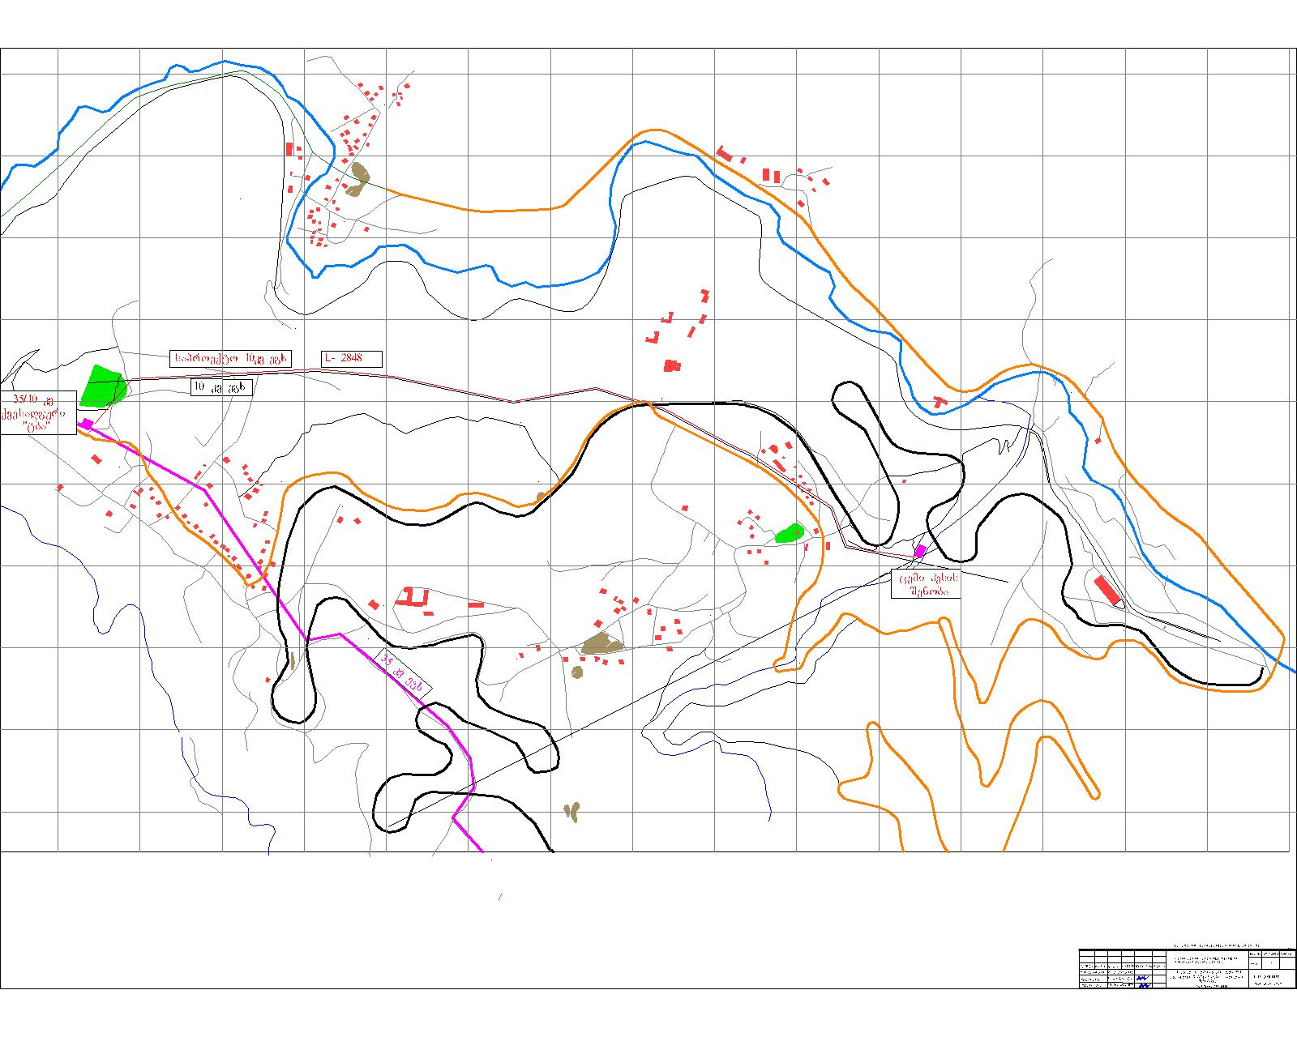
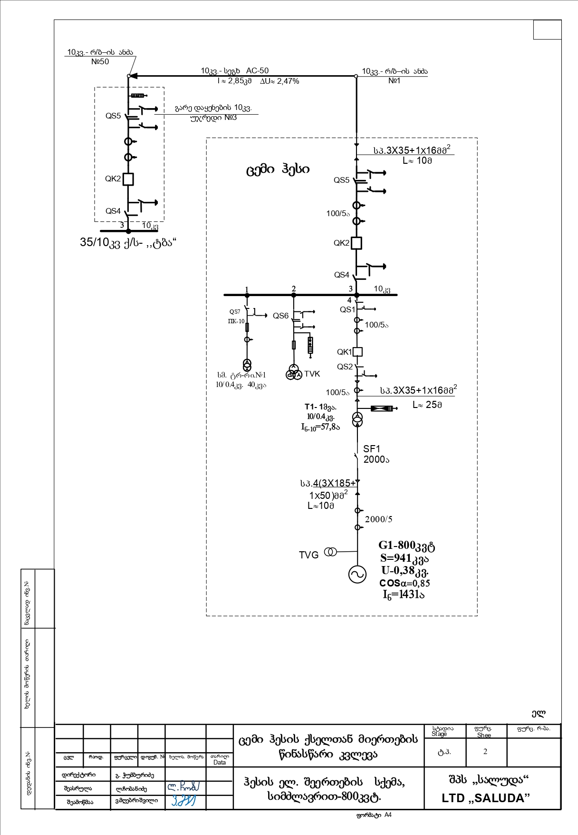
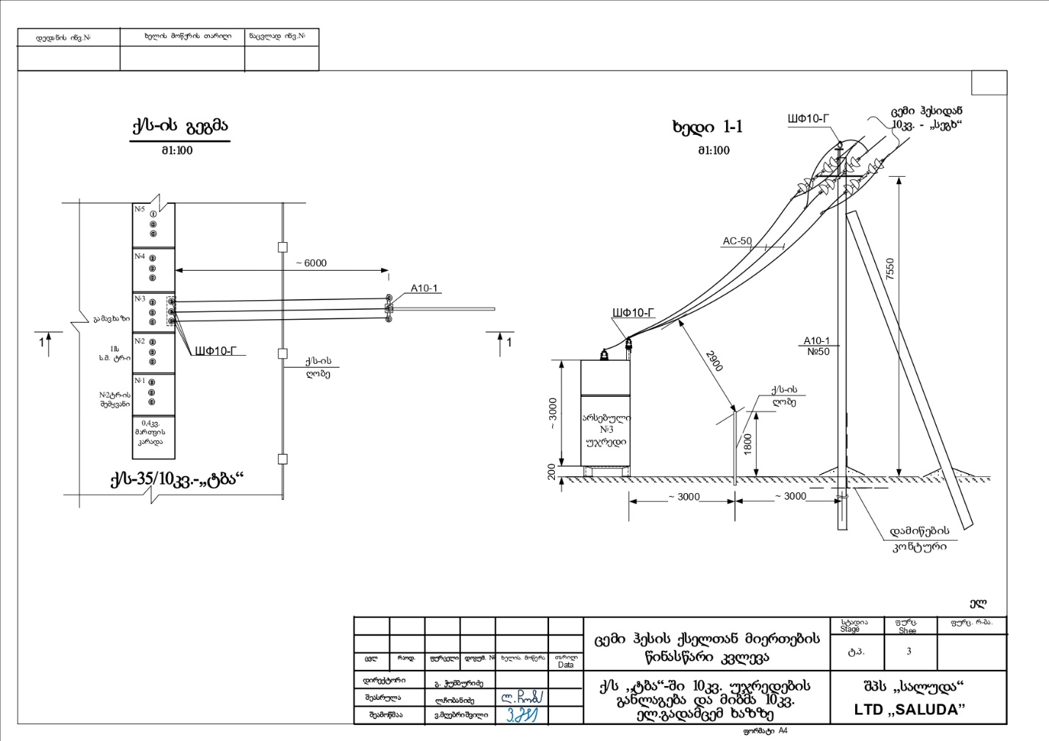

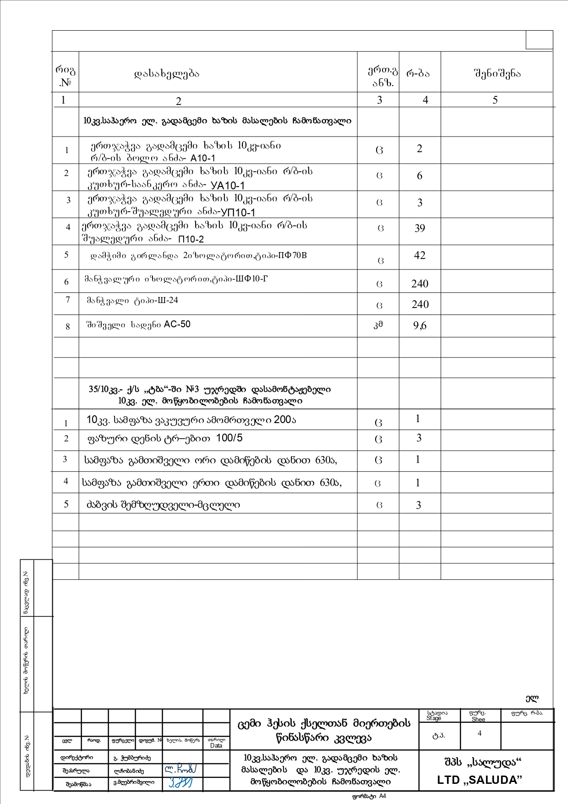

14. Sesasrulebeli samuSaoTA moculobebi da winaswari saorientacio gafaseba
„ცემი ჰესი“- ს სათავე წყალმიმღები კვანძის მოწყობა

# | samuSaos dasaxeleba | Gganz. | raode-  noba | erT. Rir. lari | saerTo Rir.  Lari
1 | 2 | 3 | 4 | 5 | 6
მოსამზადებელი და გრუნტის სამუშაოები
1 | III-IV ჯგ. გრუნტის დამუშავება ბულდოზერით სათავე ნაგებობის მშენებლობის ადგილამდე ჩასასვლელი გზის მოსაწყობად და სამშენებლო ტერიტორიის მოსასწორებლად | m³ | 600 | 2,0 | 1200
2 | III-IV გრუნტის დამუშავება სათავე ნაგებობის ქვაბულში, ექსკავატორით ნაგებობების საძირკველის მოსაწყობად, ამოღებული გრუნტის გვერდზე დაყრით | Mm³ | 800 | 2,5 | 2000
3 | ექსკავატორით დამუშავებული გრუნტის გადაადგილება ბულდოზერით მშენებლობის ადგილიდან მოსაცილებლად | m³ | 800 | 2,0 | 1600
4 | IV ჯგ. გრუნტის დამუშავება ექსკავატორით დროებითი წყალგამყვანი კალაპოტის მოსაწყობად | Mm³ | 400 | 2,5 | 1000
5 | მასიური ბეტონის ბლოკების, ზომით 1,0×1,0×2,0 m. შეძენა, შემოტანა და ადგილზე დალაგება დროებითი წყალგამყვანი კალაპოტის და დროებითი დამბის მოსაწყობად | Mm³ | 30 | 200 | 6000
6 | გრუნტის საბოლოო დამუშავება ხელით ბეტონის კონსტრუქციების ძირში | m³ | 60 | 15 | 900
7 | ხრეშის გამათანაბრებელი ფენის მოწყობა ბეტონის კონსტრუქციების ქვეშ δ=15 სმ | Mm³ | 20 | 35 | 3500
 | სულ მოსაზადებელი და გრუნტის სამუშაოები | lari |  |  | 16200
ბეტონის სამუშაოები სათავე ნაგებობის მოწყობაზე
8 | B-7,5 მარკის მჭლე ბეტონის მოსამზადებელი ფენის მოწყობა δ=10 სმ | Mm³ | 15 | 140 | 2100

1 | 2 | 3 | 4 | 5 |  | 6
9 | ბეტონის წყალსაშვიანი კაშხლის, და გამრეცხი მალის მოწყობა შუალედური ბურჯებითა და გვერდითი კედლებით მB-25 მარკის მონოლითური არმირებული ბეტონით. არმატურის შეცულობა 40 კგ/მ³ | m³ | 920 | 340 |  | 312800
10 | კაშხლის ზედაპირული ფენის მოწყობა ბ-35 მარკის ცვეთამედეგი მონოლითური ბეტონით | m³ | 30 | 300 |  | 9000
11 | წყალსაცემი ჭის მოწყობა ჩამკეტი კბილით B-25 მარკის მონოლითური არმირებული ბეტონით. არმატურის შეცულობა 40 კგ/მ³ | m³ | 164 | 320 |  | 52480
12 | ბეტონის კედლების მოწყობა წყალსაცემი ჭის გაყოლებაზე, ორივე მხრიდან B-25 მარკის მონოლითური არმირებული ბეტონით. არმატურის შეცულობა 40 კგ/მ³ | მ³ | 70 | 340 |  | 23800
13 | საფეხურებიანი თევზსავალი კვანძის მოწყობა B-25 მარკის მონოლითური არმირებული ბეტონით. არმატურის შეცულობა 60 კგ/მ³ | m³ | 90 | 360 |  | 32400
14 | წყალმიმღები კვანძის მოწყობა B-25 მარკის მონოლითური არმირებული ბეტონით. არმატურის შეცულობა 50 კგ/მ³ | m³ | 260 | 340 |  | 88400
15 | სახიდე (ფეხით სასიარულო ხიდი) ფილების მოწყობა სათავე ნაგებობაზე B-25 მარკის მონოლითური არმირებული ბეტონით. არმატურის შეცულობა 60 კგ/მ³ | m³ | 10 | 380 |  | 3800
სულ ბეტონი |  |  |  |  |  | 524780
სხვადასხვა სამუშაოები სათავე ნაგებობის მოწყობაზე
16 | შემტბორავი ფარების მოწყობა სათავე ნაგებობის კაშხალზე. ზედაპირული ბორბლიანი ფარი ПК-300-300. (ერთი ფარის წონა ფარი 1091 კგ. ჩასატანებელი დეტალები 777 კგ. ამწე მექანიზმი - 275 კგ. სულ 2143 კგ | ცალი  ტ | 2  4,30 |  | 4000 |  | 17200
17 | სიღრმული ფარის მოწყობა გამრეცხ მალზე ГС -250 (ფარის წონა: ფარი 1456 კგ. ჩარჩო -1826 კგ. ამწე მექანიზმი-355 კგ. ჯამში 3710 კგ) | ცალი  ტ. | 1  3,70 |  | 4000 |  | 14800

1 |  | 2 | 3 |  |  |  |  |  | 4 |  | 5 | 6
18 |  | ფარის მოწყობა სადაწნეო მილსადენის შესასვლელ კვეთზე. სიღრმული ფარი ГС-80 (ფარი-604 კგ. ჩარჩო - 354 კგ. ღერძი- 207 კგ. ამწე მექანიზმი -220 კგ, სულ 2889 კგ) | ცალი  ტ. |  |  |  |  |  | 1  1,40 |  | 4000 | 5600
19 |  | უხეში გისოსის მოწყობა წყალმიმღების შესასვლელ კვეთზე. გისოსის ზომები 200×120 სმ | ტ. |  |  |  |  |  | 0,41 |  | 4000 | 1640
20 |  | წმინდა გისოსის მოწყობა სადაწნეო მილსადენის შესასვლელ სათავისთან. გისოსის ზომების 200×200 სმ. | ტ. |  |  |  |  |  | 0,22 |  | 4000 | 880
21 |  | სადრენაჟე ხვრეტების მოწყობა წყალსაცემი ჭის ფილაში, ფოლადის მილების d=159 მმ. ჩატანებით. | ცალი  მ. |  |  |  |  |  |  | 40  44 | 25 | 1100
22 |  | ბეტონის კედლების გარე, გრუნტთან შეხებაში მყოფი ზედაპირების ჰიდროიზოლაცია ორი ფენა ბიტუმით შეღებვით | მ² |  |  |  |  |  |  | 600 | 10 | 6000
31 |  | მოაჯირის მოწყობა სათავე ნაგებობის პერიმეტრზე ფოლადის მილკვადრატებით | ტ. |  |  |  |  |  |  | 1,2 | 4000 | 4800
32 |  | დეფორმაციული ნაკერების მოწყობა სათავე ნაგებობასა და სალექარზე სპეციალური, რეზინის პროფილებით | მ |  |  |  |  |  |  | 40 | 30 | 1200
33 |  | წყალქცევის განხორციელება სათავე ნაგებობის მშნებლობისას, 60 მ³/სთ წარმადობის ტუმბოებით | მანქ./სთ. |  |  |  |  |  |  | 200 | 20 | 4000
 |  | სულ სხვადასხვა სამუშაოებზე | ლარი |  |  |  |  |  |  |  |  | 57220
 |  | სულ სათავე ნაგებობაზე | ლარი |  |  |  |  |  |  |  |  | 598200
ჰესის სადაწნეო მილსადენის მოწყობა
1 |  | III ჯგუფის გრუნტის დამუშავება ექსკავატორით | მ³ |  |  |  | 14000 |  |  |  | 2,5 | 35000
2 |  | კლდოვანი გრუნტის გაფხვიერება პნევმოჩაქუჩით | მ³ |  |  |  | 18000 |  |  |  | 10 | 180000
3 |  | გაფხვიერებული კლდოვანი გრუნტის დამუშავება ექსკავატორით | მ³ |  |  |  | 18000 |  |  |  | 2,0 | 36000
4 |  | დამუშავებული გრუნტის დატვირთვა ავტოთვითმცლელზე და გატანა სანაყაროზე | მ³ |  |  |  | 19000 |  |  |  | 4,0 | 76000
5 |  | გრუნტის დამუშავება-მოსწორება მილის სამონტაჟო ტრანშეის ძირში ხელით | მ³ |  |  |  | 200 |  |  |  | 15 | 3000
6 |  | ფოლადის d=630 δ=7 მმ მილის შეძენა და ადგილზე შემოტანა | მ  ტ. |  |  |  | 2010  216 |  |  |  | 300 | 603000
1 |  | 2 | 3 |  |  |  | 4 |  |  |  | 5 | 6
7 |  | ფოლადის d=630 δ=7 მმ. მილის ანტიკოროზიული იზოლაცია და მონტაჟი | მ |  |  |  | 2010 |  |  |  | 40 | 80400
8 |  | აკვედუკის მოწყობა ფოლადის დეტალებით, სადაწნეო მილსადენით მდინარის კალაპოტის გადაკვეთაზე. აკვედუკის სიგრძე 18,0 მ. | ტ. |  |  |  | 4,0 |  |  |  | 4000 | 16000
9 |  | აკვედუკის საყრდენების საძირკველის ფილების მოწყობა მონოლითური ბეტონით B-20. არმატურის შეცულობა 30 კგ/მ³ | მ³ |  |  |  | 10 |  |  |  | 280 | 2800
10 |  | საანკერო საყრდენების მოწყობა სადაწნეო მილსადენის ტრასის მოხვევის კვეთებში მონოლითური ბეტონით B-20. არმატურის შეცულობა 30 კგ/მ³ | მ³ |  |  |  |  | 150 |  |  | 280 | 42000
11 |  | გრუნტის უკუჩაყრა ტრანშეაში და ადგილზე მოსწორება ბულდოზერით და ექსკავატორით | მ³ |  |  |  |  | 13000 |  |  | 1,5 | 19500
 |  | სულ სადაწნეო მილსადენი | ლარი |  |  |  |  |  |  |  |  | 931700
სააგრეგატე შენობის და გამყვანი ტრაქტის მოწყობა
1 |  | III ჯგუფის გრუნტის დამუშავება ექსკავატორით სააგრეგატე შენობის ქვაბულის მოსაწყობად | მ³ |  |  | 500 |  |  |  |  | 2,5 | 1250
2 |  | დამუშავებული გრუნტის გადაად-გილება ბულდოზერით | მ³ |  |  | 500 |  |  |  |  | 2,0 | 1000
3 |  | გრუნტის საბოლოო დამუშავება ხელით ბეტონის კონსტრუქ-ციებისათვის საფუძველის მოსამ-ზადებლად | მ³ |  |  | 40 |  |  |  |  | 15 | 600
4 |  | ხრეშის მომზადების მოწყობა სააგრეგატე შენობის ბეტონის კონსტრუქციების ძირში | მ³ |  |  | 30 |  |  |  |  | 35 | 1050
5 |  | მჭლე ბეტონის მომზადების მოწყაობა | მ³ |  |  | 20 |  |  |  |  | 130 | 2600
6 |  | მონოლითური არმირებული ბეტონის B-25 ფილა ტურბინა-აგრეგატების სამონტაჟო დარბაზში. არმატურის შეცულობა 50 კგ/მ³ | მ³ |  |  | 95 |  |  |  |  | 340 | 32300
7 |  | მონოლითური ბეტონის B-25 კედლების მოწყობა. არმატურის შეცულობა 50 კგ/მ³ | მ³ |  |  | 30 |  |  |  |  | 340 | 10200
8 |  | არმირებული მონოლითური ბეტონის B-25 ფილისა და კედლების მოწყობა სამონტაჟო მოედანზე. არმატურის შეცულობა 50 კგ/მ³ | მ³ |  |  | 25 |  |  |  |  | 340 | 8500
1 |  | 2 | 3 |  |  | 4 |  |  |  |  | 5 | 6
9 |  | არმირებული მონოლითური ბეტონის B-25 ფილისა და კედლების მოწყობა სამომსახურეო მიშენებაში. არმატურის შეცულობა 50 კგ/მ³ | მ³ |  |  | 50 |  |  |  |  | 340 | 17000
10 |  | სატრანსფორმატორო ქვესადგურის ფილისა და კედლების მოწყობა მონოლითური ბეტონით B-25. არმატურის შეცულობა 50 კგ/მ³. | მ³ |  |  | 15 |  |  |  |  | 340 | 5100
11 |  | ტურბინებიდან გამომუშავებული წყლის გამყვანი გალერეის მოწყობა მონოლითური ბეტონით B-25. არმატურის შეცულობა 60 კგ/მ³ | მ³ |  |  | 20 |  |  |  |  | 340 | 6800
12 | ფოლადის დეტალები (ორტესებრი საკოლონე სვეტები, კოჭები, მილაკვადრატები, კუთხოვანები და ა.შ.) სააგრეგატე შენობის ზედა ნაწილის და გადახურვის მოსაწყობად |  |  | ტ. | 15 |  |  |  |  |  | 4000 | 60000
13 | საკედლე და გადახურვის სენდვიჩ-პანელები |  |  | მ² | 500 |  |  |  |  |  | 80 | 40000
14 | ტიხრების, იატაკის და შეკიდული ჭერის მოწყობა სამომსახურეო მიშენებაში |  |  | ლარი | - |  |  |  |  |  | - | 5000
15 | ფანჯრები, კარებები, წყალმო-მარაგება, კანალიზაცია. |  |  | ლარი |  |  |  |  |  |  |  | 6000
16 | სააგრეგატე შენობის მიმდებარე ტერიტორიის შემოღობვა, ჭიშკარი კუტიკარით, ეზოს კეთილმოწყობა |  |  | ლარი |  |  |  |  |  |  |  | 7000
 | სულ  სააგრეგატე შენობის სამშენებლო ნაწილი |  |  | ლარი |  |  |  |  |  |  |  | 204400
17 | ტურბინა-გენერატორის და ხიდურა ამწის შეძენა, შესაბამისი ელექტრომოწყობილობით |  |  | ლარი |  |  |  |  |  |  |  | 600000
18 | სულ სააგრეგატე შენობა მოწყობილობის ჩათვლით |  |  | ლარი |  |  |  |  |  |  |  | 804400
19 | ელექტროგადამცემი ხაზის მოწყობა, შიდა მოხმარება |  |  | ლარი |  |  |  |  |  |  |  | 150000
20 | ჰესის სააგრეგატე შენობამდე მისასვლელი გზის მოწყობა |  |  | ლარი |  |  |  |  |  |  |  | 60000
 | სულ ჰესის მოწყობა |  |  | ლარი |  |  |  |  |  |  |  | 2544300
 | გაუთვალისწინებელი ხარჯები 5% |  |  | ლარი |  |  |  |  |  |  |  | 127215
 | სულ გაუთვალისწინებელი ხარჯებით |  |  | ლარი |  |  |  |  |  |  |  | 2671515
 | პროექტირება |  |  | ლარი |  |  |  |  |  |  |  | 100000
 | სულ |  |  | ლარი |  |  |  |  |  |  |  | 2771515
 | დღგ 18% |  |  | ლარი |  |  |  |  |  |  |  | 498873
 | სულ დღგ-ს ჩათვლით |  |  |  |  |  |  |  |  |  | 3270388  3,270388:2,85=1147504≈  1,150 ათასი აშშ $
 | 1 კვტ დადგმული სიმძლავრის თვითღირებულება  1147504:500=2295= აშშ დოლარი |  |  |  |  |  |  |  |  |  | 2295≈2300  აშშ დოლარი

15. Construction organization
15.1 General:
According to the memorandum signed with the Government of Georgia, the construction works of "Tsemi HPP", including the installation and commissioning of the HPP, should be completed within 17 months.

The construction works of the HPP will be carried out by the contractor construction organization, which will be identified on the basis of the tender procedure. Clarification and concretization of construction organization issues will be possible only after identifying the construction organization of the contractor, the capabilities of this construction organization, the equipment at his disposal, etc. considering.
At the stage of technical and economic justification of "Tsemi Hesi", when the detailed project documentation of the HPP has not been processed and the organization implementing the construction has not been selected, the issues of the organization of the construction of the HPP can be discussed only in general. Individual specific details: the location of the construction camp, the number of construction personnel and accommodation issues, the number and composition of construction machinery brought to the construction site can be decided by the contractor, taking into account the considerations of the construction organization.
15.2 "Tsemi Hesi" construction schedule
As we mentioned above, the completion of the construction of the project HPP, according to the memorandum, is expected within 17 months. When determining the time frame for the construction of individual nodes of the HPP, the capabilities of the contractor organization implementing the construction, as well as the flood and low water periods of the river, should be taken into account. The nodes of the HPP that should be placed in the river bed, specifically the main intake node of the HPP and the aqueduct arranged at the crossing of the river bed with a pressure pipeline must be built during the period of low water in the river, which according to the hydrological data of the Tsemistskali River lasts from the end of July to March of the following year, i.e. for 7 months. Taking into account the aforementioned and also the volumes and laboriousness of the works to be performed at individual nodes of the HPP, the reference schedule for the construction of "Tsemi HPP" was developed, which is presented below in the form of a table.
The implementation of the construction is planned to start on February 1, 2023 and be completed (including the installation and commissioning of the HPP) 16 months later, on June 1, 2024.
15.3 ჰესის მშენებლობის განხორციელების საორიენტაციო გრაფიკი
# | სამუშაოს დასახელება | სამუშაოს განხორციელების პერიოდი
1 | მშენებლის მობილიზაცია.სამშენებლო ბანაკის მოწყობა | 2023 წლის 1 თებერვალი - 15 თებერვალი. – 15 დღე
2 | საპროექტო ჰესის სათავე ნაგებობასთან და სააგრეგატე შენობასთან ჩასასვლელი გზების მოწყობა | 2022 wlis 16 თებერვალი - 28 თებერ-ვალი – 12 დღე
3 | მოედნის მომზადება შემოტანილი მილების დასასაწყობებლად | 2023 wlis 1 მარტი 15 მარტი. 15 დღე.
4 | სამშენებლო მოედნების დროებითი ელექტრომომარაგების მოწყობა | 2023 1 მარტი - 10 მარტი -10 დღე
5 | სადაწნეო მილსადენის მოსაწყობად საჭირო ფოლადის მილების შემოტანა და დასაწყობება | 2023 wlis 1 აპრილი -30 აპრილი - 2,0 თვე
6 | სათავე ნაგებობის მშენებლობისათვის საჭირო მასალების შემოტანა და დასაწყობება | 2023 წლის 1 ივნისიდან-31 ივლისამდე. 2 თვე
7 | სათავე ნაგებობის მშენებლობა | 2023 წლის 1 აგვისტოდან - 2023 წლის 31 დეკემბრამდე  -5 თვე.
8 | ჰესის სადაწნეო მილსადენის მოწყობა, ტრანშეის მომზადება, მილების მონტაჟი, აკვედუკისა და ბეტონის საანკერო საყრდენების მოწყობა | 2023 წლის 1 მარტიდან - 2023 წლის 30 ნოემბრამდე  -9 თვე
9 | სააგრეგატე შენობის მშენებლობისათვის საჭირო მასალების შემოტანა და დასწყობება | 2023 წლის 1 აგვისტო - 15 აგვისტო - 15 დღე
10 | სააგრეგატე შენობისა და გამყვანი ტრაქტის მშენებლობა | 2023 წლის 1 აგვისტო - 2024 წლის 31 იანვარი 5 თვე
11 | ელექტროგადამცემი ხაზის მოწყობა სარეაბილიტაციო სამუშაოები სატრანსფორმატორო ქვესადგურში | 2023 wlis 1 სექტემბერი  2023 wlis 30 ნოემბერი  3 თვე
12 | ჰესის შენობაში ტურბინა-აგრეგატების, ხიდურა ამწის და ელექტრო კაბელების დამონტაჟება | 2024 წლის 1 თებერვალი 2024 წლის 15 მარტი - 45 დღე
13 | ჰესის გაწყობა გაშვებისა და ექსპლუატაციაში შეყვანის სამუშაოები | 2024 წლის 16 მარტი - 2024 წლის 1 ივნისი. 2,5 თვე.

15.3 samSeneblo samuSaoTa ganxorcieleba:
mosamzadebeli samuSaoebi: mSeneblobis sawyis etapze saWiroa ganxorcieldes mosamzadebeli samuSaoebi, rac gulisxmobs:
- samSeneblo teqnikis mobilizacias:
- teqnikuri personalisa da samuSao Zalis treinings.
- samuSao adgilis momzadebas;
kontraqtorma unda uzrunvelyos mSeneblobaze dasaqmebuli personalis, (subkontraqtoris personalis CaTvliT) treiningi janmrTerlobis dacvis, Sromis usafrTxoebisa da garemos dacvis sakiTxebSi. samSeneblo samuSaoebis dawyebamde, mSeneblobaze dasaqmebul nebismier muSaks unda hqondes aRniSnuli treningebis gavlis damadasturebeli sertifikati. Aucileblad unda Catardes mSeneblobaze dasaqmebuli mZRolebisa da samSeneblo teqnikis (eqskavatori, buldozeri, greideri, amwe-krani da sxva) operatorebis testireba da saWiroebis SemTxvevaSi, maTi treiningi. samuSaoze daiSvebian mxolod kvalificiuri, Sesabamisi sertifikatis mqone operatorebi.
saWiroa Catardes specialuri treiningi qimiuri da infeqciuri nivTierebebis Semnaxveli kompleqtebis moxmarebaSi. aseve treiningi im muSakebisaTvis romeltac uwevT muSaoba tranSeebsa da qvabulebSi.
mSeneblobaze dasaqmebuli mTliani personali unda gaecnos garemos dacvis moTxovnebs da daicvas es moTxovnebi muSaobis procesSi.
mosamzadebeli samuSaoebis Semadgeneli elementebia::
- saproeqto obieqtis dakvalva, rac Tavisi mxriv Sesdgeba Semdegi samuSaoebisa da procedurebisagan:
- markSeideruli niSnulebis dadgma da perioduli monitoringi;
- samuSao ubnebis sazRvrebis amRniSvneli niSnulebis dadgma da perioduli monitoringi;
- calkeuli nagebobebis (kvanZebis) mSeneblobis adgilmdebareobis dadgena;
- hidromeqanikuri mowyobilobis montaJisaTvis,maTi ganTavsebis, poziciisa da zomebis gadamowmeba;
- samuSao adgilis momzadeba, rac Tavis mxriv moicavs Semdeg procedurebs:
- im adgilebis SemosazRvra, sadac proeqtis mixedviT gaTvaliswinebulia miwis eqskavaciis samuSaoTa ganxorcieleba;
- saeqskavacio farTobidan zeda niadagis fenis moxsna, ZiriTadad buldozeriT, da calkeu;l adgilebSi dagroveba SemdgomSi dasasawyobeblad gasatanad;
- balastis Semotana da ganawileba samSeneblo ubnebze, proeqtis Sesabamisad. amasTan balastis Semotana unda ganxorcieldes mxolod winaswar gansazRvruli da Sesabamis instanciebTan SeTanxmebuli adgilebidan;
samuSaoTaA warmoeba
samSeneblo samuSaoTa warmoebisaTvis mobilizebuli iqneba sxvadasxva jgufebi gansxvavebuli specifikis samuSaoebis Sesasruleblad, rogoricaa rogoricaa: saproeqto obieqtis adgilze dakvalva, gruntis damuSaveba, tranSeebisa da qvabulebis gaTxra da ukuyriliT amovseba, xarisxovani yrilis mowyoba, armaturis dawvna, saproeqto konstruqciebis dabetoneba, milebis montaJi, hesis hidromeqanikuri da eleqtromowyobilobis montaJi da a.S.
samSneblo samuSaoebis warmoebisas, masalebisa da teqnikis usafrTxo gadaadgileba unda kontroldebodes mesignalis mier, romelsac gavlili unda hqondes specialuri treiningi.
gruntis damuSaveba ganxorcieldeba eqskavatorebisa da buldozerebis gamoyenebiT. damuSavebuli, tranSeidan da qvabulidan amoRebuli grunti ganTavsdeba dasamuSavebeli tranSeebisa Dda qvabulebis gverdiT gamoyofil sarezervo farTobebze, SemdgomSi maTu ukuyrilebisaTvis gamosayeneblad. Zedmeti grunti gatanili unda iqnes samSeneblo obietidan, am mizniT specialurad gamoyofil sanayaro adgilebze.Asaproeqto nagebobaTa safuZvelSi niadagis rbili da arasaTაnado meqanikuri Semadgenlobis gruntis fenebis gamovlenis SemTxvevaSi, aRniSnulis Sesaxeb unda ecnobos mSeneblobis zedamxedvels da miRebuli iqnes Sesabamisi RonisZiebebi gruntis aRniSnuli, arasaTanado konsistenciis fenis mosacileblad.
gruntis eqskavaciis samuSaoebis dasrulebis Semdeg, saWiroa ganxorcieldes gruntis miRebuli zedapiris donis gaTanabreba saWiro doneze da proeqtiT miRebul sididemde gamkvriveba.Bgruntis eqskavaciis samuSaoTa ganxorcielebisas, saWiroaUeqskavaciis adgilis dacva wylis moxvedrisa da gruntis gadatenianebisagan.LE
betonis nagebobebis safuZvelSi, xreSis momzadebis fenis mosawyobad gamoyenebuli unda iqnes Sesabamisi granulometriuli Semadgenlobis mqone xreSi, romelic aucileblad unda Seicavdes wvril fraqcias, rac uzrunvelyofs xreSis saTanado donemde datkepnis SesaZleblobas. xarisxovani yrilis mowyobisas, gamoyenebuli grunti unda ganawildes da daitkepnos araumetes 250 mm. sisqis fenebad. TiToeuli fenis datkepnis xarisxi unda gakontroldes zedamxedveli inJinris mier.
betonis samuSaoebis dawyebamde saWiroa dasabetonebeli obieqtebis dakvalva saproeqto naxazebis mixedviT. kerZod geodezistebis mier unda ganxorcieldes nagebobebis RerZebis dakvalva da centraluri niSnulebis datana.

xis yalibebi
betonis samuSaoebis Sesasruleblad saWiro xis yalibebi unda iyos vibraciagamZle da uZlebdes samSeneblo samuSaoebis warmoebisas ganviTarebul datvirTvebs, ar iRunebodes masSi betonis xsnaris ganTavsebisas. xis yalibebi unda damzaddes Sesabamisi xarisxis xis masalisagan. im betonis konstruqciebis dabetonebisas, romlis zedapiric ar Cans (F₁ klasi), yalibebis mosawyobad SeiZleba gamoyenebuli iqnes uxeS zedapiriani xis masala. F₂ klasis zedapiriani betonis konstruqciebis dabetonebis SemTxvevaSi, yalibebis mosawyobad gamoyenebuli unda iqnes uxeSi xe gluvi zedapiriT, romelzec gadakruli unda iqnes Sewebebuli firficari. F₃ klasis betonis zedapiris misaRebad, yalibebis mosawyobad gamoyenebuli unda iqnes mxolod Sewebebuli firficari.
xis yalibi unda damzaddes iseTnairad, rom misi daSla ganxorcieldes maqsimalurad advilad, betonis zedapiris dazianebis gareSe. xis yalibis ficrebis SeerTebebi unda iyos myari, raTa ar moxdes dabetonebisas yalibidan cementis xsnaris gamoJonva.
xis yalibis montaJis dasrulebisas, mSeneblobis zedamxedvelis mier unda moxdes yalibis vizualuri Semowmeba. akrZalulia yalibis moxsna betonis Casxmidan 12 saaTis gasvlamde. Yyalibis moxsnis dro unda ganisazRvros im moTxovnis gaTvaliswinebiT, rom yalibis moxsnam ar gamoiwvios Casxmuli betonis formis Secvla da dazianeba. yalibis formebi da samagrebi unda gaiwmindos, mogrovdes da ganTavsdes am mizniT specialurad gamoyofil ubnebze. yalibis ficrebidan gareT gamosuli lursmnebi aucileblad unda iqnes mocilebuli, personalis dazianebis Tavidan asacileblad.

armatura.
betonis konstruqciebis armirebisaTvis gamoyenebuli armatura unda iyos Sesabamisi klasis da xarisxis. Aarmaturis Reroebi unda daifaros brezentiT raTa daculi iqnes atmosferuli naleqebisagan, da gamoyenebis win gaiwmindos Jangisagan.
mSeneblobaze Semotanili armatura, unda aRiricxos da dainomros, raTa gamoyenebisas cnobili iyos TiToeuli elementis klasi da diametri. saproeqto naxazebis mixedviT ganxorcieldeba armaturis daWra da gadaRunva, risTvisac gamoyenebuli iqneba specialuri danadgarebi. Armaturis gadaRunva unda ganxorcieldes gacxelebis gareSe, Tanabari wneviT daproeqtiT gansazRvrul teqnikur maxasiaTeblebTan SesabamisobiT. sasurveli formisa da zomis, gamosayeneblad gamzadebuli armatura Seinaxeba specialurad gamoyofil adgilze. Armaturis gadazidva unda warmoebdes, specialuri trailerebis meSveobiT. Aarmaturis zeda karkasis dasamagreblad gamoyenebuli unda iqnes armaturis fiqsatorebi, armaturis fiqsatorebis zomebi da raodenobs gaTvlili unda iqnes iseTnairad, rom uzrunvelyofili iqnes armaturis karkasis stabiluroba nbetonis Casxmisad, da daxuli iqnes betonis damcavi fenis proeqtiT gansazRvruli mniSvneloba.
armaturis montaJis dasrulebis Semdeg, dabetonebis dawyebamde, armaturis ganTavsebisa da damagrebis xarisxi da saproeqto naxazebTan Sesabamisoba unda gadamowmdes mSeneblobis zedamxedvelis mier.

betoni.
damkveTisa da kontraqtori samSeneblo organizaciis mier miRebuli gadawyvetilebis Sesabamisad, saproeqtok onstruqciebis dabetonebis samuSaoebi SeiZleba ganxorcieldes an Semotanili qarxnuli betonis gamoyenebiT, an adgilze damzadebuli betoniT.
betonis adgilze damzadebis SemTxvevaSi, rekomendirebulia Semdego maxasiaTeblebis mqone betonis kvanZis gamoyeneba:
- betonis kvanZis tipi – sveli sistema, sruli avtomatizaciiTa da wylis gamagrilebliT;
- modeli – SB-75A;
- warmadoba – 30 m³/saaTi;
- Semavsebeli bunkerebi – 4 cali, TiToeuli 20 m³ tevadobis;
- cementis silosis tevadoba – 75 toniani 1 cali da 32 toniani- 1 cali.
betonis transportireba unda ganxorcieldes Sesabamisi moTxovnebis dacviT, raTa Tavidan iqnes acilebuli transportirebisas betonis dabinZureba da ganmeorebiT arevis saWiroeba. betonis gadazidvis Semdeg saWiroa betonmzidebis gawmenda darCenili betonis xsnarisagan. Bbetonis yovel Semotanil partias Tan unda moyves, betonis klasis damadasturebeli specialuri baraTi.
ცxel amindSi betonis Casxmisas, betonis temperaturam ar unda gadaaWarbos 30 graduss. Cic anmindSi betonis Casxmisas minimaluri dasaSvebi temoperatura Seadgens 5 gradus. temparturis gazomva xdeba specialuri Termometris meSveobiT.
dabetonebis blokebis simaRle ar unda aRematebodes 2 metrs. betonma unda miiRos saboloo forma, inertul SemavsebelSi wylisa da cementis Serevidan araumetes 2 saaTis ganmavlobaSi.
dauSvebelia betonis gadmosxma 1 metrze meti simaRlidan. betoni daculi unda iyos nebismieri ucxo minarevebis moxvedrisagan.
betonis Casxmamde saWiroa xis yalibebis sufTa wyliT dasveleba. Betonis Casxma unda swarmoebdes Tanabar fenebad, romelTA sisqec umetes SemTxvevebSi, garda calkeuli specifikuri pirobebisa, ar unda aRematebodes 600 mm.-s. drois Sualedi qveda fenis dabetonebis dasrulebidan axali zeda fenis Casxmamde, ar unda aRematebodes 30 wuTs.
betonirebis samuSaoebis mniSvnelovani Semadgeneli komponentia axalCasxmuli betonis vibracia. betonis vibrirebis gaTvaliswinebuli unda iqnes mTeli rigi moTxovnebi. kerZod:
- dauSvebelia vibratoris mimagreba armaturaze an konstruqciis sxva damontaJebul nawilebze;
- dauSvebelia betonis napralebis Semcirebis mizniT betonis xelmeore vibracia;
- dauSvebelia gadametebuli vibracia, ramac SeiZleba gamoiwvios betonis xsnaria aRreva an xis yalibSi cementis xsnaris gamoJonva.
- siRrmiseuli vibratoris amoReba betonis xsnaridan unda ganxorcieldes nela, raTa betonSi ar warmoiqmnas carieli adgilebi;
betonirebis procesis dasrulebisTanave, betonis zedapiri unda daifaros sveli jvaloTi an plastmasis safarioT, raTa ar moxdes betons zedapiridan wylis intensiuri aorTqleba.
civ amindSi betonis samuSaoebis Catarebisas, gaTvaliswinebuli unda iqnes specialuri moTxovnebi. Tumca “Sevaburi hesi”-s mSeneblobis regionis klimaturi pirobebidan gamomdinare, betonirebis ganxorcieleba metad civi, uaryofiTi temperaturis pirobebSi, naklebad mosalodnelia.
saWiroa xorcieldebodes Casxmuli betonis testireba arsebuli standartebis Sesabamisad. betonis zedapiri gamkvrivebisas mudmivad unda iyos svel mdgomareobaSi, rasac uzrunvelyofs betonis gamkvrivebaze momuSave specialuri jgufi.
mSeneblobis zedamxedvelebis mier, xis yalibebis moculebis Semdeg, unda Semowmdes dabetonis xarisxi. Gamovlenili wunis SemTxvevaSi, droulad unda ganxorcieldes dawunebuli betonis Secvla. Aaxladdabetonebul konstruqciaSi, 0,3 mm.-ze meti siganis napralebis arsebobisas, unda moxdes napralebis gaganiereba betonis mkvriv Sremde, napralisaTvis V-s formis micema da Sevseba specialuri SemavsebliT BS8110-is Sesabamisad. betonSi arsebuli, 10 mm.-ze meti diametris xvrelebi aseve unda amoivsos specialuri SemavsebliT.
betonis konstruqciebis temperaturuli, deformaciuli da konstruqciuli nakerebi ewyoba arsebuli standartebis (BS8007, BS4254) Sesabamisad. nakerebis mowyobamde saWiroa betonis zedapiris gawmenda da gamSraleba.
betonis zedapiris dasacavad, miwis doneze dabla ganTavsebuli (miwasTan SexebaSi myofi) betonis konstruqciebis zedapirebi unda SeiRebos aranaklebi 1 mm. sisqis bitumis feniT. Mmiwis doneze maRla ganTavsebuli betonis konstruqciebis zedapirebi daigrunteba dabali webvadobis praimeriT da SeiRebeba or fenad, an Ria nacrisferi epoqsidis saRebaviT, sisqiT 125 mikroni anda modificirebuli polimeruli cementis, 500 mikronis sisqis feniT

16. Environmental impact assessment (ecology)
Due to the small capacity of "Tsemi HPP", processing of environmental impact report (EIA) of "Tsemi HPP" is not considered.
In the present feasibility study, as a short summary, we note that the implementation of the "Tsemi HPP", based on the scale, construction and specific conditions created at the site of the HPP construction, should not cause any significant, negative impact on the ecological stability of the surrounding environment and the social environment created in the region of construction. - on the economic situation.
The construction of nodes included in the project HPP does not affect the homestead plots of the population, does not require the eviction of anyone, the cutting of the homestead plots located near residential houses, etc. The removal of residential houses directly from the places of production of construction works is enough so that the local population is not disturbed by the noise and dust caused by the construction. In addition, special measures will be taken in the process of construction works to minimize the noise and dust caused by the construction. No construction work will be allowed at night.
Special measures will be taken to prevent fuel and lubricants from construction machinery from entering the river water. It is not allowed to wash construction machinery and vehicles in river water. Washing of machine-mechanisms, their maintenance with fuel-lubricants, will be carried out in specially designated areas, where special collectors will be provided to collect and accumulate contaminated water, for further cleaning of water. Technically sound, modern construction equipment will be mobilized for the production of construction works.
It is also noteworthy that the implementation of the construction of the HPP is provided by the use of factory-made concrete delivered by concrete trucks, which significantly reduces the noise and dust caused by the construction, compared to the construction made with concrete made on site.
As part of the main water receiving structure of the HPP, it is planned to arrange a stepped fishing nodule, which will later be transferred to a natural type of fishing channel. The construction of the fish hatch guarantees that the construction of the hydroelectric power station will in no way prevent the migration of fish species common on the Tsemistskal River.
The local population will be mainly employed in the construction of the project HPP. It is envisaged to use local personnel as operating personnel even after the commissioning of the HPP. The main part of the property tax paid by Hesi will be included in the budget of Borjomi Municipality. So, the construction and further operation of the HPP will have a positive impact on the socio-economic situation of the population of Borjomi Municipality.
17. Analysis of economic and financial indicators of "Tsemi Hesi";
17.1 Basic assumptions of economic and financial analysis
Below are the main assumptions on which the economic and financial analysis of "Tsemi Hesi" is based.
Basic assumptions
Installed Power (MW) | 0.50
Annual energy production in the conditions of an average wet year (million kWh) | 2,875
Total investment (million USD, excluding VAT, price escalation and financing costs)  (million GEL) | 1.09  3.29
share of own capital %  million US dollars  million GEL | 35 %  0.38  1.15
loan share %  million US dollars  million GEL | 65 %  0.71  2.14
Exchange rate of lari against the US dollar | 3.0
Effective loan rate | 9.5 %
Loan period (year) | 10
Loan grace period (year) | 2
Electricity tariff for 12 months (US dollar cents) | 7.5
Own consumption, stoppages and conduction losses - 2.5% of output (million kWh) | 72
Income from the sale of electricity, taking into account 2.5% of own consumption - 2,803,1250,075 (US dollars) | 210,234
Annual operating costs (% of 1.0 kWh generation) | 0.5 %
Tax on dividend payment % (model assumes annual distribution of dividend) | 20 %
Property tax (%) | 1 %
Property Insurance Rates (%) | 0.3 %
Overhaul cost every 4 years (USD) | 25,000
Depreciation period (years) | 25

Total benchmark assessment

Below is the cost of implementation of Tzemi HPP. Amounts are given in thousands of lari without VAT. The total cost does not include finance costs and does not take into account price escalation. The estimated cost of the project is 3.29 mln. GEL (1.09 million USD). The projected cost of the project is based on the assessment of the volumes of construction and installation works, the benchmark assessment related to the management of similar projects, studies and other project implementation.
Job title | money
 | One thousand GEL
Headwork | 598
Pressure pipeline | 932
HPP aggregate building, transmission channel and road | 264
Electric transmission line | 150
Electro-mechanical equipment and crane | 600
Total capital expenditure | 2,544
Other preparatory works, lands and permits | 150
Design and research | 150
Management and vision | 300
Total operating and other expenses | 600
Total construction cost | 3,144
Unforeseen expenses | 141
Total cost | 3,286

17.1 Economic and Financial Analysis
An investment of 3.29 million GEL (1.09 million US dollars) will be required to build the hydroelectric station. The period of implementation of the mentioned investment includes a period of up to 2 years, during which the mentioned investment will be implemented. The average investment cost per installed megawatt is approximately 6.57 million GEL (2.19 million USD).
Depending on the riskiness of the project, the share of its loan resources in the total investment capital may be 65%. The duration of the loan is calculated for a period of 10 years, taking into account a grace period of 2 years. During the grace period, accrued interest is capitalized. The cost of the credit resource is calculated taking into account the prevailing interest rates in the Georgian banking system and is 9.5% of the US dollar loan resource.
The annual cost of investment capital for project shareholders is 12%, and the weighted average cost of capital is 10.4%. The investment to be made by the shareholders of the project amounts to 1.15 million GEL (0.38 million USD) and the loan amounts to 2.14 million GEL (0.71 million USD).
The economic analysis of the project assumes that the electricity generated for a full 12 months will be sold at 7.5 US cents.
After the commissioning of the hydroelectric plant, the annual income of the project is 0.63 million GEL (0.21 million USD), and the average annual profit, after covering interest costs, is 0.14 million GEL (0.05 USD). The annual cost of servicing the loan (including interest and principal amount) is approximately 0.35 million GEL (0.12 USD) annually.
The payback period of the project after completion of construction is 10.6 years, and its internal rate of return IRR, taking into account financial leverage and the cost of investment capital, is 15.29%.
The loan service ratio (DSCR) according to the years from the beginning of repayment of the loan is as follows:
Year | 2024 | 2025 | 2026 | 2027 | 2028 | 2029 | 2030 | 2031 | 2032 | 2033
DSCR | 1.30 | 1.46 | 1.30 | 1.30 | 1.37 | 1.36 | 1.36 | 1.28 | 1.34 | 1.33

The debt service ratio is greater than 1 in all years, which indicates that the project will be able to generate sufficient cash flow to cover the debt obligations.
Below are the forecast financial sources of "Tsemi Hesi":

Forecast statement of profit and loss during the first 10 years (amounts are given in thousand GEL)
Year |  | 2022 | 2023 | 2024 | 2025 | 2026 | 2027 | 2028 | 2029 | 2030 | 2031
Income from sale of electricity |  | - | - | 631 | 631 | 631 | 631 | 631 | 631 | 631 | 631
Total income |  | - | - | 631 | 631 | 631 | 631 | 631 | 631 | 631 | 631
Production cost |  | - | - | (70) | (70) | (70) | (70) | (70) | (70) | (70) | (70)
Insurance cost |  | - | - | (9) | (9) | (8) | (8) | (7) | (6) | (6) | (5)
Operating cost |  | - | - | (14) | (14) | (14) | (14) | (14) | (14) | (14) | (14)
Property tax expense |  | - | - | (32) | (30) | (28) | (26) | (24) | (22) | (20) | (19)
EBITDA |  | - | - | 506 | 508 | 511 | 513 | 515 | 518 | 520 | 523
Wear and tear |  | - | - | (194) | (194) | (194) | (195) | (195) | (195) | (195) | (197)
Operating profit/(loss) |  | - | - | 312 | 314 | 317 | 318 | 320 | 323 | 325 | 326
Accrued financial expense |  | (51) | (208) | (194) | (180) | (164) | (146) | (127) | (106) | (83) | (58)
Financial income |  | - | - | - | - | - | - | - | - | - | -
Profit/(loss) before tax |  | (51) | (208) | 117 | 134 | 153 | 171 | 193 | 217 | 242 | 268
Profit taxხ  Bear/(income) |  | - | - | - | (27) | (31) | (34) | (39) | (43) | (48) | (54)
Profit/(loss) for the period |  | (51) | (208) | 117 | 108 | 122 | 137 | 154 | 173 | 194 | 215

Cash flow forecast statement for the first 10 years (amounts are in thousands of GEL)
წელი |  | 2022 | 2023 | 2024 | 2025 | 2026 | 2027 | 2028 | 2029 | 2030 | 2031
 |  | 2 | 3 | 4 | 5 | 6 | 7 | 8 | 9 | 10 | 11
Cash flow from operating activities
Operating profit/(loss) |  | - | - | 506 | 508 | 511 | 513 | 515 | 518 | 520 | 523
Change in working capital |  | - | - | (53) | - | - | - | - | - | - | -
Profit tax paid |  | - | - | - | - | (57) | (34) | (39) | (43) | (48) | (54)
Net cash provided by operating activities |  | - | - | 453 | 508 | 453 | 479 | 477 | 475 | 472 | 469
Cash flow from investing activities
Capital expenditure |  | (570) | (2,716) | - | - | - | (25) | - | - | - | (25)
Net cash  from investment activities |  | (570) | (2,716) | - | - | - | (25) | - | - | - | (25)
Cash flow from financing activities
Received equity |  | 575 | 575 | - | - | - | - | - | - | - | -
Received loan |  | - | 2,136 | - | - | - | - | - | - | - | -
Amount of interest paid |  | - | - | (208) | (194) | (180) | (164) | (146) | (127) | (106) | (83)
Payment of the loan amount |  | - | - | (141) | (154) | (168) | (184) | (202) | (221) | (242) | (265)
Net cash from financing activities |  | 575 | 2,711 | (348) | (348) | (348) | (348) | (348) | (348) | (348) | (348)
Net increase/(decrease) in cash and cash equivalents |  | 5 | (5) | 105 | 160 | 105 | 105 | 128 | 126 | 124 | 96
Cash and cash equivalents at the beginning of the period |  | - | 5 | (0) | 105 | 265 | 369 | 475 | 603 | 730 | 853
Cash and cash equivalents at the end of the period |  | 5 | (0) | 105 | 265 | 369 | 475 | 603 | 730 | 853 | 949

Financial statement as of December 31 (amounts are in thousands of GEL)
წელი |  | 2022 | 2023 | 2024 | 2025 | 2026 | 2027 | 2028 | 2029 | 2030 | 2031
Cash flow from operating activities
Operating profit/(loss)
Change in working capital |  | 570 | 3,286 | 3,092 | 2,898 | 2,704 | 2,534 | 2,339 | 2,143 | 1,948 | 1,776
Profit tax paid |  | - | - | - | (27) | - | - | - | - | - | -
Net cash provided by operating activities |  | 570 | 3,286 | 3,092 | 2,871 | 2,704 | 2,534 | 2,339 | 2,143 | 1,948 | 1,776
Cash flow from investing activities |  | - | - | 53 | 53 | 53 | 53 | 53 | 53 | 53 | 53
Capital expenditure |  | 5 | (0) | 105 | 265 | 369 | 475 | 603 | 730 | 853 | 949
Net cash  from investment activities |  | 5 | (0) | 157 | 317 | 422 | 527 | 656 | 782 | 906 | 1,002
Cash flow from financing activities |  | 575 | 3,286 | 3,249 | 3,188 | 3,126 | 3,061 | 2,994 | 2,925 | 2,854 | 2,778
Received equity
Received loan
Amount of interest paid |  | 575 | 1,150 | 1,150 | 1,150 | 1,150 | 1,150 | 1,150 | 1,150 | 1,150 | 1,150
Payment of the loan amount |  | (51) | (208) | 117 | 108 | 122 | 137 | 154 | 173 | 194 | 215
Net cash from financing activities |  | - | (51) | (258) | (141) | (34) | 89 | 226 | 380 | 553 | 747
 |  | 524 | 892 | 1,009 | 1,116 | 1,239 | 1,376 | 1,530 | 1,703 | 1,897 | 2,112
Net increase/(decrease) in cash and cash equivalents
Cash and cash equivalents at the beginning of the period
 |  | - | 1,995 | 1,841 | 1,918 | 1,734 | 1,531 | 1,310 | 1,068 | 803 | 512
Cash and cash equivalents at the end of the period |  | - | 1,995 | 1,841 | 1,918 | 1,734 | 1,531 | 1,310 | 1,068 | 803 | 512
Cash flow from operating activities
Operating profit/(loss)
Change in working capital |  | - | - | - | - | - | - | - | - | - | -
Profit tax paid |  | 51 | 258 | 245 | (15) | (31) | (48) | (67) | (88) | (111) | (137)
Net cash provided by operating activities |  | - | 141 | 154 | 168 | 184 | 202 | 221 | 242 | 265 | 290
 |  | 51 | 399 | 399 | 154 | 154 | 154 | 154 | 154 | 154 | 154
Cash flow from investing activities |  | 51 | 2,394 | 2,240 | 2,072 | 1,887 | 1,685 | 1,464 | 1,222 | 957 | 666
Capital expenditure
Net cash  from investment activities |  | 575 | 3,286 | 3,249 | 3,188 | 3,126 | 3,061 | 2,994 | 2,925 | 2,854 | 2,778

18. Procurement planning and implementation plan;

“cemi hesi”-s mSeneblobis procesSi gansaxorcielebeli Sesyidvebis Semadgenloba, moculoba da mimdevroba damokidebulia gansaxorcielebeli samuSaoebis moculobaze da SesabamisobaSi unda iyos gansaxorcielebeli samuSaoebis Sesrulebis gegma-grafikTan, romelic warmodgenilia winamdebare teqnikur-ekonomikuri dasabuTebis mSeneblobis organizirebis paragrafSi. (paragrafi # 15).
zemodaRniSnulis gaTvaliswinebiT Sedgenili, savaraudo Sesyidvebis gegma-grafiki warmodgenilia qvemoT, cxrilis saxiT.

Sesyidvebis gegma-grafiki

# | Sesyidvis daniSnuleba | Sesyidvis ganxocielebis xangrZlivoba dReebSi | Sesyidvis dasawyisi
1 | hesis sadawneo milsadenis mosawyobad saWiro, 20190 m. d=630 mm foladis milebis SeZena | 30 | 2023 წლის მარტი
2 | saTave wyalmimRebi kvanZebis mSeneblobis gansaxorcieleblad saWiro masalebis (armatura, cementi, inertuli masalebi, mza betoni, biTumi, Zelyoruli zRudarebis da qargilebis mosawyobad saWiro xis masala) SeZena | 120 | 2023 წლის ივნისი
3 | saTave nagebobze dasamontaJebeli farebis damzadeba-SeZena |  | 2023 წლის ოქტომბერი
4 | saagregate SenobebSi dasamonta-Jebeli turbina-generatorisa da eleqtromowyobilobis SeZena | შსყიდვა განხორციელდება 2 ტრანშად | 2023 წლის სექტემბერი  2023 წლის დეკემბერი
5 | saagregate Senobis mSeneblobisaTvis saWiro masalebis (armatura, cementi, inertuli masalebi, mza betoni, biTumi, Zelyoruli zRudarebis da qargilebis mosawyobad saWiro xis masala, metalokramiti, kar-fanjrebi da sxva) SeZena |  | 2023 წლის აგვისტო
6 | saagregate SenobebSi dasamon-taJebeli amwe-kranebis SeZena |  | 2023 წლის ნოემბერიi
7 | ჰesis mSeneblobis dafinanseba |  | 6 ტრანშად, შესრუ-ლებული სამუშაოების მოცულობის მიხედ-ვით

- samuSao Zalis datreningebis grafiki

radganac “cemi hesi”-s mSenebloba ganxorcielebuli iqneba kontraqtori samSeneblo organizaciis meSveobiT, hesis mSeneblobaze dasaqmebuli personalis, adgilobrivi Tu Camoyvanili muSaxelis datreningeba, maTi saWiro kvalifikaciis uzrunvelyofa dakisrebul movaleobaTa Sesasruleblad, warmoadgens aRniSnuli, kontraqtori organizaciis movaleobas da unda ganxorcieldes am samSeneblo organizaciis pasuxismgeblobiT.
rac Seexeba uSualod, Sesabamisi kvalifikaciis mqone, akaskadis SemadgenlobaSi Semavali hesebis saeqspluatacio personalis momzadebas da am mizniT Sesabamisi treningebis organizebas. Hhesis simZlavridan gamomdinare hesis eqspluataciaze dasaqmebuli personalis raodenoba ar iqneba didi, da sul Semoifargleba 8 TanamSromeliT. Eesenia:
hesis direqtori;
hesebis direqtoris moadgile;
hesis saagregate Senobis morige operatorebi- 3 operatori, ganawilebuli sam cvlad, TiTo cvlaSi 1 operatori.
hesis saTave wyalmimRebi kvanZis morige-operatori – 3 operatori., ganawilebuli sam cvlad, TiTo cvlaSi 1 operatori;
hesis direqtorad da direqtoris moadgiled, SerCeuli iqnebian Sesabamisi kvalifikaciis mqone TanamSromlebi. rac Seexeba hesebis saagregate Senobebisa da saTave wyalmimRebi kvanZebis morige-operatorebs, aRniSnul poziciebze gaTvaliswinebulia adgilobrivi mosaxleobis dasaqmeba. kandidaturebis SerCeva da maTi treiningi gaTvaliswinebulia ganxorcieldes 2024 wlis marti-maisSi.

- proeqtis ganxorcielebisaTvis saWiro miwis nakveTebis adgilmdebareobis gansazRvra.

“cemi hesi”-s ganxorcielebisaTvis saWiro miwis farTobi SeiZleba daiyos 3 nawilad:
hesis saTave wyalmimRebi kvanZis mSeneblobisaTvis saWiro miwis nakveTi;
“hesis sadawneo milsadenis mosawyobad gamoyofili 2010 m. sigrZis zoli;
hesis saagregate Senobis mosawyobad gaTvaliswinebuli miwis nakveTi;
proeqtis ganxorcielebisaTvis saWiro miwis nakveTebis ganTavseba warmodgenilia winamdebare teqnikur-ekonomikuri dasabuTebis grafikul nawilSi, hesis saerTo gegmaze. mSeneblobisaTvis saWiro, mudmiv sargeblobaSi gadasacemi, rogorc saxelmwifos, ise kerZo pirebis kuTvnili nakveTebis Seif failebi, warmodgenili iqneba calke dokumentis saxiT, hesis detaluri proeqtis damuSavebis etapze.

21 Graphical part of the feasibility study

N | The name of the drawing | of the sheet N
1 | General plan of the HPP (on 2 sheets) | 1
2 | General plan of the headwater intake junction | 2-1
3 | A detailed diagram of the headwater intake junction | 2-2
4 | Cross-sections of the headwater intake node (on 11 sheets) | 3
5 | Longitudinal profile of HPP pressure pipeline (on 7 sheets) | 4
6 | Pressure pipeline cross-sections (on 13 sheets) | 5
7 | HPP aggregate building and water tract (on 5 sheets) | 6

